Design Thinking & Innovation Management
Question Bank – Solved Study Material
SY B.Tech • PCCOE Pune • AY 2026-27 • Summative exam (30 marks)

Unit I – Foundations of Design Thinking
Unit II – Design Thinking Process
Unit III – Tools for Design Thinking & Innovation
Unit IV – Innovation Management

How to use this material
Summative exam: 30 marks, 1 hr 15 min, 4 questions (one block per unit), all compulsory, with options inside Q3 and Q4. Questions carry 2, 4 or 5 marks.
Question | Parts | Marks
Q.1 (compulsory) | A: i), ii) B: i), ii) | 5 + 2
Q.2 (compulsory) | A and B | 4 + 4
Q.3 | A: any one of i)/ii) B: compulsory | 5 + 2
Q.4 | Any two of A, B, C | 4 + 4

How long should my answer be?
Marks | Write about | Must include
2 marks | 4–6 lines (≈50–70 words) | Definition + 2 key points or one example
4 marks | ≈ 1 page (≈120–160 words) | Definition, 4–5 points, a diagram or table if it fits
5 marks | 1–1.5 pages (≈160–220 words) | Intro, 5–6 points / steps, labelled diagram, example, short conclusion
6 marks | 1.5 pages (≈220–260 words) | Everything for 5 marks + comparison table or worked example

Exam tips: underline key words, draw neat labelled diagrams (they earn marks even when text is short), use point-wise answers, and end long answers with a one-line conclusion. The green "Remember" boxes give a short trick to recall each answer.

Contents
How to use this material 2
Contents 3
Unit I: Foundations of Design Thinking 11
Q1. Define Design Thinking and explain its key principles for identifying user needs in software development. 11
Q2. Differentiate a user-centered approach from a technology-centered approach using a college attendance application as an example. 11
Q3. A team is planning a smart helmet for two-wheeler riders. Apply the Empathize and Define phases to identify users' needs and frame a clear problem statement. 12
Q4. Students, faculty, and parents use a college attendance application for different purposes. Identify the needs of these stakeholders and explain why the design should consider all of them. 12
Q5. Explain how empathy and challenging assumptions help a design team avoid solving the wrong problem. 13
Q6. Explain how Design Thinking helps an IT team identify the right problem before beginning software development. 13
Q7. While observing a college classroom, identify two possible problems faced by students or faculty and convert one into a user-centered problem statement. 14
Q8. A team redesigning a laptop keyboard wants to improve usability for IT students. Generate three possible improvements based on users' needs. 14
Q9. A team observes how people use a ThinkPad during work and study. Explain how these observations can inform user-centered product decisions. 15
Q10. An IDEO team observes people using shopping carts and discovers that their actual difficulties differ from the team's initial assumptions. Analyze how observation and problem definition can help reveal the real problem. 15
Q11. Explain the importance of creativity, user-centricity, and ideation in software engineering. 16
Q12. A student team is redesigning a smart water bottle for everyday use. Apply the Empathize, Define, and Ideate phases to identify a user need, frame a problem statement, and suggest possible ideas. 16
Q13. A toothbrush is being designed for young children. Explain how understanding the intended users can influence design decisions such as ease of use and appeal. 17
Q14. During a Wallet Challenge, participants are asked to improve a wallet for a specific user. Generate three ideas that respond to different user needs or everyday situations. 18
Q15. A software team has generated several ideas for improving a college service. Apply user-centered criteria to shortlist ideas for further consideration and justify your selection. 18
Q16. Differentiate user pain points, system gaps, and digital opportunities with suitable examples. 19
Q17. A team imagines how Google Maps might support users in 2035. Identify a likely user problem and propose a future feature that addresses it, rather than introducing technology only for novelty. 20
Q18. A college canteen uses paper tokens and manual order tracking. Identify user pain points and system gaps, then frame one digital opportunity as a problem statement. 20
Q19. Users frequently abandon an online admission form before submitting it. Analyze possible reasons and identify what evidence the team should gather before redesigning the form. 21
Q20. A college service team proposes an app because similar institutions have one. Analyze how the team should assess whether a genuine user need or system gap justifies the proposed solution. 22
Q21. Define Product-Market Fit and explain why it matters when developing a software product. 23
Q22. A team plans a campus food-ordering application. Apply Product-Market Fit principles to identify the target users, the need to validate, and the feedback to collect before development. 23
Q23. A study-planner app receives many downloads, but few users return to it. Analyze what this may indicate about Product-Market Fit and identify information the team should investigate. 24
Q24. A team proposes a mobile application for first-year students. Explain how it can validate whether the proposed problem is important enough for students to use the product. 25
Q25. A product team receives positive feedback from a few friends about its app idea. Analyze why this feedback alone may be insufficient to establish Product-Market Fit. 25
Q26. Define Product-Technology Fit and explain its relevance to developing software solutions. 26
Q27. A smart helmet uses sensors and mobile connectivity to support riders. Apply Product-Technology Fit principles to assess whether the proposed technology suits user needs and practical constraints. 26
Q28. A college proposes using advanced AI for a simple online registration process. Analyze whether the technology is appropriate by considering user requirements, complexity, and practical constraints. 27
Q29. A college kiosk is being considered for voice control. Apply Product-Technology Fit principles to assess its suitability for the intended users and usage environment. 27
Q30. A team selects a new technology because it is popular, but it makes the product harder to use. Analyze the mismatch and recommend what the team should evaluate before proceeding. 28
Q31. Define Product-Business Fit and explain why it is important for a software product. 29
Q32. A team plans to offer a campus-management application through annual institutional subscriptions. Apply Product-Business Fit principles to identify the customers, costs, and revenue factors to examine. 29
Q33. A software solution addresses a real user need and uses suitable technology, but its maintenance costs exceed its revenue. Analyze the Product-Market, Product-Technology, and Product-Business Fit concerns. 30
Q34. A team proposes an event-management app for colleges. Identify the business factors it should assess before offering the product to institutions. 31
Q35. A product has interested users, but the team has not identified who will pay for it. Analyze why this creates a Product-Business Fit concern and suggest what the team should investigate. 32
Q36. Describe the characteristics of a design mindset and explain its importance for IT project teams. 32
Q37. Students report that a college application is difficult to use. Apply a design mindset to investigate the problem before suggesting interface improvements. 33
Q38. A team rejects user feedback because it believes its original interface is already correct. Analyze the weaknesses in this response and recommend a more user-centered approach. 34
Q39. An IT team begins coding before validating the user problem. Analyze the risks of this approach and explain how Design Thinking can help the team proceed more effectively. 34
Q40. Users report that a new interface is confusing, but the team wants to retain it to avoid rework. Analyze the situation using a design mindset and recommend the team's next step. 35
Quick Revision – Unit I 36
Unit II: Design Thinking Process 37
Q1. Explain the purpose of the Empathize stage in Design Thinking. 37
Q2. Explain how the five stages of Design Thinking can be applied to develop a digital solution for improving the college canteen experience. 37
Q3. Identify the purpose of the Empathize and Define stages in solving user-centred problems. 38
Q4. Illustrate the User Research and its importance in digital system development. 38
Q5. Create an empathy map for College student. Develop an empathy map for students experiencing difficulties with online project submissions. Use the insights to derive user needs and propose suitable digital interventions. 39
Q6. Design a user research plan for a mobile application that helps students manage their academic schedules. 40
Q7. Develop a user persona for an elderly person who finds it difficult to use a mobile banking application. 40
Q8. Compare two personas for a college learning management system: a first-year student and a faculty member. Identify their different needs. 41
Q9. Compare brainstorming, brainwriting, and reverse brainstorming for solving an IT-related problem. 41
Q10. Analyze how user pains, gains, thoughts, and feelings can influence the design of a digital payment application. 42
Q11. A development team repeatedly generates conventional ideas for a complex software problem. Design a structured ideation process using lateral thinking, SCAMPER, reverse brainstorming, and idea prioritization. 43
Q12. A college plans to develop an integrated digital campus platform. Develop a complete Design Thinking approach covering all five stages, from user research to prototype testing. 43
Q13. A hospital faces long registration queues, repeated data entry, and patient dissatisfaction. Reframe the problem from the perspectives of patients, receptionists, and administrators, and propose a suitable "How Might We" statement. 44
Q14. Apply mental block removal techniques for the issues occurred through brainstorming sessions. 45
Q15. Explain the role of problem framing and requirement understanding in the Design Thinking process. Illustrate your answer with a suitable example from an IT-based problem. 46
Q16. Students find it difficult to locate study materials and track assignment deadlines on the college learning portal. Analyze the situation and formulate a clear problem statement based on user needs. 46
Q17. Commuters are unable to obtain accurate bus arrival times, causing delays and inconvenience. How would you investigate user needs and formulate a problem statement for a smart transport application? Compare the conventional transport facility and smart transportation IT based application. 47
Q18. As a Design Thinking practitioner, create a user persona for a student who would use Google Drive application. Include the persona's background, goals, needs, frustrations, behaviours, and expectations from the proposed digital system. Explain how the persona will help guide the application design. 48
Q19. Senior citizens find mobile banking applications difficult to navigate. Develop a user persona representing an elderly user and identify their needs and challenges. 48
Q20. New students and visitors struggle to locate classrooms, laboratories, administrative offices, and other campus facilities. Develop a persona for a first-time campus visitor and propose user-centred features based on the persona's needs. 50
Q21. A development team directly starts coding a hospital appointment application without conducting user research. Analyze the possible consequences and recommend how the five-stage Design Thinking framework could improve the development process. 50
Q22. An online learning platform has low student engagement despite offering multiple features. Evaluate how each stage of Design Thinking can help identify the underlying problems and redesign the platform. 51
Q23. A college plans to develop an AI-based academic support chatbot, but students report that existing support systems fail to address their actual needs. Analyze the scenario and demonstrate how the five-stage Design Thinking framework can be used to develop an effective solution. 52
Q24. Students face frequent accidents due to potholes and slippery roads during the rainy season. Apply all five stages of Design Thinking to propose a user-centred digital road safety solution. 53
Q25. A university plans to redesign its learning platform for students with different abilities, devices, and internet access conditions. Create personas representing diverse users and justify how their requirements can inform an inclusive and accessible system design. 53
Q26. Evaluate students on persona completeness, evidence-based user characteristics, identification of goals and pain points, requirement derivation, and relevance to digital system design. 54
Q27. College students find it difficult to search for books, check availability, and renew borrowed resources online. Create a user persona and identify the design requirements derived from the persona. 54
Q28. Rural citizens experience difficulties using online government services because of limited digital literacy and unreliable internet connectivity. Design a user persona and recommend design considerations based on the user's context. 55
Q29. Given a problem in a digital payment system, formulate a user-centred approach using all five stages of Design Thinking and justify how testing and feedback can refine the proposed solution. 55
Q30. Differentiate between the Empathize, Define, and Ideate stages using a suitable example of a campus-based digital system. 56
Q31. Users of an online shopping website experience difficulties finding products and completing payments. Analyze how the Design Thinking framework can be applied to improve the user experience. 56
Q32. A college wants to develop a mobile application. Apply how the five stages of Design Thinking can guide the development of this application. 57
Q33. Discuss the use of Divergent Thinking and Convergent Thinking in the Double Diamond model. 57
Q34. Differentiate between the two diamonds in the Double Diamond framework with suitable examples from IT system design. 58
Q35. Elaborate how divergent and convergent thinking are used in the Discover, Define, Develop, and Deliver phases. 59
Quick Revision – Unit II 59
Unit III: Tools for Design Thinking & Innovation 61
Q1. Explain any three techniques for removing mental blocks that hinder creative thinking and innovation. 61
Q2. Apply SCAMPER technique and demonstrate the SCAMPER product example – Adidas. 61
Q3. Apply SCAMPER technique and demonstrate the SCAMPER product example – STARBUCKS. 62
Q4. Apply SCAMPER Technique to modify the existing business model of McDonald's. 63
Q5. Explain the purpose of paper prototyping and use of high-fidelity prototype. 63
Q6. Differentiate between divergent and convergent thinking. Give suitable example for it. 64
Q7. Construct an empathy map for a student who faces difficulties using the college canteen during peak hours. 65
Q8. Develop a persona for a two-wheeler rider who experiences road-safety problems during the rainy season. 65
Q9. Prepare a customer journey map for a student registering for a technical workshop. Identify pain points and opportunities. 66
Q10. Apply brainstorming techniques to generate solutions for reducing food waste in a college canteen. 67
Q11. Create a storyboard illustrating the steps involved in resolving a student's internet connectivity problem on campus. 67
Q12. Select an appropriate Design Thinking tool to understand the difficulties faced by elderly users of a digital payment application. Justify your selection. 68
Q13. A city experiences frequent two-wheeler accidents due to slippery roads, mud accumulation, and potholes during the rainy season. Use Design Thinking tools to investigate the problem and propose an innovative solution. 69
Q14. Evaluate the effectiveness of empathy mapping and customer journey mapping in identifying hidden user needs. Justify your answer with a real-world example. 69
Q15. Propose a design intervention to improve public transport experiences for senior citizens. Demonstrate how user research, persona development, ideation, and prototyping contribute to your solution. 70
Q16. Develop an innovative solution to improve accessibility of digital learning platforms for students with different learning needs. Explain your choice of Design Thinking tools. 71
Q17. A student team is unable to generate innovative ideas because of fear of failure, fixed assumptions, and peer pressure. Analyze these mental blocks and propose suitable techniques to overcome them and encourage creative thinking. 71
Q18. Evaluate the effectiveness of lateral thinking, reverse brainstorming, and random-word association in overcoming creative barriers. 72
Q19. Design an activity using brainstorming, mind mapping, and SCAMPER to help students overcome mental blocks and generate creative solutions to a campus problem. 73
Q20. Illustrate how mind mapping and SCAMPER can help individuals move beyond conventional thinking. 74
Q21. A college plans to develop a mobile application for student attendance management. Design a low-fidelity prototype to demonstrate the application's basic features. 75
Q22. Differentiate between low-fidelity and high-fidelity prototyping in terms of cost, time, functionality, and user feedback. 76
Q23. A team develops a prototype of a Water purifier system in rural area and develops an application to monitor its usage. Describe how usability testing can identify design flaws and guide improvements. 76
Q24. Users find a proposed mobile banking application's interface confusing. Evaluate whether low-fidelity or high-fidelity prototyping would be more appropriate at different stages of the design process. Justify your answer. 77
Q25. Demonstrate paper prototyping with an example and explain its role in the Design Thinking process. 77
Q26. Explain how paper prototyping can help identify usability problems before developing the actual software. 78
Q27. Students frequently forget assignment deadlines despite receiving email notifications. Apply lateral thinking to propose alternative ways of reminding students. 79
Q28. A college wants to reduce paper consumption but cannot completely eliminate printed documents. Develop innovative alternatives by applying lateral thinking. 79
Q29. Select a common problem faced by students and apply the Six Thinking Hats or Random Word Technique to generate at least five alternative solutions. [white hat, red hat, black hat, green hat, blue hat, yellow hat] 80
Q30. Demonstrate brainstorming and mind mapping can be combined to generate ideas for solving a real-world IT problem. 80
Q31. A team generates 50 ideas for improving a digital library system. Evaluate these ideas on grouping and priority and shortlist for prototyping. 81
Q32. Explain how emotions, user actions, pain points, and proposed solutions can be represented in a storyboard for an IT-based system. 82
Q33. A design team has developed a technical solution but cannot effectively communicate its benefits to stakeholders. Explain how a storyboard can demonstrate the problem, proposed intervention, and expected impact. 83
Q34. A proposed mobile application receives negative feedback because its workflow does not match user expectations. Evaluate how storyboarding can help identify usability problems before software development. 83
Q35. Develop a storyboard for a proposed IT solution using the following elements in each frame: Scene, User Action, User Thought or Emotion, Problem Encountered, System Interaction, and Outcome. 84
Quick Revision – Unit III 85
Unit IV: Innovation Management 86
Q1. Describe the role of technology innovation in improving productivity and competitiveness in IT-based industries. 86
Q2. Differentiate invention and technology innovation with a suitable IT example. 86
Q3. Identify and describe any three major sources of innovation in software organizations, with examples. 86
Q4. Differentiate incremental, radical, disruptive, and architectural innovation with suitable examples. 87
Q5. Compare Agile innovation with the traditional sequential software-development approach. 88
Q6. Illustrate the purpose of a Minimum Viable Product (MVP) in validating an IT product idea. 88
Q7. Summarize the importance of risk management and innovation-performance measurement in software organizations. 89
Q8. A software company receives complaints about slow application loading and complicated navigation. Identify suitable sources of innovation and propose improvements based on reported user needs. 89
Q9. An IT company wants to automate its customer-support process using AI. Identify innovation opportunities and propose a suitable technology-based solution. 90
Q10. An LMS improvement includes accessibility features, better search, and reduced page-loading time. Classify these changes into suitable innovation types and justify your classification. 90
Q11. A start-up develops a software platform using a technology that enables capabilities not previously practical. Distinguish this innovation from incremental innovation and identify the uncertainties involved. 91
Q12. An established company faces competition from a low-cost digital service targeting underserved customers. Apply the concept of disruptive innovation to identify how the new service could change the market. 91
Q13. A company combines cloud computing, AI, analytics, and existing enterprise software components into a unified platform. Classify the innovation and illustrate the role of architectural innovation. 92
Q14. A mobile-banking team receives frequently changing requirements. Apply Agile innovation principles to organize development into short cycles with regular feedback. 92
Q15. An IT product team is uncertain whether users need AI-based code completion. Design a rapid experiment to test this assumption before making a major investment. 93
Q16. A start-up is developing a campus-management application. Identify the core user problem, select essential features, and propose an MVP scope with justification for the selected features. 94
Q17. A company launches an MVP but receives low user adoption. Apply feedback collection and validation practices to determine the next development step. 95
Q18. Apply the Agile innovation framework--exploration, incubation, acceleration, continuous learning, and scaling--to an AI-based student-assistance application. 95
Q19. An IT organization experiences slow releases because of silos between development, testing, and operations teams. Recommend innovation-management practices to improve collaboration and time to market. 96
Q20. An IT company is moving from traditional R&D-driven innovation to Agile, data-driven, and ecosystem-based innovation. Prepare a phased transition plan. 97
Q21. For a cloud-based document-management system, identify and categorize the major technical, financial, operational, market, and security risks. 98
Q22. A start-up with limited funds is developing an AI healthcare application. Apply a probability–impact matrix to prioritize risks and recommend suitable mitigation measures. 99
Q23. A software company plans to integrate a third-party AI API. Identify technology-dependence, privacy, reliability, and cost risks and recommend safeguards. 100
Q24. For a subscription-based productivity application, select suitable performance indicators for adoption, retention, usability, delivery speed, and financial viability. 101
Q25. A company develops an automated testing tool. Prepare a KPI measurement plan to track defect reduction, testing time, and development cost. 101
Q26. A start-up has three product ideas but sufficient funds to pursue only one. Apply innovation-selection criteria involving customer value, technical feasibility, business viability, risk, and strategic fit. 102
Q27. An Agile software team experiences delayed releases and low customer satisfaction. Apply performance metrics and feedback practices to identify improvement opportunities. 103
Q28. A successful MVP is ready to be scaled into a full product. Prepare an implementation plan covering innovation management, risk assessment, resource allocation, and deployment. 103
Q29. An IT company observes declining user engagement in its LMS. Apply suitable innovation practices to propose improvements while considering user needs, time, and cost constraints. 104
Q30. A resource-constrained start-up must choose between improving its existing application and introducing a new technology-based feature. Apply innovation-selection criteria to prepare an implementation plan within budget and time limits. 105
Q31. A start-up is uncertain about the feasibility and user acceptance of an AI-based recruitment application. Develop an MVP plan covering essential features, testing, user feedback, and measurable success criteria. 106
Q32. An IT company adopts Agile innovation to reduce release delays. Apply Agile practices to design a workflow incorporating sprint planning, prototyping, customer feedback, and continuous improvement. 106
Q33. A cloud application stores confidential customer data. Apply a risk-assessment method to identify major risks, estimate their probability and impact, prioritize them, and recommend mitigation measures. 108
Q34. A software organization wants to measure innovation performance. Apply suitable KPIs to prepare a measurement plan covering delivery, adoption, quality, learning, and business outcomes. 109
Q35. An AI-based campus-management MVP has been released. Apply innovation-management practices to prepare the next-stage implementation plan covering user feedback, improvements, risk controls, and scaling criteria. 110
Quick Revision – Unit IV 111

Unit I: Foundations of Design Thinking

Q1. Define Design Thinking and explain its key principles for identifying user needs in software development.
3 Marks • L2 – Understand • Low • CO1
Design Thinking (DT) is a human-centred, iterative problem-solving approach that first understands users deeply, then creates, prototypes and tests solutions with them.
Key principles:
1. User-centricity / empathy – start from real users, not from technology.
2. Define the right problem – frame the need before coding.
3. Collaboration – mixed teams (developer, designer, tester, user).
4. Ideation – generate many ideas before choosing one.
5. Prototype and test early – learn cheaply from users.
6. Iteration – loop back whenever feedback shows a gap.
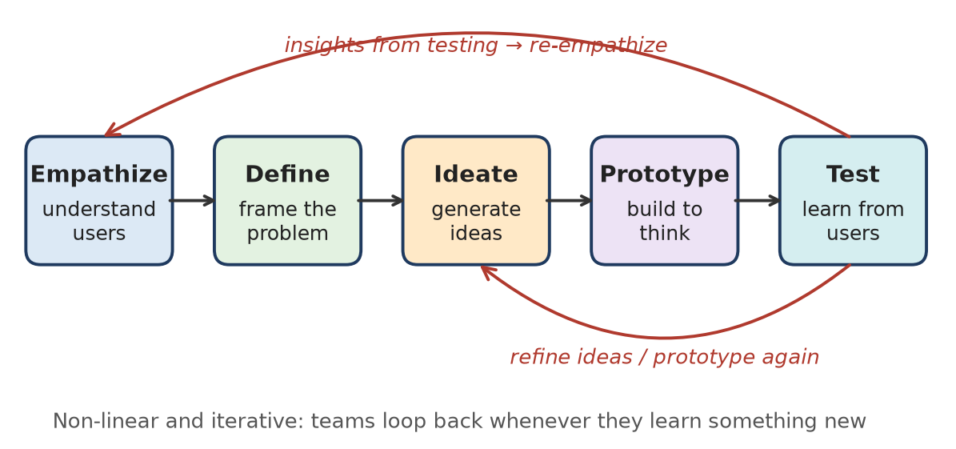
Figure: Five-stage Design Thinking process
Remember: DT = "Understand people → frame problem → try ideas → learn → repeat".

Q2. Differentiate a user-centered approach from a technology-centered approach using a college attendance application as an example.
4 Marks • L2 – Understand • Low • CO1
A user-centred approach builds the attendance app around the needs of students, faculty and parents. A technology-centred approach starts from a technology (e.g. face recognition) and expects users to adapt to it.
Point | User-centred | Technology-centred
Starting point | User needs and pain points | Available or trendy technology
Attendance example | Faculty want 1-tap marking in 30 seconds | Team adds face-recognition because it is "cool"
Requirement source | Interviews, observation | Developer assumptions
Testing | Early, with real users | Late, after full build
Result | Easy to use, high adoption | Slow, confusing, low adoption
Risk | Low – problem validated | High – rework after launch

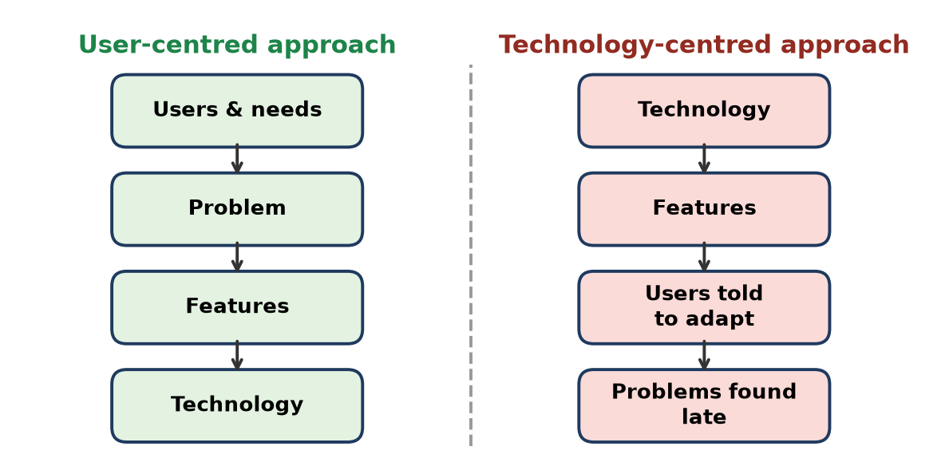
Figure: User-centred vs technology-centred flow
Conclusion: technology should serve the user need, not the other way round.
Remember: "Need first, tech second" – users before gadgets.

Q3. A team is planning a smart helmet for two-wheeler riders. Apply the Empathize and Define phases to identify users' needs and frame a clear problem statement.
5 Marks • L3 – Apply • Moderate • CO1
Empathize – understand riders:
1. Observe riders in traffic, rain and night; interview college students, delivery riders and office commuters.
2. Findings (empathy notes):
- Says: "Helmet is heavy and hot", "I can't hear navigation".
- Does: removes helmet at signals, takes calls while riding.
- Feels: unsafe at night, worried family won't know after a fall.
3. Pain points: heat and weight, poor visibility, phone distraction, no emergency alert.
Define – synthesise into a problem:
- User: daily two-wheeler commuter (e.g. delivery rider, 22–35 years).
- Need: ride safely and stay connected without taking hands off the handle.
- Insight: riders use phones while riding because they fear missing calls and routes.
Problem statement (POV): "A daily delivery rider needs a way to get navigation and call alerts and to send an automatic SOS after a crash, hands-free, because using the phone while riding is unsafe and families cannot be informed in emergencies."
HMW: How might we keep riders informed and safe without touching their phones?
Remember: Empathize collects feelings and facts; Define turns them into "User + Need + Insight".

Q4. Students, faculty, and parents use a college attendance application for different purposes. Identify the needs of these stakeholders and explain why the design should consider all of them.
5 Marks • L3 – Apply • Moderate • CO1
Stakeholder needs:
Stakeholder | Main purpose | Key needs
Students | Track their own attendance | Subject-wise %, low-attendance alert, leave request
Faculty | Mark and manage attendance | Fast 1-tap/QR marking, offline mode, defaulter list
Parents | Monitor the ward | SMS/WhatsApp alerts, simple monthly report, local language
Admin / HoD | Compliance | Reports, export for university, audit trail

Why consider all of them:
1. Different goals: one screen design cannot satisfy marking (faculty) and monitoring (parents).
2. Adoption: if faculty find marking slow, data is never entered and students and parents get nothing.
3. Avoids conflict: e.g. privacy – parents see only their ward's data.
4. Fewer change requests later – needs captured early reduce rework.
5. Value for every user increases acceptance and satisfaction.
Design implication: role-based dashboards (student / faculty / parent view) with shared data.
Remember: One app, many users – design a "view" for each role.

Q5. Explain how empathy and challenging assumptions help a design team avoid solving the wrong problem.
4 Marks • L2 – Understand • Low • CO1
Teams often jump to a solution based on what they think. Empathy and challenging assumptions make sure the real problem is solved.
Empathy helps by:
1. Seeing the user's real context – observing users shows actual behaviour, not reported behaviour.
2. Finding hidden needs – feelings and frustrations users do not say directly.
3. Prioritising the pain that matters most to users.
Challenging assumptions helps by:
1. Asking "Why?" (5 Whys) until the root cause appears.
2. Listing assumptions ("students want an app") and testing each with data.
3. Avoiding bias from the team's own experience.
Example: A team assumed students skip the library website because it looks old and planned a redesign. Interviews showed the real problem was that book availability was not shown. A simple live-availability feature solved it.
Result: less wasted development, better adoption.
Remember: "Ask, observe, doubt" before you build.

Q6. Explain how Design Thinking helps an IT team identify the right problem before beginning software development.
3 Marks • L2 – Understand • Low • CO1
Design Thinking spends time in the problem space before the solution space:
1. Empathize – interviews, observation and analytics reveal real user pain points.
2. Define – insights are combined into a clear problem statement / HMW question.
3. Divergent → convergent thinking – many possible problems are explored, then the most important one is chosen (first diamond of the Double Diamond).
4. Validation – quick prototypes check that the problem matters before full coding.
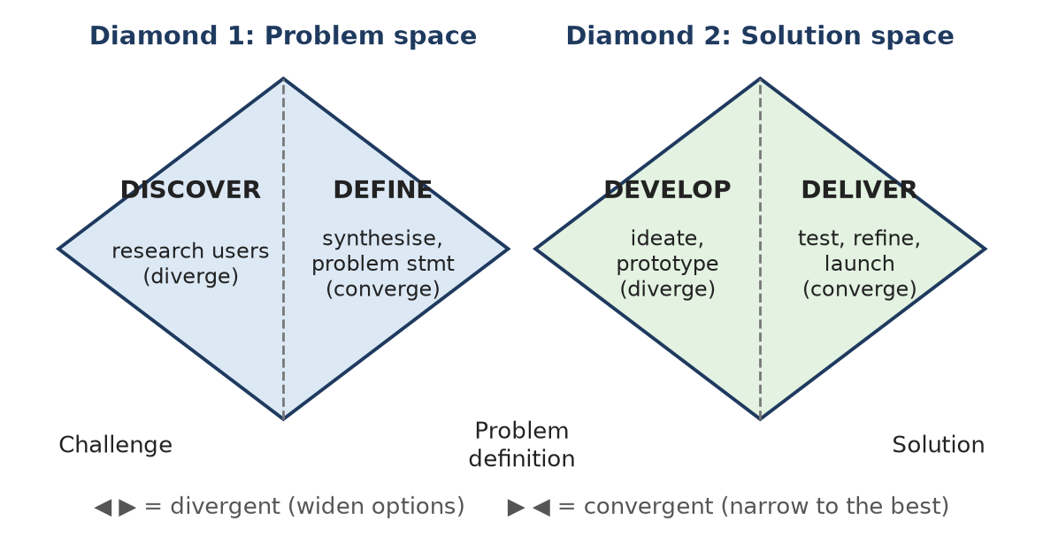
Figure: Double Diamond – the first diamond finds the right problem
Remember: "Build the right thing" before "build the thing right".

Q7. While observing a college classroom, identify two possible problems faced by students or faculty and convert one into a user-centered problem statement.
5 Marks • L3 – Apply • Moderate • CO1
Observation (Empathize): a 60-student lecture was observed for one week.
Problems identified:
1. Back-bench visibility: students at the back cannot read the board or small projector text; they take photos of slides on their phones.
2. Attendance time loss: the faculty spends 8–10 minutes calling roll numbers; students get restless and proxy attendance happens.
Converting Problem 2 into a user-centred problem statement
- User: faculty member teaching large classes.
- Need: record accurate attendance quickly.
- Insight: roll-call wastes about 10% of a 1-hour lecture and still allows proxies.
Problem statement: "A faculty member teaching a 60-student class needs a quick and reliable way to record attendance because manual roll-call wastes about 10 minutes of each lecture and cannot prevent proxy attendance."
HMW question: "How might we make attendance marking take less than one minute while preventing proxies?"
Possible ideas later: rotating QR code, Bluetooth-beacon check-in.
Remember: Good problem statement = User + Need + Insight (no solution inside).

Q8. A team redesigning a laptop keyboard wants to improve usability for IT students. Generate three possible improvements based on users' needs.
5 Marks • L3 – Apply • Moderate • CO1
User research (empathy): IT students code for long hours, often at night, use many shortcuts and carry laptops between labs and hostels.
User need / pain point | Proposed improvement | Benefit
Typing in dark hostel rooms and labs | Adjustable backlit keys with auto-dim | Fewer typing errors, saves battery
Heavy use of coding shortcuts (Ctrl, Alt, brackets, function keys) | Full-size arrow and function keys plus a programmable "dev key" row for IDE commands (run, debug, comment) | Faster coding, less finger strain
Wrist pain and spills during long sessions | Ergonomic key travel (about 1.5 mm), palm rest and spill-resistant design | Comfort and durability

How these come from users:
1. Observed students using external keyboards → current keys feel shallow.
2. Interviews: "I keep pressing Fn by mistake" → place Ctrl and Fn as users expect.
3. Test each idea with a prototype keyboard and measure typing speed and errors.
Remember: Watch how they type, then design the keys – needs before features.

Q9. A team observes how people use a ThinkPad during work and study. Explain how these observations can inform user-centered product decisions.
5 Marks • L3 – Apply • Moderate • CO1
Observation shows what users actually do, which is often different from what they say.
Possible observations and design decisions:
Observation | Insight | Product decision
Users type for hours and use the TrackPoint/touchpad without leaving the keyboard | Productivity depends on comfort | Keep a high-quality keyboard and pointing stick
Laptop carried between home, office and classes | Weight and toughness matter | Light, durable body; long battery
Many video calls and online classes | Camera and privacy are concerns | Better webcam with a privacy shutter
Users plug in many devices | Port shortage frustrates | Keep USB-A, USB-C and HDMI ports
Students work in low light | Visibility issue | Backlit keyboard

How observations help:
1. Reveal unspoken needs (workarounds such as carrying a dongle).
2. Provide evidence for prioritising features.
3. Turn into personas (student, office worker) and requirements.
4. Ideas are tested with users before production.
Remember: "Watch the workaround" – every workaround is a design opportunity.

Q10. An IDEO team observes people using shopping carts and discovers that their actual difficulties differ from the team's initial assumptions. Analyze how observation and problem definition can help reveal the real problem.
6 Marks • L4 – Analyze • Moderate • CO1
Situation: In the well-known IDEO shopping-cart project (shown on ABC Nightline, 1999), the team redesigned a cart in about five days. Instead of assuming the problem was only "a better-looking cart", they went to supermarkets to observe.
Analysis – role of observation (Empathize):
1. Real behaviour seen: shoppers left the cart in the aisle and walked off to pick items; children could be unsafe in the seat; carts were stolen.
2. Expert input: store staff and safety experts shared issues such as child injuries.
3. Assumptions broken: the real issues were safety, theft and shopping efficiency, not looks.
Role of problem definition (Define):
1. Insights were grouped into themes – safety, convenience, theft.
2. A clear problem frame guided ideation: "How might we make shopping faster and safer for parents with children?"
3. The resulting prototype used removable hand baskets, a safer child seat and an open frame with no large panel worth stealing.
Initial assumption | Real problem found
Cart needs a new look | Shoppers need speed and child safety
Cart is the only container | People prefer carrying small baskets
Theft is not our concern | Theft is a major cost for stores

IT parallel: watching users of an e-commerce app may show that they abandon carts because of hidden delivery charges, not because of UI colours.
Conclusion: observation finds what really happens and problem definition turns it into the right question to solve.
Remember: Assume less, observe more – the real problem lives in the user's behaviour.

Q11. Explain the importance of creativity, user-centricity, and ideation in software engineering.
3 Marks • L2 – Understand • Low • CO1
1. Creativity – finds new and better solutions beyond copying existing apps (e.g. UPI's QR-scan payment flow); gives a competitive edge.
2. User-centricity – requirements come from real users, so software is usable, adopted and needs less rework; supports usability and accessibility.
3. Ideation – structured idea generation (brainstorming, SCAMPER, mind maps) gives many options before committing to one design, reducing the risk of a poor choice.
Together they lead to innovative, useful and successful software rather than just working code.
Remember: C-U-I: Create new, Use real needs, Ideate many.

Q12. A student team is redesigning a smart water bottle for everyday use. Apply the Empathize, Define, and Ideate phases to identify a user need, frame a problem statement, and suggest possible ideas.
6 Marks • L3 – Apply • Moderate • CO1
1. Empathize – understand users
- Methods: interviews with students, office workers and gym users; one-day observation; short survey.
- Findings:
- Says: "I forget to drink water when I am coding or studying."
- Does: carries a bottle but brings it back half full; ignores phone reminders.
- Feels: tired and gets headaches in the afternoon.
- Pain points: no awareness of intake, bottle hard to clean, the app needs frequent charging.
2. Define – frame the problem
- Insight: users do not lack water; they lack timely, non-annoying awareness.
- Problem statement: "A busy college student needs a gentle, effortless way to track and remember water intake because phone reminders are ignored during long study sessions."
- HMW: How might we help students drink enough water without disturbing their work?
3. Ideate – generate ideas (brainstorming / SCAMPER)
Idea | Responds to
LED ring on the cap glows softly when a sip is due | Ignored phone alerts
Sensor tracks sips and syncs daily intake to a simple app | No awareness of intake
Wide-mouth, dishwasher-safe body with removable electronics | Hard to clean
Long-life battery (weeks) or solar cap | Frequent charging
Smartwatch vibration plus a weekly hydration streak | Motivation

Next step: shortlist the LED-cap and sip-tracking ideas, then build a quick prototype for testing.
Conclusion: Empathize finds the hidden need, Define focuses it, and Ideate widens the options.
Remember: E-D-I: Feel it → Frame it → Flood it with ideas.

Q13. A toothbrush is being designed for young children. Explain how understanding the intended users can influence design decisions such as ease of use and appeal.
5 Marks • L3 – Apply • Moderate • CO1
Users: children aged 3–8 (primary users) and parents (buyers and supervisors). Their abilities and motivations differ from adults'.
User understanding → design decisions:
User insight | Design decision
Small hands, weak grip | Thick, rubber-grip handle – easy to hold (ease of use)
Small mouth, sensitive gums | Small head, extra-soft bristles
Children get bored quickly | Bright colours, cartoon characters, fun shapes (appeal)
Do not brush for 2 minutes | Built-in 2-minute timer/music or a light that changes colour
Parents want hygiene and safety | Non-toxic material, suction base to stand upright
Children like rewards | Optional app with a star chart for brushing streaks

How this helps:
1. Ease of use – fits the child's physical ability, so they can brush alone.
2. Appeal – fun design motivates children to brush daily.
3. Satisfies both users – the child enjoys it and the parent trusts it.
IT parallel: a kids' learning app also needs large buttons, voice guidance and rewards.
Remember: Design for the hand that holds it and the parent who buys it.

Q14. During a Wallet Challenge, participants are asked to improve a wallet for a specific user. Generate three ideas that respond to different user needs or everyday situations.
5 Marks • L3 – Apply • Moderate • CO1
The Wallet Challenge (Stanford d.school exercise) asks participants to interview a partner, find their real need and redesign the wallet for that person.
Interview insights from three different users:
User and situation | Need found | Idea
College student who uses UPI daily but often forgets the ID card and metro card | Carry fewer things; never forget essentials | Slim phone-back wallet with an RFID slot for college ID and metro card, plus a Bluetooth tracker that alerts if left behind
Traveller handling cash in two currencies and boarding passes | Keep documents organised and safe | Travel organiser wallet with colour-coded pockets, RFID-blocking layer and passport slot
Elderly person with weak eyesight who needs cash and medicine cards | Easy to open and find items | Large-zip wallet with labelled, high-contrast pockets and an emergency contact card window

Why this works:
1. Ideas come from empathy interviews, not personal preference.
2. Each idea addresses a specific everyday situation.
3. Ideas are quickly sketched and shown to the user for feedback.
Remember: The best wallet is designed for one person's pocket, not for everyone's.

Q15. A software team has generated several ideas for improving a college service. Apply user-centered criteria to shortlist ideas for further consideration and justify your selection.
6 Marks • L3 – Apply • Moderate • CO1
Situation: five ideas generated for improving the college library service – A. live book-availability search; B. AI chatbot for all queries; C. one-tap online renewal with due-date alerts; D. VR library tour; E. seat-booking for the reading hall.
User-centred criteria (score 1–5):
1. User need / pain solved (desirability) – from interviews.
2. Frequency of use – how many users, how often.
3. Ease of use – simple for every user.
4. Feasibility – can be built with current skills and time.
5. Evidence – supported by research, not opinion.
Idea | Need | Frequency | Ease | Feasibility | Evidence | Total
A. Live availability | 5 | 5 | 5 | 4 | 5 | 24
C. Renewal + alerts | 5 | 4 | 5 | 5 | 5 | 24
E. Seat booking | 4 | 4 | 4 | 4 | 3 | 19
B. AI chatbot | 3 | 3 | 3 | 2 | 2 | 13
D. VR tour | 1 | 1 | 2 | 2 | 1 | 7

Shortlist: A and C (E kept as a backup).
Justification:
- They solve the top pain points heard in interviews (wasted trips, late fines).
- Used by almost every student every week.
- Simple to use and cheap to build quickly.
- B and D are attractive but novelty-driven, with weak evidence of need.
Next step: prototype A and C, test with 8–10 students and refine.
Conclusion: a user-centred scoring matrix turns opinions into an evidence-based selection.
Remember: Pick ideas users need, not ideas the team likes.

Q16. Differentiate user pain points, system gaps, and digital opportunities with suitable examples.
4 Marks • L2 – Understand • Low • CO1
Opportunity assessment looks at the problem from three angles:
Basis | User pain point | System gap | Digital opportunity
Meaning | A frustration the user feels | Something the current system cannot do or does poorly | A chance to create value using IT
Viewpoint | User / emotional | Process / technical | Solution / business
Found by | Interviews, empathy map | Process analysis, workflow mapping | Combining pains and gaps with technology trends
Canteen example | Long queues, cold food | Paper tokens, no order tracking | Pre-order app with live token status
Admission example | Repeated document uploads | No link between departments | Single sign-on admission portal

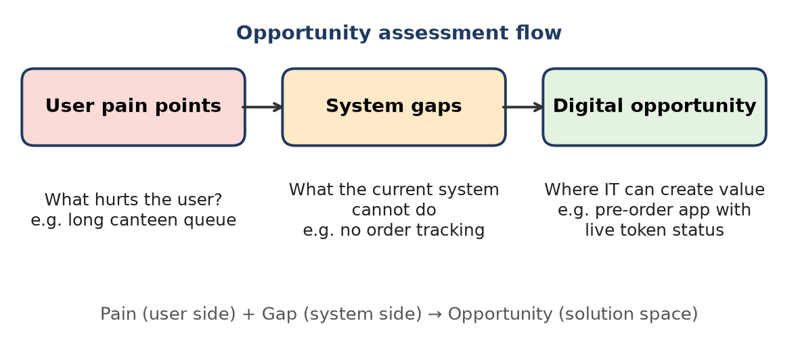
Figure: Pain points + system gaps lead to a digital opportunity
Remember: Pain = user hurts, Gap = system fails, Opportunity = IT fixes.

Q17. A team imagines how Google Maps might support users in 2035. Identify a likely user problem and propose a future feature that addresses it, rather than introducing technology only for novelty.
6 Marks • L3 – Apply • Moderate • CO1
Situation: future-thinking for Google Maps; the feature must solve a real user problem, not show off technology.
Likely user problem (2035):
- Cities will be more crowded and will have mixed transport (metro, e-bus, e-bike, shared vehicles, possibly autonomous taxis).
- Pain point: users must switch between many apps, cannot predict crowding or connections, and elderly or disabled users struggle with accessible routes.
- Problem statement: "Daily commuters, including people with disabilities, need one reliable door-to-door journey plan because switching between transport apps causes delays, missed connections and unsafe or inaccessible routes."
Proposed feature: "Seamless Accessible Journey"
1. One plan, one ticket – combines metro, bus and e-bike with live connections and single payment.
2. Crowd and delay prediction – suggests a less crowded coach or a later bus with a seat.
3. Accessibility mode – step-free routes, working lifts, ramp information shared by users.
4. Re-routing assistant – voice guidance when a connection is missed.
5. Safety layer – well-lit walking routes at night and live location sharing with family.
Why it is need-driven, not novelty:
Novelty idea | Need-based idea
Holographic 3-D maps | Predicting missed connections
AR dinosaurs on the route | Step-free route for wheelchair users

Validation: interview commuters, prototype in one city, measure reduced journey time and fewer missed connections.
Conclusion: future features should begin with tomorrow's user problems, with technology as the enabler.
Remember: Future-proof = future problem first, future tech second.

Q18. A college canteen uses paper tokens and manual order tracking. Identify user pain points and system gaps, then frame one digital opportunity as a problem statement.
6 Marks • L3 – Apply • Moderate • CO1
Situation: paper tokens, a cashier counter and a manual list of orders at the kitchen window.
User pain points (from students, staff, faculty):
1. Long queues at break time – students wait 15–20 minutes and miss lectures.
2. Tokens get lost and numbers are called loudly but missed.
3. No idea whether an item is available until reaching the counter.
4. Cash change problems; UPI is not always accepted.
5. Food gets cold while waiting for a token to be called.
System gaps (process / technology):
1. No digital order record – the kitchen cannot predict demand → food waste.
2. No real-time status of orders.
3. Manual cash reconciliation – errors and delays.
4. No menu or stock data shared with customers.
5. No feedback channel to improve quality.
Pain point (user) | Linked system gap
Long queue | Single manual ordering counter
Missed token call | No live order status
Item not available | No stock visibility
Food waste / cold food | No demand data

Digital opportunity: a pre-order and live-token web/mobile app with UPI payment, live status ("Order #42 ready") and daily sales data for the kitchen.
Problem statement: "Students with short breaks need a way to order and pay before reaching the canteen and know exactly when their food is ready because manual tokens cause long queues, missed calls and wasted break time."
HMW: How might we let students collect hot food within their 15-minute break?
Conclusion: mapping pains to gaps shows exactly where IT adds value.
Remember: Queue + paper = pain; data + status = opportunity.

Q19. Users frequently abandon an online admission form before submitting it. Analyze possible reasons and identify what evidence the team should gather before redesigning the form.
6 Marks • L4 – Analyze • Moderate • CO1
Situation: high drop-off on the admission portal; the team wants to redesign it but must first find the real causes.
Possible reasons (causal / fishbone analysis):
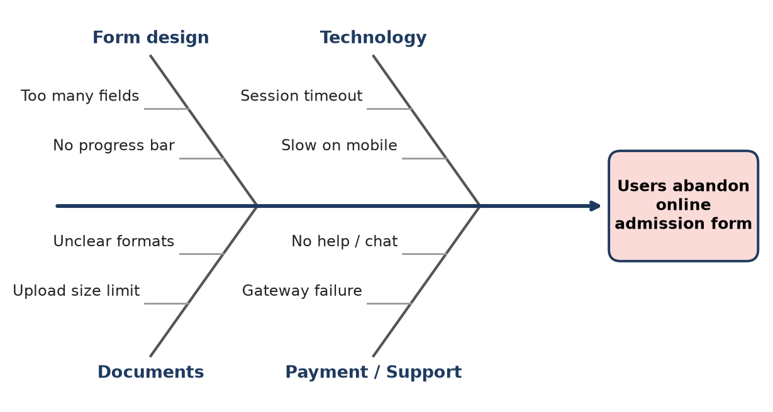
Figure: Fishbone diagram – causes of form abandonment
1. Form design: too many fields on one page, no progress indicator, unclear labels.
2. Technology: session timeout loses data, slow loading on mobile, no auto-save.
3. Documents: strict file-size limits, unclear formats (PDF/JPG), scanning difficulty.
4. Payment and support: gateway failures, unclear fees, no help or chat.
5. User context: rural applicants with poor internet; parents filling the form on a phone.
Evidence to gather before redesigning:
Evidence | Method | Shows
Drop-off step | Web analytics funnel (e.g. Google Analytics) | Exact page where users leave
Error logs | Server and payment logs | Timeouts, upload and gateway failures
User behaviour | Session recordings, heatmaps | Confusion, repeated clicks
User voice | Interviews and short exit survey | Reasons and feelings
Observation | Usability test with 5–8 applicants | Real difficulties
Device data | Mobile vs desktop share | Need for mobile-first design
Support tickets | Helpdesk emails and calls | Common complaints

Then: combine evidence, define the main problem (e.g. "70% leave at document upload") and redesign that step first (step-wise form, auto-save, clear upload help).
Conclusion: measure where and ask why before changing the form – otherwise the redesign may fix the wrong step.
Remember: Data says where they leave; users say why.

Q20. A college service team proposes an app because similar institutions have one. Analyze how the team should assess whether a genuine user need or system gap justifies the proposed solution.
6 Marks • L4 – Analyze • Moderate • CO1
Situation: "Other colleges have an app, so we need one" – this is copying a solution, not solving a problem (solution-first thinking).
Risks of this approach:
1. No proof that users have a problem – low downloads.
2. It may duplicate existing tools (ERP portal, WhatsApp groups).
3. Wasted budget and maintenance cost.
How to assess genuine need (opportunity assessment):
1. Empathize: interview students, faculty and parents; observe current service use.
2. Identify pain points: e.g. "I miss notices", "fee receipts are hard to find".
3. Identify system gaps: map the current process – is information scattered, manual or delayed?
4. Check existing alternatives: do the website or WhatsApp already solve it?
5. Quantify: survey 100+ users – how many face the problem, how often, how severe.
6. Validate cheaply: clickable mock-up or responsive web page; measure interest.
7. Check the three fits: desirability (users want it), feasibility (tech and skills), viability (budget and maintenance).
Question | If YES | If NO
Is there a frequent, painful problem? | Continue | Stop – no need
Is there a system gap current tools cannot fill? | Continue | Improve existing tool
Do users prefer an app to the web? | Build app | Build responsive web
Can the college maintain it? | Build | Re-scope

Recommendation: proceed only if the evidence shows a real need and gap; otherwise improve the existing portal.
Conclusion: benchmarking gives ideas, but user evidence justifies investment.
Remember: "They have it" is not a need; "users struggle" is.

Q21. Define Product-Market Fit and explain why it matters when developing a software product.
3 Marks • L2 – Understand • Low • CO1
Product-Market Fit (PMF) means the product satisfies a strong need of a clearly defined market, so users adopt it, keep using it and recommend it (term made popular by Marc Andreessen).
Why it matters:
1. Without PMF, even well-coded software fails – there is no demand.
2. Shows desirability – users want it.
3. Signs: high retention, organic growth, users willing to pay.
4. Guides where to invest – scale only after PMF.
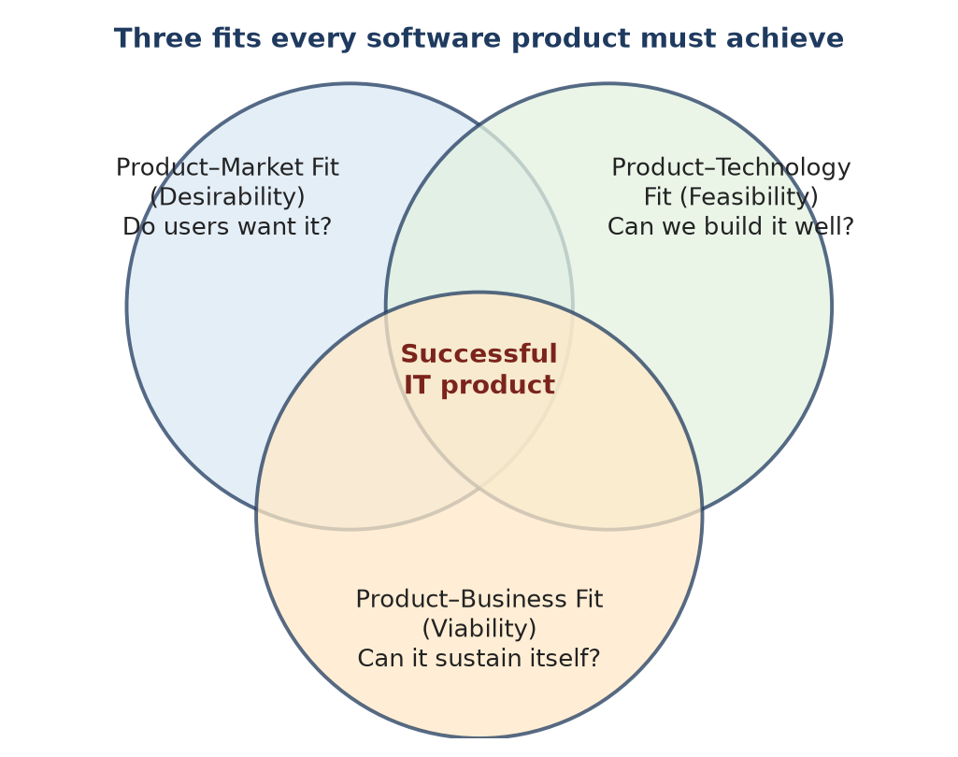
Figure: The three fits – PMF, PTF, PBF
Remember: PMF = "Right product for the right users who keep coming back".

Q22. A team plans a campus food-ordering application. Apply Product-Market Fit principles to identify the target users, the need to validate, and the feedback to collect before development.
5 Marks • L3 – Apply • Moderate • CO1
1. Target users (market segment):
- Primary: students with short breaks (about 3,000 on campus).
- Secondary: faculty and staff; canteen operators (supply side).
2. Need to validate (core assumptions):
1. Students lose significant time in canteen queues.
2. They are willing to pre-order and pay by UPI.
3. The canteen can prepare orders on time with a digital list.
4. Enough students will order regularly (daily or weekly).
3. Feedback to collect before development:
Feedback | Method
Queue time and frustration level | Observation, short survey
Willingness to pre-order and pay online | Interviews; "would you use it?" plus fake-door sign-up
Must-have features (menu, status, payment) | Ranking survey
Operator capacity and concerns | Interview with canteen owner
Price sensitivity (convenience fee?) | Survey

4. PMF test: launch a simple Google-Form or WhatsApp pre-order pilot for 2 weeks; measure repeat orders. Strong repeat usage (e.g. 40% ordering again) signals a fit.
Remember: Validate the hunger before cooking the app.

Q23. A study-planner app receives many downloads, but few users return to it. Analyze what this may indicate about Product-Market Fit and identify information the team should investigate.
6 Marks • L4 – Analyze • Moderate • CO1
Situation: high acquisition (downloads) but low retention → a classic sign of weak or no Product-Market Fit.
What it indicates:
1. Marketing or curiosity worked, but the app does not solve a strong recurring need.
2. Onboarding may be confusing – users quit before seeing value.
3. The value delivered is less than the effort (manual entry of every task).
4. The app may target the wrong segment (e.g. school students instead of college students).
5. Competing habits (paper diary, Google Calendar, Notion) are "good enough".
Information to investigate:
Area | What to check | How
Retention | Day-1, Day-7, Day-30 retention; cohort analysis | Analytics
Drop-off point | Where users leave (sign-up, first plan) | Funnel analytics
Activation | % users who create their first plan | Event tracking
Reasons | Why users stopped | Exit survey, interviews
Segment | Who stays vs who leaves | Cohort by user type
Competition | What they use instead | Interviews
Reviews | Complaints in Play Store reviews | Review analysis

Next steps:
- Interview loyal users to find the "aha moment" and build around it.
- Simplify onboarding (e.g. import timetable automatically).
- Test changes with A/B experiments and track retention.
Conclusion: downloads measure interest; retention measures fit – the team must fix value, not marketing.
Remember: Downloads = curiosity; returns = fit.

Q24. A team proposes a mobile application for first-year students. Explain how it can validate whether the proposed problem is important enough for students to use the product.
5 Marks • L3 – Apply • Moderate • CO1
Assumed problem: first-year students struggle to find campus information (timetable, rooms, clubs, notices).
Validation steps (before coding):
1. Problem interviews – 20–30 first-year students: "Tell me about the last time you could not find information." Listen for frequency and pain.
2. Survey – rate the problem's importance (1–5); how often it happens.
3. Observation – watch new students during induction week.
4. Existing alternatives – if WhatsApp groups solve it well, the problem may be weak.
5. Smoke test – landing page or poster with a QR code to "join the beta"; count sign-ups.
6. Clickable prototype – test whether students choose it over current methods.
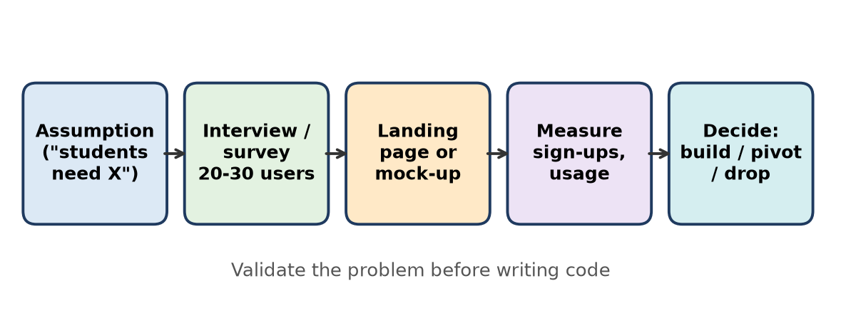
Figure: Validating the problem before coding
Decision rule: build only if most students rate the problem as important and the sign-up rate is high; otherwise pivot to a stronger problem.
Remember: If students won't sign up for the idea, they won't use the app.

Q25. A product team receives positive feedback from a few friends about its app idea. Analyze why this feedback alone may be insufficient to establish Product-Market Fit.
5 Marks • L4 – Analyze • Moderate • CO1
Situation: a few friends say "Great idea!" – the team thinks it has PMF.
Why this is insufficient:
1. Small sample – 4–5 people do not represent the market.
2. Bias – friends are polite and avoid hurting feelings (courtesy bias).
3. Not target users – friends may not have the problem at all.
4. Opinions, not behaviour – "I would use it" is not the same as actual usage or payment.
5. No retention data – PMF needs repeated use over time.
6. Leading questions – "Don't you love this?" invites "yes".
Weak evidence | Strong evidence
Friends' praise | Interviews with unknown target users
"I would use it" | Sign-ups, pre-orders, usage data
One-time reaction | Retention after 30 days
Feature compliments | Willingness to pay / recommend

What to do: talk to 20–30 real target users using neutral questions (the "Mom Test" idea – ask about past behaviour, not opinions on your idea), run a smoke test or MVP, and track retention.
Remember: Friends' "wow" ≠ market's "buy".

Q26. Define Product-Technology Fit and explain its relevance to developing software solutions.
3 Marks • L2 – Understand • Low • CO1
Product-Technology Fit (PTF) means the chosen technology suits the product's user needs and practical constraints – it can be built, run reliably and maintained (feasibility).
Relevance:
1. Avoids over-engineering (e.g. blockchain for a simple form).
2. Ensures performance, scalability and security match the need.
3. Fits the team's skills, budget and timeline.
4. Works in the users' environment (low-end phones, poor internet).
Example: a responsive web app (PWA) for a college notice board instead of a heavy native app.
Remember: PTF = right tool for the user's job, not the trendiest tool.

Q27. A smart helmet uses sensors and mobile connectivity to support riders. Apply Product-Technology Fit principles to assess whether the proposed technology suits user needs and practical constraints.
5 Marks • L3 – Apply • Moderate • CO1
User needs: crash alert, hands-free navigation and calls, comfort, low cost.
PTF assessment:
Technology | User need served | Practical constraints to check | Fit?
Accelerometer / gyroscope sensors | Crash detection + SOS | False alarms on potholes; needs a cancel option | Good (with calibration)
Bluetooth to phone | Navigation and call audio | Battery drain, pairing ease | Good
GPS via phone (not inside helmet) | Location for SOS | Lower weight and cost | Good
Built-in camera / HUD display | Recording, visual navigation | Weight, cost, distraction, heat | Weak – optional
Battery | All features | Must last 1 week, rain-proof charging port | Must be tested

Constraints to evaluate:
1. Weight and comfort – electronics must not make the helmet heavy.
2. Environment – rain, heat, dust (IP rating).
3. Safety standard – must still meet ISI helmet certification.
4. Cost – affordable for students and delivery riders.
5. Connectivity – SOS should fall back to SMS in weak network areas.
Conclusion: sensors + Bluetooth fit well; heavy features like HUD do not fit the core need yet.
Remember: Fit = need × constraints; drop tech that adds weight but not value.

Q28. A college proposes using advanced AI for a simple online registration process. Analyze whether the technology is appropriate by considering user requirements, complexity, and practical constraints.
6 Marks • L4 – Analyze • Moderate • CO1
Situation: registration only needs name, details, document upload, fee payment and confirmation. The college wants "advanced AI" in it.
1. User requirements:
- Fast, simple form; works on mobile; clear instructions; instant confirmation.
- Users do not need predictions or complex AI – they need simplicity and reliability.
2. Complexity analysis:
Aspect | Simple web form | Advanced AI solution
Development time | Weeks | Months
Cost | Low | High (models, GPUs, experts)
Skills | Normal web developers | ML engineers, data scientists
Accuracy risk | Deterministic | Possible wrong extraction or decisions
Explainability | Transparent | Black box
Maintenance | Easy | Retraining, monitoring

3. Practical constraints:
- Limited college IT budget and staff.
- Data privacy of student documents (sensitive personal data).
- Must work on low-end phones and slow internet.
- Fixed admission deadlines – no time for experimental tech.
Verdict: advanced AI has poor Product-Technology Fit here – over-engineering that adds cost and risk without user value.
Where small AI could fit (optional):
- OCR to auto-fill marks from a marksheet (validated by the user).
- An FAQ chatbot for common doubts – only if queries are very high.
Recommendation: build a clean, responsive multi-step form with auto-save, validation and UPI payment; add AI only if data later shows a real need.
Conclusion: choose the simplest technology that fully meets user requirements.
Remember: Don't use a rocket to cross the road – simple problem, simple tech.

Q29. A college kiosk is being considered for voice control. Apply Product-Technology Fit principles to assess its suitability for the intended users and usage environment.
5 Marks • L3 – Apply • Moderate • CO1
Intended users: students, parents and visitors seeking information (directions, fees, timetables). Environment: busy, noisy entrance lobby.
Assessment:
Factor | Analysis | Fit
Noise | Crowds, announcements – speech recognition errors | Poor
Language and accents | Users speak Marathi, Hindi, English, mixed | Needs multilingual model
Privacy | Speaking roll numbers or fee details aloud | Poor
Accessibility | Helps visually impaired and less-literate users | Good
Speed | Short queries are faster by voice; long ones are not | Mixed
Hygiene | Touch-free is useful | Good
Cost and maintenance | Microphones, internet, speech API cost | Moderate

Recommendation: use a hybrid kiosk – large touch-screen as the main input, with optional voice (push-to-talk, noise-cancelling microphone) for accessibility and simple queries like "Where is the IT department?"
Validate: pilot for one week; measure recognition accuracy and task completion time.
Conclusion: voice alone has weak PTF in a noisy lobby; voice as an add-on fits well.
Remember: Match tech to the room: noisy place → touch first, voice second.

Q30. A team selects a new technology because it is popular, but it makes the product harder to use. Analyze the mismatch and recommend what the team should evaluate before proceeding.
6 Marks • L4 – Analyze • Moderate • CO1
Situation: e.g. a college app adds a 3-D/AR interface or a heavy JavaScript framework because it is trending; users now face slow loading and confusing navigation.
Analysis of the mismatch (poor PTF):
1. Technology-push, not need-pull – the decision started from hype.
2. Usability loss – more steps, longer load time, unfamiliar gestures.
3. Context ignored – users have low-end phones and patchy internet.
4. Team skill gap – bugs and slow fixes.
5. Hidden costs – licences, hosting, maintenance.
Popular tech promise | Actual user effect
"Modern and impressive" | Slower, confusing
"Future-ready" | Fails on old phones
"Rich features" | Core task takes longer

What to evaluate before proceeding:
1. User need link – which user problem does the technology solve?
2. Usability tests – compare task time and errors, old vs new (A/B test).
3. Performance – load time, offline support, device compatibility.
4. Team capability – skills, learning time, community support.
5. Cost and maintainability – total cost of ownership.
6. Security and scalability needs.
7. Simpler alternatives that give the same benefit.
Recommendation: roll back or limit the technology to an optional feature, run a small proof of concept with real users, and adopt it only if usability improves.
Conclusion: popularity is not suitability – technology must earn its place through user benefit.
Remember: Trendy ≠ handy; test the tech on users first.

Q31. Define Product-Business Fit and explain why it is important for a software product.
3 Marks • L2 – Understand • Low • CO1
Product-Business Fit (PBF) means the product has a sustainable business model – the right customers pay enough, through suitable channels, to cover costs and support the organisation's goals (viability).
Importance:
1. A useful product can still fail if costs exceed revenue.
2. Identifies who pays (customer) vs who uses (user).
3. Decides the pricing model – subscription, freemium, licence, ads.
4. Aligns with the company's strategy and capabilities.
5. Ensures money for maintenance, support and growth.
Remember: PBF = "Can this product pay for itself and keep running?"

Q32. A team plans to offer a campus-management application through annual institutional subscriptions. Apply Product-Business Fit principles to identify the customers, costs, and revenue factors to examine.
6 Marks • L3 – Apply • Moderate • CO1
Business model: B2B SaaS – colleges pay an annual subscription; students, faculty and parents use it.
1. Customers (who pays vs who uses):
- Paying customer: college management / trust; decision makers are the Principal, IT head and accounts office.
- Users: students, faculty, parents, administrative staff.
- Segments: engineering colleges, schools, universities – differ in size and budget.
2. Costs to examine:
Cost type | Examples
Development | Developer salaries, design, testing
Infrastructure | Cloud hosting, storage, SMS/email gateway charges
Customer acquisition | Sales visits, demos, marketing
Onboarding | Data migration, staff training
Support and maintenance | Helpdesk, bug fixes, updates, security
Compliance | Data-privacy measures, audits

3. Revenue factors:
1. Pricing basis – per student per year, or tiered (Basic / Pro / Enterprise).
2. Number of institutions and their size.
3. Renewal rate – annual churn decides long-term revenue.
4. Add-ons – fee payment module, exam module, parent app.
5. One-time fees – setup, customisation, training.
6. Payment cycle – yearly payment helps cash flow.
Key checks:
- Revenue per college > cost to serve + acquisition cost.
- Break-even – how many colleges are needed.
- Willingness to pay – validated through pilots with 2–3 colleges.
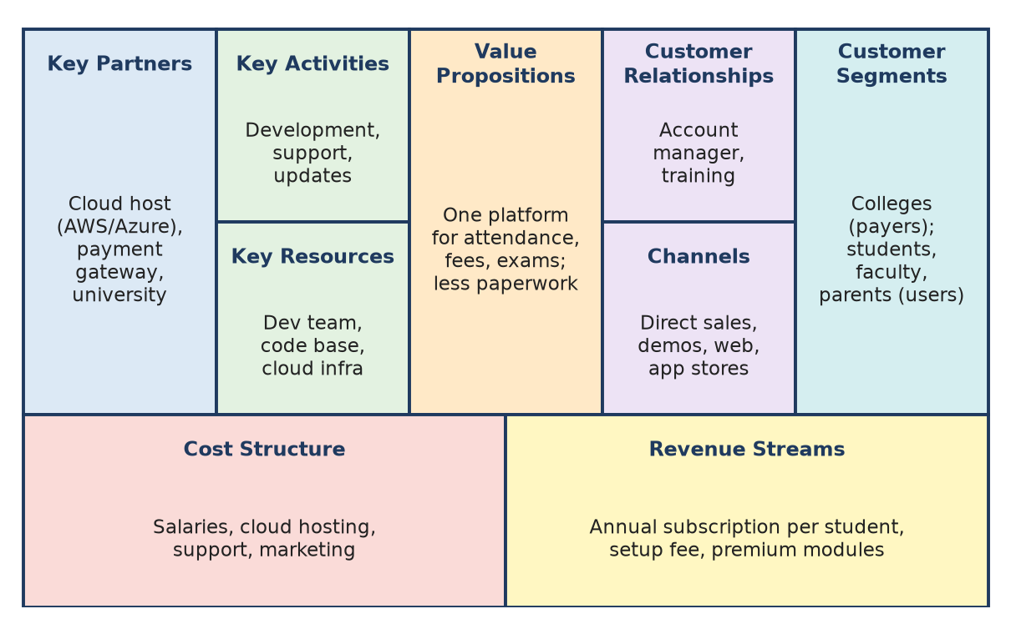
Figure: Business Model Canvas for a campus-management SaaS
Conclusion: PBF exists when colleges renew every year and revenue covers all costs.
Remember: Users love it + colleges pay + costs covered = Business Fit.

Q33. A software solution addresses a real user need and uses suitable technology, but its maintenance costs exceed its revenue. Analyze the Product-Market, Product-Technology, and Product-Business Fit concerns.
6 Marks • L4 – Analyze • Moderate • CO1
Situation: users like the product (PMF ✓), the technology works (PTF ✓), but maintenance cost > revenue (PBF ✗).
Figure: All three fits are needed for success
Analysis of each fit:
Fit | Status | Concern to examine
Product-Market | Achieved, but check depth | Are users only using or also willing to pay? Is the market large enough?
Product-Technology | Works, but check cost | Is the architecture too costly (over-provisioned servers, paid APIs, many custom versions)?
Product-Business | Failing | Pricing too low, wrong payer, high support cost, low renewals

Possible root causes:
1. Under-pricing or free product with no revenue stream.
2. Customisation for every client increases maintenance.
3. Costly infrastructure – unoptimised cloud usage.
4. High support load due to complex UI.
5. Small market – too few paying customers.
Recommendations:
- Revise pricing: subscription tiers, freemium with paid premium features.
- Reduce cost: optimise cloud (auto-scaling), automate testing/deployment, standardise features instead of custom builds.
- Improve self-service: better onboarding and help docs to reduce support tickets.
- Find the real payer: institutions or sponsors instead of individual users.
- Track metrics: customer lifetime value vs acquisition and service cost.
Conclusion: solving a real need with good technology is not enough – the product survives only when the business model is viable.
Remember: Loved + buildable but loss-making = 2 out of 3 fits; fix viability.

Q34. A team proposes an event-management app for colleges. Identify the business factors it should assess before offering the product to institutions.
5 Marks • L3 – Apply • Moderate • CO1
Business factors to assess (Product-Business Fit):
1. Customer and decision maker – who pays? (college, student council, event sponsors); who approves the purchase?
2. Market size – number of colleges, events per year, budget for events.
3. Value proposition – saves time on registrations, payments, certificates; better than Google Forms + WhatsApp?
4. Revenue model – annual licence per college, per-event fee, small commission on ticket sales, sponsor ads.
5. Cost structure – development, hosting, payment-gateway charges, support, sales.
6. Competition – existing platforms (e.g. Unstop, Google Forms, Eventbrite-like tools); our differentiator.
7. Channels – direct sales, faculty coordinators, college fests.
8. Legal and compliance – payment regulations, student data privacy.
9. Scalability and support – handling peak loads during fests.
10. Break-even and renewal rate.
Factor | Key question
Customer | Who pays and who decides?
Revenue | How do we earn per college or event?
Cost | What does serving one college cost?
Competition | Why choose us over free tools?

Remember: Ask "Who pays, how much, how often, and what does it cost us?"

Q35. A product has interested users, but the team has not identified who will pay for it. Analyze why this creates a Product-Business Fit concern and suggest what the team should investigate.
5 Marks • L4 – Analyze • Moderate • CO1
Situation: users are interested (some PMF signal), but there is no paying customer → no revenue model → weak Product-Business Fit.
Why this is a concern:
1. No revenue – cannot cover development, hosting and support.
2. User ≠ payer – students may use an app, but colleges or sponsors may be the ones who pay.
3. Interest is not willingness to pay – free users often leave when charged.
4. Investors and management will not fund an unclear model.
5. The product may be shut down despite being useful.
What to investigate:
Area | Questions
Payer options | Users? Institutions? Advertisers? Sponsors or government?
Willingness to pay | How much? Test with pricing pages or pre-orders
Value to payer | What benefit does the payer get (time saved, data, reach)?
Revenue model | Subscription, freemium, licence, commission, ads
Costs | Cost to serve each user
Competitors' pricing | What do similar products charge?

Suggestion: run small pricing experiments (e.g. a premium tier for a pilot group) and pilot with one institution as the paying customer.
Remember: Interested users are fans; paying customers are the business.

Q36. Describe the characteristics of a design mindset and explain its importance for IT project teams.
3 Marks • L2 – Understand • Low • CO1
A design mindset is the attitude of approaching problems with empathy, curiosity and willingness to experiment.
Characteristics: empathy, curiosity, collaboration, bias to action (experimentation), iteration, comfort with ambiguity, learning from failure, visual thinking.
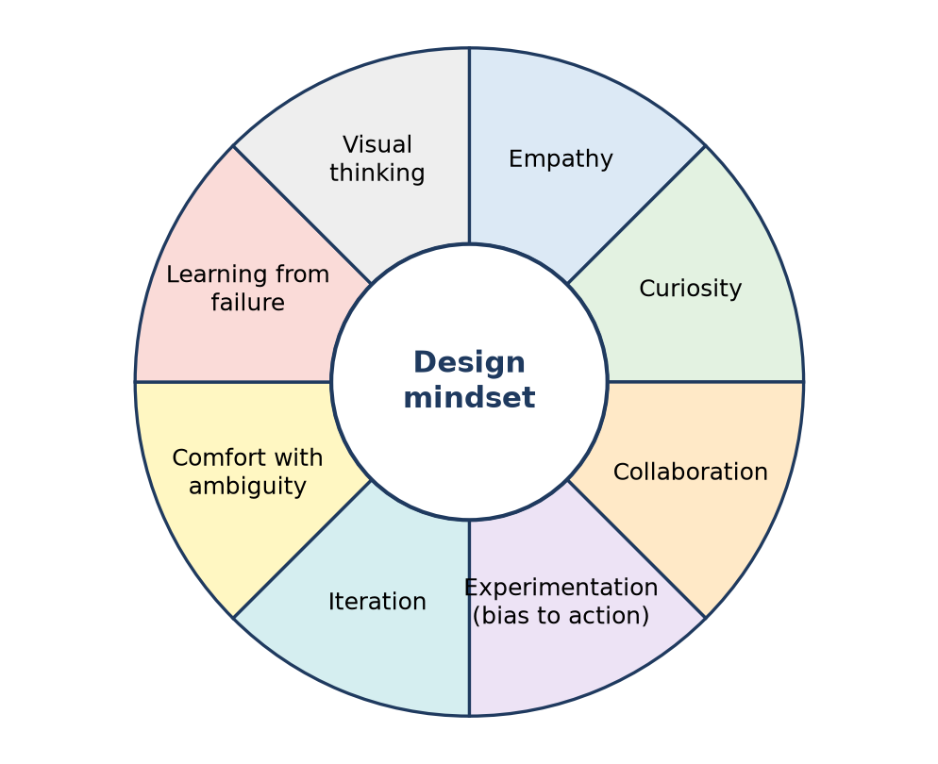
Figure: Characteristics of a design mindset
Importance for IT teams:
1. Builds software users actually need.
2. Encourages early prototypes and feedback → less rework.
3. Improves teamwork across developers, testers and designers.
4. Fits naturally with Agile sprints.
Remember: Think like a user, act like an experimenter.

Q37. Students report that a college application is difficult to use. Apply a design mindset to investigate the problem before suggesting interface improvements.
5 Marks • L3 – Apply • Moderate • CO1
Situation: complaints such as "the app is confusing". A design mindset means investigating first, not jumping to a redesign.
Investigation steps:
1. Empathy and curiosity – interview 8–10 students of different years; ask about their last difficult task.
2. Observe (usability test) – give tasks such as "check attendance" or "download a fee receipt"; note time, errors and hesitation (think-aloud method).
3. Analyse data – app analytics: drop-off screens, most-used features, crash reports; Play Store reviews.
4. Synthesise – empathy map and affinity grouping of issues, e.g.:
- Navigation: menus hidden under too many levels.
- Content: unclear labels ("Module 3").
- Performance: slow loading of results.
5. Define – "Students need to reach frequent tasks within 2 taps because current navigation hides them."
6. Ideate and prototype – then suggest improvements such as a home dashboard with frequent tasks, clear labels and a search bar.
7. Test and iterate – compare task time before and after.
Mindset traits used: empathy, curiosity, collaboration, experimentation, iteration.
Remember: Investigate → understand → then redesign; never redesign blind.

Q38. A team rejects user feedback because it believes its original interface is already correct. Analyze the weaknesses in this response and recommend a more user-centered approach.
6 Marks • L4 – Analyze • Moderate • CO1
Situation: users complain, but the team says "Our design is right; users will learn." This shows a fixed, ego-driven mindset, not a design mindset.
Weaknesses in this response:
1. Confirmation bias – the team values its own assumptions over evidence.
2. "We are not the user" – developers know the system, so it feels easy to them.
3. Lost trust and adoption – frustrated users stop using the app or create workarounds.
4. Higher cost later – problems grow after launch; fixing them then is more expensive.
5. Missed insights – feedback is free research about real needs.
6. Against Agile values – "customer collaboration" and "responding to change".
Team's belief | Reality
"Interface is correct" | Correctness is judged by users' success
"Users will learn" | Users leave instead of learning
"Few complaints only" | Many unhappy users never complain

Recommended user-centred approach:
1. Acknowledge feedback and collect it systematically (in-app form, reviews, support tickets).
2. Verify with evidence – usability tests with 5–8 users; measure task success, time and errors.
3. Find root causes – empathy maps, journey maps.
4. Prioritise issues by severity and frequency.
5. Prototype fixes and A/B test against the old design.
6. Iterate in sprints and tell users what changed ("You said, we did").
7. Build a culture of humility – "strong opinions, weakly held".
Conclusion: the interface is correct only when users can use it easily – feedback is data, not an attack.
Remember: Users are the judges; the team is only the lawyer.

Q39. An IT team begins coding before validating the user problem. Analyze the risks of this approach and explain how Design Thinking can help the team proceed more effectively.
6 Marks • L4 – Analyze • Moderate • CO1
Situation: "solution-first" development – coding starts on assumptions.
Risks:
Risk | Effect
Wrong problem solved | Nobody uses the product
Missing or wrong requirements | Frequent change requests, rework
Wasted time and money | Months of effort lost
Poor usability | Low adoption, bad reviews
Late discovery of issues | Costly fixes after release (cost of change rises with each phase)
Team demotivation | Effort feels wasted

How Design Thinking helps:
1. Empathize – interviews and observation to learn users' real pains.
2. Define – a clear problem statement and success criteria agreed by all.
3. Ideate – explore several solutions instead of the first idea.
4. Prototype – paper or Figma prototypes cost hours, not months.
5. Test – users try prototypes; the team learns before coding.
6. Iterate – combine with Agile sprints and MVP releases.
Figure: Design Thinking loop to use before and alongside coding
Example: Dropbox tested demand with a short demo video before building the full product; sign-ups grew sharply overnight, proving the need.
Conclusion: a few days of Design Thinking can save months of wasted coding.
Remember: Validate first, code second – "fail cheap on paper, not costly in code".

Q40. Users report that a new interface is confusing, but the team wants to retain it to avoid rework. Analyze the situation using a design mindset and recommend the team's next step.
6 Marks • L4 – Analyze • Moderate • CO1
Situation: the team fears rework cost (sunk-cost thinking), while users find the interface confusing.
Analysis using a design mindset:
1. Empathy – confusion means users fail tasks; this directly hurts adoption and satisfaction.
2. Sunk-cost fallacy – effort already spent should not decide the future; the cost of keeping a bad UI (support calls, lost users) may be higher.
3. Iteration mindset – rework is a normal part of design, not a failure.
4. Learning from failure – feedback shows what to fix.
5. Evidence over opinion – measure how serious the confusion is before deciding.
Keep as is | Iterate on the interface
No rework now | Small focused rework
More support tickets, drop-offs | Better task success
Users leave | Users stay and trust the product
Problem grows with scale | Fixed early, cheaper

Recommended next steps:
1. Collect evidence – usability test with 5–8 users; analytics on drop-off screens.
2. Identify the top 3–5 confusing points (labels, navigation, icons).
3. Prioritise quick wins – fixes that need little code (clear labels, tooltips, reordering the menu).
4. Prototype changes in Figma and test before coding.
5. Release incrementally in the next sprint; A/B test old vs new.
6. Monitor metrics – task success rate, time on task, support tickets.
Conclusion: keep what works, fix what confuses – small, evidence-based iterations avoid both user loss and big rework.
Remember: Don't protect the code; protect the user experience.

Quick Revision – Unit I
Term | Meaning / key fact
Design Thinking | Human-centred, iterative problem solving: Empathize → Define → Ideate → Prototype → Test
User-centred approach | Start from user needs; technology comes last
Empathy | Understanding users' feelings, context and behaviour (observe, interview)
Problem statement (POV) | User + Need + Insight, with no solution inside
HMW question | "How might we…?" – turns a problem into an ideation prompt
Pain point | Frustration felt by the user
System gap | What the current system or process cannot do
Digital opportunity | Where IT can create value from pains and gaps
Product-Market Fit | Product meets a strong market need; shown by retention and referrals (desirability)
Product-Technology Fit | Technology suits needs and constraints (feasibility)
Product-Business Fit | Sustainable revenue model; who pays covers costs (viability)
Validation | Interviews, smoke tests, prototypes before coding
Design mindset | Empathy, curiosity, collaboration, experimentation, iteration, learning from failure
IDEO shopping cart | Observation revealed safety, theft and speed problems, not looks
Sunk-cost trap | Keeping a bad design because of past effort

Unit II: Design Thinking Process

Q1. Explain the purpose of the Empathize stage in Design Thinking.
Understand • Low • CO2
Empathize is the first stage of Design Thinking, where the team tries to understand users' experiences, needs and feelings from the users' point of view, without judging.
Purpose:
1. Understand real users – learn what users do, say, think and feel through interviews, observation and immersion.
2. Find hidden needs and pain points – many needs are unspoken (e.g. students upload projects at midnight because the portal is slow in the day).
3. Remove assumptions – the team designs for users, not for itself.
4. Collect evidence for the Define stage (empathy maps, personas).
Remember: Empathize = "walk in the user's shoes" before writing a single line of code.

Q2. Explain how the five stages of Design Thinking can be applied to develop a digital solution for improving the college canteen experience.
Apply • Moderate • CO2
The five stages are applied step by step, with loops back when new learning appears.
Figure: Five-stage Design Thinking process
1. Empathize – observe the canteen at lunch break; interview students, staff and the canteen owner. Findings: long queues, cash/change problems, food runs out, no menu visibility.
2. Define – problem statement: "Students need to get their food quickly during a short break because they lose 15–20 minutes standing in queues."
3. Ideate – brainstorm: pre-order app, QR menu, UPI payment, token display screen, daily demand forecast for the owner.
4. Prototype – paper screens of a pre-order app (menu → cart → pay → pickup token); a simple Figma clickable version.
5. Test – let 15–20 students order through the prototype; measure order time and confusion points; refine (e.g. add "ready" notification).
Remember: Canteen app = Watch the queue → Write the problem → Wild ideas → Wireframe → Watch users try it.

Q3. Identify the purpose of the Empathize and Define stages in solving user-centred problems.
CO2
Together these two stages make sure the team solves the right problem for the right user.
Stage | Purpose | Output
Empathize | Understand users' needs, behaviour, emotions and context through interviews, observation, immersion | Interview notes, empathy map, user quotes
Define | Analyse and synthesise research to find the core need and frame a clear, human-centred problem | Persona, POV / problem statement, HMW questions

- Empathize collects data (divergent); Define focuses it (convergent).
- Example: Empathize shows students miss assignment deadlines; Define frames it as "Students need one place to see all deadlines because notices are spread over WhatsApp, email and the portal."
Remember: Empathize gathers the "why"; Define writes the "what" to solve.

Q4. Illustrate the User Research and its importance in digital system development.
Apply • Moderate • CO2
User research is the systematic study of target users – their needs, behaviours, goals and pain points – using methods such as interviews, surveys and observation, so that a digital system is designed on evidence instead of guesswork.
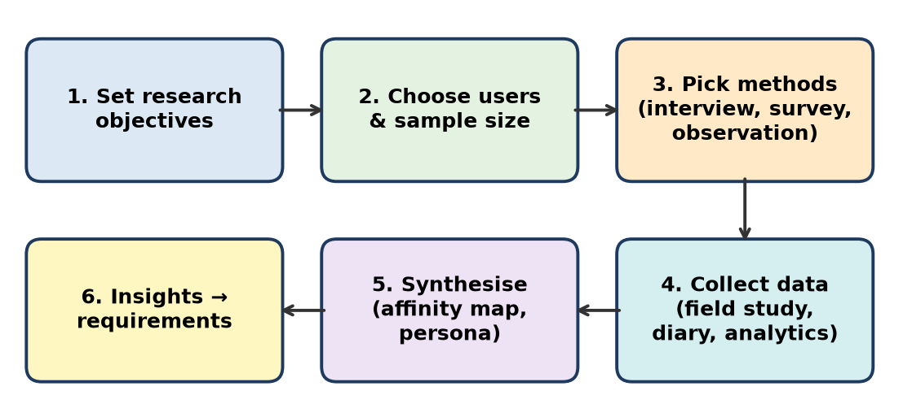
Figure: User research process
Common methods: interviews, surveys/questionnaires, contextual observation, diary studies, usability tests, analytics (clicks, drop-off).
Importance in digital system development:
1. Correct requirements – features come from real needs, reducing scope creep.
2. Less rework and cost – errors found before coding are cheaper to fix.
3. Better usability and adoption – users find the system easy, so they keep using it.
4. Covers all stakeholders – e.g. students, faculty and admin for an ERP.
5. Data for decisions – helps prioritise the backlog in Agile.
Example: Before building an e-library app, interviews reveal students mainly want to check availability before walking to the library – so "live shelf status" becomes a key feature.
Remember: No research = building in the dark; research = turning on the light.

Q5. Create an empathy map for College student. Develop an empathy map for students experiencing difficulties with online project submissions. Use the insights to derive user needs and propose suitable digital interventions.
Apply • Moderate • CO2
An empathy map is a four-quadrant tool (Says, Thinks, Does, Feels) that captures what we learnt about a user, with pains and gains at the bottom.
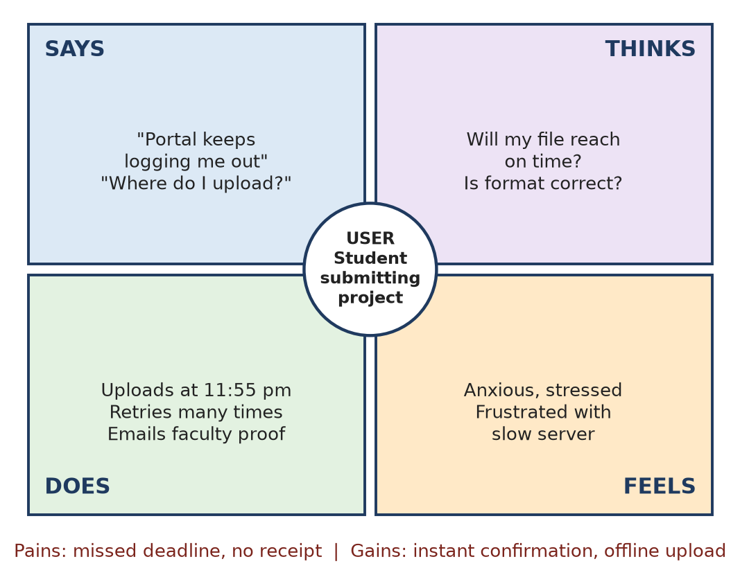
Figure: Empathy map – student submitting a project online
Insights → user needs → digital interventions
Insight | User need | Digital intervention
Portal logs out, slow near deadline | Upload reliably even at peak time | Auto-save, resumable upload, scalable cloud storage
No confirmation received | Proof that submission reached | Instant receipt e-mail/SMS with timestamp
Unsure of format/size | Clear rules before uploading | Format checker, size compressor, sample file
Anxiety about deadline | Timely reminders | Push reminders 48 h / 24 h / 2 h before
Uploads at midnight | Flexible access | Mobile-friendly upload, offline queue

Remember: Map → Need → Feature: every feature must trace back to a box on the empathy map.

Q6. Design a user research plan for a mobile application that helps students manage their academic schedules.
Understand • Low • CO2
A user research plan states why, whom, how and when we will study users.
Element | Plan
Objective | Learn how students track lectures, assignments, exams and what makes them miss deadlines
Participants | 15–20 students: FY to final year, hostel and day scholars
Methods | 8 interviews, 1 survey (Google Forms, 100 responses), 3-day diary study, observe use of current apps
Key questions | How do you note deadlines now? When did you last miss one, and why?
Synthesis | Affinity map → persona → needs list
Timeline | 2 weeks

Remember: Research plan = Why, Who, How, What to ask, When.

Q7. Develop a user persona for an elderly person who finds it difficult to use a mobile banking application.
Apply • Moderate • CO2
A persona is a fictional but research-based profile of a typical user, used to keep the team focused on real needs.
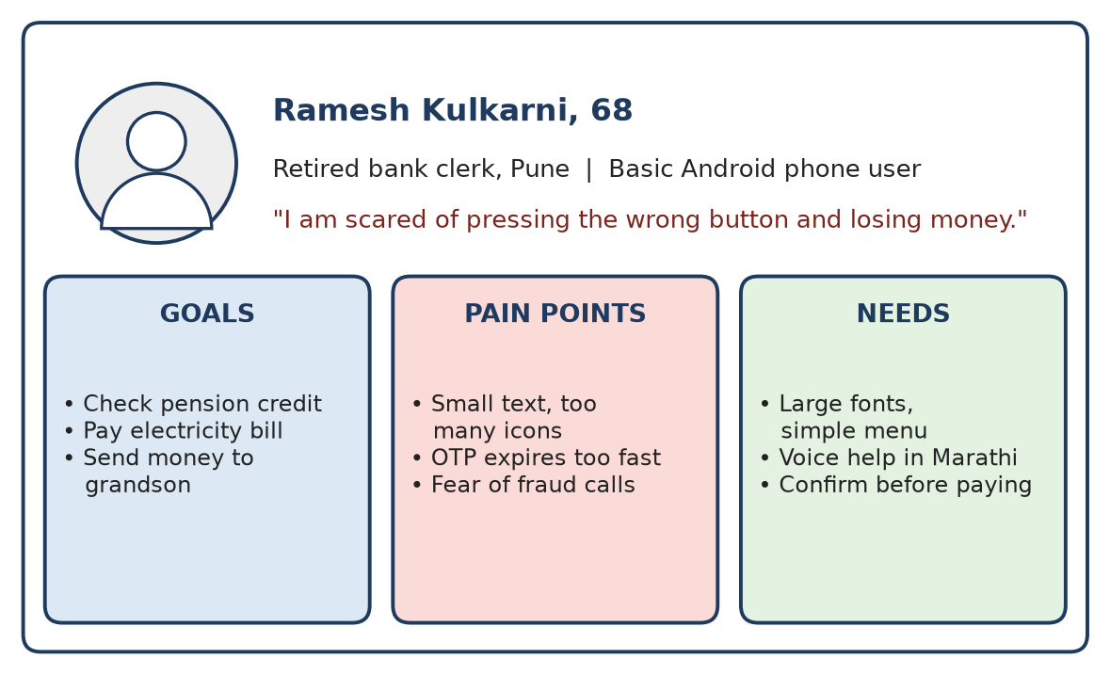
Figure: Persona – elderly mobile banking user
Field | Details
Name / age | Ramesh Kulkarni, 68, retired bank clerk, Pune
Tech use | Basic Android phone; uses WhatsApp and YouTube; son set up the banking app
Goals | Check pension credit, pay electricity bill, send money to grandson
Pain points | Small text, too many icons, OTP expires quickly, fear of fraud calls, English-only menus
Behaviour | Visits the branch for anything new; asks family to help
Needs | Large fonts, few big buttons, Marathi/voice help, confirmation before paying, easy helpline

Design use: the team adds a "Simple mode" with 4 large buttons, longer OTP time and a "Call my bank" button.
Remember: Persona = one real-feeling person the whole team designs for.

Q8. Compare two personas for a college learning management system: a first-year student and a faculty member. Identify their different needs.
Analyze • Moderate • CO2
An LMS (like Moodle or Google Classroom) has very different users; comparing personas shows why one design does not fit all.
Aspect | Persona 1: Aditi, 18, first-year student | Persona 2: Prof. Mehta, 45, faculty
Goal | Find notes, submit assignments, see marks | Upload content, create assignments, grade quickly
Tech comfort | High on mobile, new to LMS | Medium, mostly laptop
Pain points | Too many courses/menus, misses deadlines | Grading many files is slow, repeated uploads
Behaviour | Checks at night on phone | Works in short slots between lectures
Key needs | Simple dashboard, deadline reminders, mobile view | Bulk upload, rubric grading, plagiarism check, analytics
Success measure | "I never miss a submission" | "Grading takes half the time"

Design implication: role-based dashboards – a deadline-first mobile view for students and a bulk-action teaching console for faculty.
Remember: Same system, different goals → role-based design.

Q9. Compare brainstorming, brainwriting, and reverse brainstorming for solving an IT-related problem.
Analyze • Moderate • CO2
Example IT problem: "Users abandon our e-commerce checkout page."
Basis | Brainstorming | Brainwriting | Reverse brainstorming
Meaning | Group says ideas aloud freely, no criticism | Each person writes ideas silently, then passes the sheet to build on (6-3-5 method) | Ask "How can we make the problem worse?", then reverse each answer
Process | Facilitator + whiteboard, quantity first | 6 people × 3 ideas × 5 rounds | List causes of failure → flip into solutions
Strength | Fast, energetic, builds on ideas | Equal participation, no dominance, many ideas | Exposes hidden problems and risks
Weakness | Loud members dominate, groupthink | Less discussion, slower | Can become negative if not reversed
Checkout example | "One-click pay", "guest checkout" | Written chains: "save card" → "UPI autopay" → "auto-fill address" | "Make it worse: force sign-up, hide charges" → reverse: guest checkout, show total early

Conclusion: use brainwriting for shy/large teams, brainstorming for quick energy, and reverse brainstorming when the team is stuck or needs to spot risks.
Remember: Speak it – Write it – Flip it.

Q10. Analyze how user pains, gains, thoughts, and feelings can influence the design of a digital payment application.
Analyze • High (HOTS) • CO2
In Design Thinking, a payment app (like Google Pay, PhonePe or Paytm) is designed around the user's pains (problems/fears), gains (benefits wanted), thoughts (what they worry about) and feelings (emotions). Each one changes a design decision.
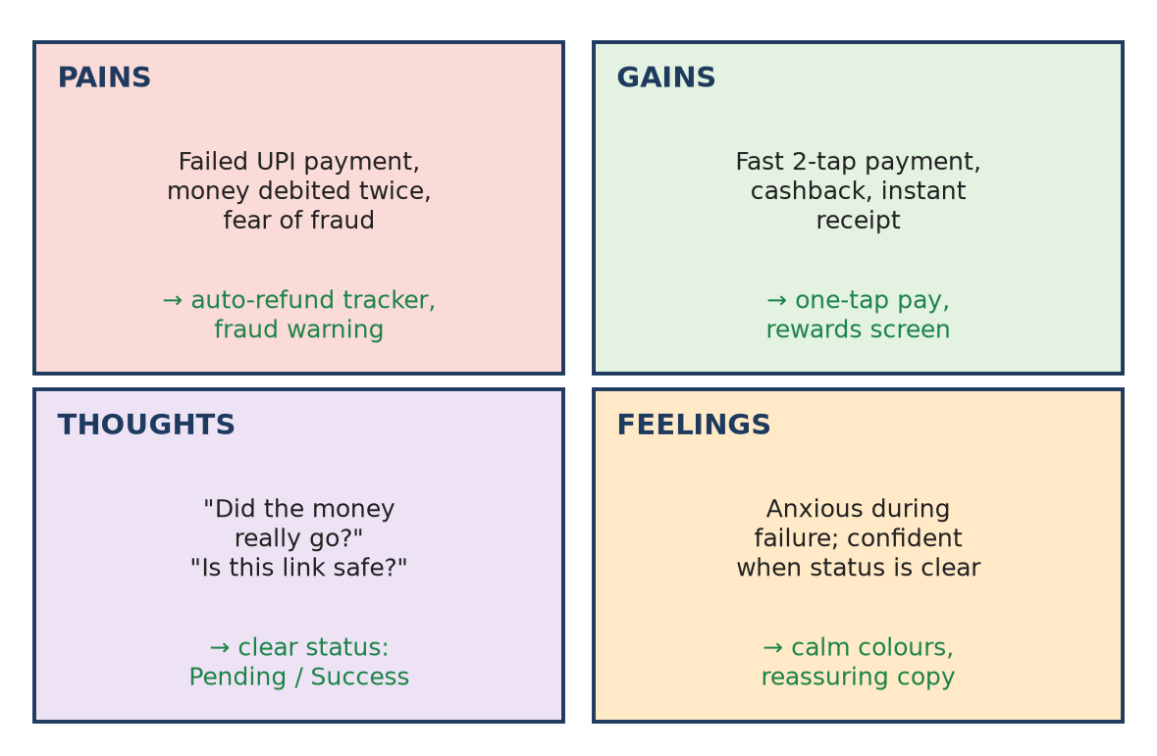
Figure: Pains, gains, thoughts and feelings → design responses
1. Pains → remove friction and fear
- Failed payment but money debited → show a clear "refund in progress" tracker.
- Fear of fraud → warn on unknown payee, never ask PIN to receive money.
2. Gains → add value users want
- Speed → scan-and-pay in two taps, saved contacts.
- Rewards and records → cashback screen, monthly spend summary.
3. Thoughts → answer the user's questions in the UI
- "Did the money go?" → large green tick, transaction ID, SMS receipt.
- "Is this link safe?" → verified merchant badge.
4. Feelings → design for emotion
- Anxiety during failure → calm colours, reassuring words ("Your money is safe").
- Confidence → consistent layout, haptic feedback on success.
User insight | Design decision
Elderly user scared of mistakes | Confirmation screen with name + amount in large text
Shop owner needs proof | Sound box / instant notification
Student wants to split bills | Split-bill feature

Conclusion: analysing pains, gains, thoughts and feelings turns a technically working payment app into one users trust and enjoy.
Remember: Pains → fix, Gains → add, Thoughts → answer, Feelings → comfort.

Q11. A development team repeatedly generates conventional ideas for a complex software problem. Design a structured ideation process using lateral thinking, SCAMPER, reverse brainstorming, and idea prioritization.
Apply • Low • CO2
A structured ideation process moves the team from a clear question, through techniques that break habits, to a short list.
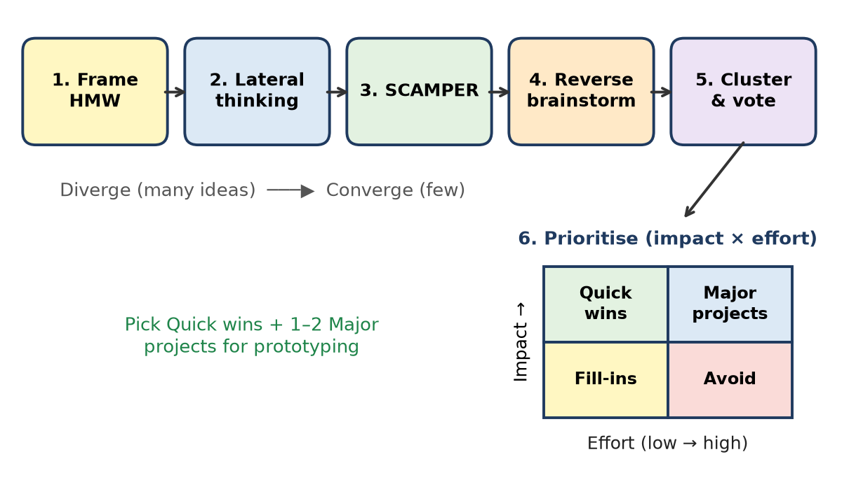
Figure: Structured ideation process
1. Frame an HMW – "How might we reduce app crashes reported by users?"
2. Lateral thinking – use random words/provocations ("What if the app had no server?") → offline-first mode.
3. SCAMPER – Substitute library, Combine logs + alerts, Eliminate heavy screens.
4. Reverse brainstorming – "How to make it crash more?" → reverse the answers.
5. Prioritize – cluster, dot-vote, then impact × effort matrix; pick quick wins for prototyping.
Remember: Frame → Provoke → SCAMPER → Flip → Filter.

Q12. A college plans to develop an integrated digital campus platform. Develop a complete Design Thinking approach covering all five stages, from user research to prototype testing.
Analyze • High (HOTS) • CO2
Situation: the college wants one platform for attendance, fees, notices, library, exams and events, used by students, faculty, parents and admin.
Figure: Five-stage Design Thinking process
Stage | Activities for the campus platform | Output
1. Empathize | Interviews with 4 user groups, survey of 300 students, shadow office staff during fee collection, study current ERP logs | Empathy maps, pain list (many logins, notices lost, fee queues)
2. Define | Affinity mapping, personas (student, faculty, parent, admin), journey maps | POV: "Students need one login to see all academic info because data is scattered across 5 systems"; HMW questions
3. Ideate | Brainstorming, SCAMPER on existing ERP, prioritisation matrix | Single sign-on, personal dashboard, push notices, online fees, QR attendance
4. Prototype | Paper sketches → information architecture → Figma clickable hi-fi of dashboard | Testable prototype of top 5 features
5. Test | Usability tests with 5–8 users per role, task success rate, SUS score, feedback | Issues list → iterate design

Key points:
- Involve all stakeholders – a platform loved by students but rejected by admin will fail.
- Work in iterations (Agile sprints), testing each module before scaling.
- Check fit – privacy of student data, cloud cost, integration with university systems.
Conclusion: Design Thinking gives the college a platform built around real campus journeys rather than a collection of disconnected modules.
Remember: One campus, four users, five stages, many loops.

Q13. A hospital faces long registration queues, repeated data entry, and patient dissatisfaction. Reframe the problem from the perspectives of patients, receptionists, and administrators, and propose a suitable "How Might We" statement.
Analyze • High (HOTS) • CO2
Reframing means looking at one problem through different stakeholders' eyes so that the solution helps everyone, not just one group. The original problem "queues are long" is a symptom.
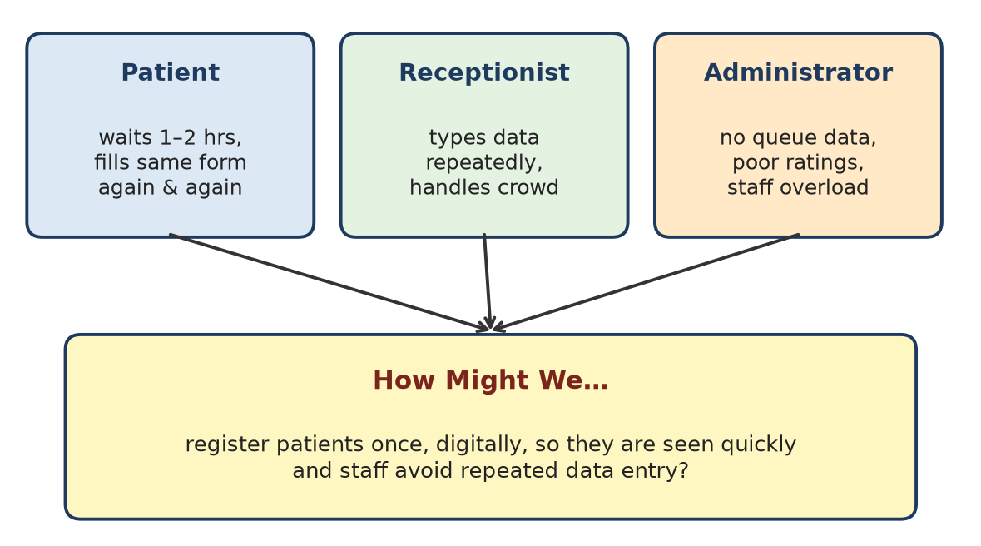
Figure: Reframing from three perspectives into one HMW
Perspective | What they experience | Reframed need (POV)
Patient | Waits 1–2 hours, fills the same form at every visit, unclear when turn comes, feels ignored | "A patient needs to register once and know their waiting time, because they are unwell and anxious."
Receptionist | Types the same details repeatedly, handles crowd and complaints, paper + software both | "A receptionist needs patient data to be available instantly, because retyping wastes time and causes errors."
Administrator | No data on peak hours, low satisfaction ratings, staff overload, revenue loss | "An administrator needs real-time queue data, because they must plan staff and improve ratings."

Common root cause: no single digital patient record and no pre-registration.
HMW statements:
- Main: "How might we register patients once, digitally, so they are seen quickly and staff avoid repeated data entry?"
- Supporting: HMW let patients pre-register from home? HMW show live token status on the phone? HMW give admins a live queue dashboard?
Possible ideas: QR/ABHA-ID based pre-registration, self-service kiosk, SMS token, auto-filled records for repeat visits.
Remember: One problem, three chairs: sit in each, then write one HMW.

Q14. Apply mental block removal techniques for the issues occurred through brainstorming sessions.
Apply • Low • CO2
Mental blocks are barriers (fear of judgement, fixed thinking, dominance, groupthink) that stop ideas in brainstorming.
Issue in session | Removal technique
Fear of criticism | "Defer judgement" rule; anonymous brainwriting
Same ideas repeat | Random word / lateral thinking provocation
One person dominates | Round-robin turns, timer per person
Fixed assumptions | Reverse brainstorming, "What if…?" questions
Fatigue, low energy | Short breaks, warm-up game, change of place

Remember: Defer, Disguise, Disrupt, Distribute, De-stress.

Q15. Explain the role of problem framing and requirement understanding in the Design Thinking process. Illustrate your answer with a suitable example from an IT-based problem.
Apply • Moderate • CO2
Problem framing is defining the right problem as a clear, user-centred statement; requirement understanding converts that problem into what the system must do. Both happen in the Define stage.
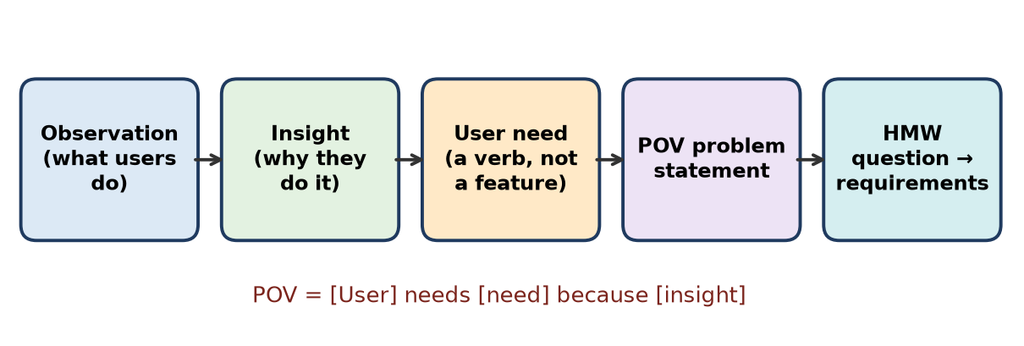
Figure: From observation to problem statement and requirements
Role:
1. Focus – stops the team from solving symptoms (e.g. "build an app") instead of causes.
2. Shared understanding – developers, designers and clients agree on one goal.
3. Guides ideation – a good POV/HMW opens many solutions.
4. Basis for requirements – functional and non-functional requirements trace back to user needs.
5. Avoids rework – wrong requirements are the costliest software errors.
IT example – food delivery tracking complaints:
- Observation: users call support asking "where is my order?"
- Insight: they cannot trust the ETA.
- POV: "Hungry customers need accurate delivery updates because unclear ETAs make them anxious."
- HMW: "How might we make delivery status feel reliable?"
- Requirements: live map tracking (functional), ETA refresh every 30 s (non-functional), push alert when rider is 2 min away.
Remember: Frame it right, and the requirements write themselves.

Q16. Students find it difficult to locate study materials and track assignment deadlines on the college learning portal. Analyze the situation and formulate a clear problem statement based on user needs.
Apply • Moderate • CO2
Situation analysis (Empathize findings):
1. Scattered content – notes in folders named by faculty, not by subject/unit; some on WhatsApp.
2. Poor search – no keyword or filter search.
3. Deadlines hidden – inside each course page; no combined calendar.
4. No reminders – students rely on friends' messages.
5. Effect – time wasted, late submissions, stress before exams.
User need: quickly find the right material and see all upcoming deadlines in one place.
POV problem statement: "Second-year students need a single, searchable view of study materials and upcoming deadlines because content and due dates are scattered across courses, causing missed submissions and wasted study time."
HMW: How might we help students find any study material within three clicks and never miss a deadline?
Measurable goal: reduce late submissions by 50% in one semester.
Weak statement | Strong statement
"Build a better portal" | Names the user, need and reason
Solution-first | Need-first, leaves room for ideas

Remember: Good problem statement = User + Need + Because (insight).

Q17. Commuters are unable to obtain accurate bus arrival times, causing delays and inconvenience. How would you investigate user needs and formulate a problem statement for a smart transport application? Compare the conventional transport facility and smart transportation IT based application.
Analyze • High (HOTS) • CO2
1. Investigating user needs (Empathize):
- Observation at bus stops during peak hours – how long people wait, whether they switch to autos.
- Interviews with daily commuters, students, elderly, and with drivers/conductors.
- Survey on preferred info channels (app, SMS, display board).
- Journey mapping – plan trip → walk to stop → wait → board → reach.
- Data study – existing GPS data, route timetables, complaints.
Key findings: printed timetables are not followed, no live information, uncertainty causes late arrival at college/office.
2. Problem statement (Define): "Daily commuters need reliable real-time bus arrival information because fixed timetables are inaccurate and uncertainty makes them late and stressed." HMW: How might we let commuters know exactly when their bus will arrive?
3. Comparison:
Basis | Conventional transport facility | Smart transport IT application
Arrival info | Printed timetable, guesswork | Live GPS tracking, ETA on phone
Ticketing | Paper ticket, cash, change problems | QR / UPI / smart card
Updates | None for delays or route changes | Push alerts on delay, diversion
Planning | Fixed routes, manual scheduling | Data analytics on demand, crowding
Accessibility | Limited info for visually impaired | Voice announcements, multilingual
Feedback | Complaint register | In-app rating and complaint tracking

Conclusion: the smart app solves the core need – certainty – which the conventional system cannot give.
Remember: From "Wait and hope" to "Track and go".

Q18. As a Design Thinking practitioner, create a user persona for a student who would use Google Drive application. Include the persona's background, goals, needs, frustrations, behaviours, and expectations from the proposed digital system. Explain how the persona will help guide the application design.
Analyze • High (HOTS) • CO2
Persona: "Sneha Patil, the Group-Project Coordinator"
Field | Details
Background | 19, SY B.Tech IT, Pune; day scholar; uses an Android phone and a shared family laptop; mobile data plan of 1.5 GB/day
Goals | Store notes and lab files safely; share project files with teammates; submit reports on time
Needs | Access files on any device; easy sharing with edit control; find files quickly; work offline on the bus
Frustrations | 15 GB free storage fills with photos; confusing "Shared with me" section; duplicate versions (final_v3_final.docx); cannot find old files
Behaviours | Uploads photos of whiteboard notes; edits docs on phone between lectures; shares links on WhatsApp groups
Expectations | Auto-organised folders by subject; clear version history; storage alerts; one-tap share with view/edit option; offline mode
Quote | "I just want the latest file, right now, on my phone."

How the persona guides design:
1. Prioritises features – version history and smart search come before advanced admin tools.
2. Mobile-first decisions – large touch targets, offline sync, low-data previews.
3. Writes user stories – "As Sneha, I want to see who edited last so that I use the latest version."
4. Settles team arguments – "Would Sneha understand this menu?"
5. Test recruitment – usability tests with students like Sneha.
Conclusion: the persona turns millions of vague "users" into one clear person, keeping Drive's design focused on real student needs.
Remember: Background, Goals, Needs, Frustrations, Behaviours, Expectations = "Big Goals Need Fixing Before Exams".

Q19. Senior citizens find mobile banking applications difficult to navigate. Develop a user persona representing an elderly user and identify their needs and challenges.
Analyze • High (HOTS) • CO2
The persona is built from interviews with senior citizens at a bank branch and observation of them using the app.
Figure: Persona – elderly mobile banking user
Field | Details
Name / age | Ramesh Kulkarni, 68, retired bank clerk, Pune; lives with wife; son works in Bengaluru
Device / skills | Basic Android phone, uses WhatsApp and YouTube; weak eyesight; types slowly
Goals | Check pension credit, pay electricity and phone bills, send money to grandson, check FD interest
Behaviour | Goes to branch for anything new; writes passwords in a diary; calls son when stuck

Challenges (pain points):
1. Visual – small fonts, low contrast, icons without labels.
2. Cognitive – too many menus, banking jargon ("IMPS", "beneficiary").
3. Motor – small buttons, gestures like swipe-to-pay are hard.
4. Time pressure – OTP and session expire too fast.
5. Fear and trust – scared of fraud calls and pressing the wrong button.
6. Language – English-only screens.
Needs → design requirements:
Need | Requirement
Read easily | Large text mode, high contrast
Feel safe | Confirmation screen with payee name and amount; fraud tips
Simple path | "Simple mode" with 4 big buttons: Balance, Pay Bill, Send Money, Help
Help when stuck | Voice guidance in Marathi/Hindi, one-tap call to bank
Enough time | Longer OTP validity, biometric login

Conclusion: designing for Ramesh makes the app easier for all users – an example of inclusive design.
Remember: Seniors need it Simple, Safe, Slow-paced, Spoken and Supported (5 S).

Q20. New students and visitors struggle to locate classrooms, laboratories, administrative offices, and other campus facilities. Develop a persona for a first-time campus visitor and propose user-centred features based on the persona's needs.
Analyze • High (HOTS) • CO2
Persona: "Rohan Deshmukh, the Lost First-Timer"
Field | Details
Background | 17, newly admitted FY B.Tech student from Nashik; visiting with his father for admission and document verification
Device | Smartphone, uses Google Maps confidently outdoors
Goals | Reach the admission office, then the IT department and hostel office in one morning
Needs | Know where each building/room is, how to reach it, office timings, which documents to carry
Frustrations | Building names like "A-wing / Old block" mean nothing to him; signboards are few; staff busy; Google Maps does not show inside buildings
Behaviour | Asks security guards and seniors; walks back and forth; nervous about being late
Quote | "I've been to three buildings and still can't find Room 204."

User-centred features:
1. Campus navigation app / web page with indoor maps and floor plans (no login needed for visitors).
2. Search by room, department or purpose ("Fee payment", "Lab 3").
3. QR codes at gate and building entries – scan to see "You are here" and directions.
4. Step-by-step visitor journeys – e.g. "Admission day route" listing offices in order.
5. Office timings and live status (open/closed, queue length).
6. Accessibility – lift and ramp routes, multilingual (English/Marathi/Hindi).
7. Help button – call the helpdesk or chat with a student volunteer.
Test: give 5 new students a task ("find the exam cell") with the prototype and measure time taken.
Conclusion: the persona shows that the real need is confidence and time-saving, not just a static map.
Remember: Lost visitor needs: Where am I? Where to go? How long? Who can help?

Q21. A development team directly starts coding a hospital appointment application without conducting user research. Analyze the possible consequences and recommend how the five-stage Design Thinking framework could improve the development process.
Analyze • High (HOTS) • CO2
Consequences of coding without user research:
1. Wrong problem solved – app offers online booking, but patients actually struggle with long waiting after arriving.
2. Missed users – elderly patients, doctors' schedules, receptionists ignored.
3. Poor usability – complex forms, English-only, no reminders → low adoption.
4. Rework and cost overrun – features rebuilt after launch; delays.
5. Low trust – privacy concerns about health data not addressed.
6. Business failure – hospital stops using it; investment wasted.
How the five stages improve the process:
Stage | Hospital appointment app
Empathize | Interview patients, doctors, receptionists; observe OPD queues
Define | POV: "Patients need to know their exact consultation time because waiting in crowded OPDs is tiring and risky."
Ideate | Slot booking, live token tracking, WhatsApp reminders, doctor delay alerts, family booking
Prototype | Paper screens → clickable Figma prototype of booking + token tracking
Test | 5–8 users of each type; fix confusing steps before coding

Figure: Five-stage Design Thinking process
Recommendation: spend the first 1–2 sprints on Empathize–Define–Prototype, then build in Agile iterations with testing at every release.
Conclusion: a few weeks of Design Thinking prevents months of rework.
Remember: Code first, cry later; empathize first, deliver right.

Q22. An online learning platform has low student engagement despite offering multiple features. Evaluate how each stage of Design Thinking can help identify the underlying problems and redesign the platform.
Evaluate • High (HOTS) • CO2
Situation: many features (videos, quizzes, forums) but students log in rarely and drop out – a sign that features do not match real needs.
Stage | How it helps | Evaluation (value)
Empathize | Interviews, analytics (where users drop off), diary study of study habits | High – reveals hidden causes: long videos, no mobile data, no personal feedback, feeling alone
Define | Affinity map, persona, POV: "Working students need short, mobile lessons with progress feedback because they study in 15-minute gaps." | High – shifts focus from "add features" to "fit students' time"
Ideate | Brainstorm, SCAMPER on current platform: micro-lessons, streaks, peer groups, offline download | Medium–High – many options; needs prioritisation
Prototype | Redesigned home screen with "Continue learning", 5-minute modules, progress bar | High – cheap way to try ideas
Test | A/B test old vs new home page; measure completion rate, weekly active users | Very high – gives proof before full rollout

Underlying problems likely found: feature overload, poor navigation, no personalisation, low motivation, content not mobile-friendly.
Redesign outcome: fewer but better features, personalised dashboard, reminders, gamification (e.g. streaks, as popularised by Duolingo), community discussion.
Judgement: Empathize and Test are the most valuable here, because the issue is engagement, which can only be understood and measured with users.
Remember: More features ≠ more engagement; more empathy = more engagement.

Q23. A college plans to develop an AI-based academic support chatbot, but students report that existing support systems fail to address their actual needs. Analyze the scenario and demonstrate how the five-stage Design Thinking framework can be used to develop an effective solution.
Analyze • Moderate • CO2
Analysis: the risk is building an AI chatbot as a "trendy" fix while the real need is unknown. Design Thinking keeps the chatbot need-driven.
1. Empathize – interview students and support staff; read past helpdesk queries. Finding: most queries are about deadlines, fee status, syllabus, and exam rules; answers are slow and inconsistent.
2. Define – POV: "Students need quick, accurate answers to routine academic questions any time because office hours are limited and notices are scattered."
3. Ideate – FAQ bot, WhatsApp bot, ERP-linked personal answers ("my attendance"), escalation to human staff, Marathi/Hindi support.
4. Prototype – "Wizard of Oz" test (a person types replies behind a chat window), then a no-code bot trained on top 50 FAQs.
5. Test – measure correct-answer rate, time saved, escalation rate; collect thumbs-up/down feedback and retrain.
Key cautions: accurate data source (official notices), privacy, clear hand-off to humans.
Remember: Ask students first, train the bot second.

Q24. Students face frequent accidents due to potholes and slippery roads during the rainy season. Apply all five stages of Design Thinking to propose a user-centred digital road safety solution.
Apply • Moderate • CO2
1. Empathize – interview two-wheeler riding students, traffic police, municipal staff; ride the routes in rain; collect accident stories. Findings: potholes hidden under water, no warning, complaints to the municipality go unanswered.
2. Define – POV: "Student two-wheeler riders need advance warning of potholes and slippery patches on their route because water hides hazards and causes falls."
3. Ideate – crowd-sourced pothole map, voice alerts while riding, safer-route suggestion, automatic pothole detection using phone accelerometer, one-tap report with photo/GPS sent to the municipal corporation.
4. Prototype – paper storyboard of the ride; Figma app: map with red hazard pins, "Report pothole" button, audio alert ("Pothole in 100 m").
5. Test – pilot with 20 riders on campus roads for two weeks; measure alerts accuracy, distraction level, number of reports fixed; refine (e.g. voice-only alerts to avoid looking at the screen).
Solution: "SafeRide" app – hazard map + voice alerts + civic reporting.
Remember: Riders, Rain, Report, Re-route, Re-test.

Q25. A university plans to redesign its learning platform for students with different abilities, devices, and internet access conditions. Create personas representing diverse users and justify how their requirements can inform an inclusive and accessible system design.
Apply • Moderate • CO2
Persona | Context | Key requirements
Kavya, 20 – visually impaired | Uses screen reader (TalkBack) | Proper alt text, keyboard/screen-reader navigation, audio content, high contrast (WCAG)
Arjun, 19 – rural student | Low-end phone, 2G/3G, data limits | Lightweight pages, offline download, low-resolution video option, SMS alerts
Fatima, 22 – hearing impaired | Laptop at home | Captions and transcripts for all videos, text-based doubt chat
Rahul, 21 – dyslexia / learning difficulty | Mobile | Simple language, dyslexia-friendly fonts, adjustable text size, text-to-speech
Meera, 35 – working part-time learner | Studies at night on phone | Short modules, resume where left, flexible deadlines

Justification – how personas inform design:
1. Each persona converts a barrier into a requirement (e.g. slow internet → offline mode).
2. They ensure WCAG accessibility standards are met, not forgotten.
3. Universal design – captions, simple layouts and light pages help everyone.
4. They guide testing with real diverse users.
Remember: Design for the edges, and the middle is covered too.

Q26. Evaluate students on persona completeness, evidence-based user characteristics, identification of goals and pain points, requirement derivation, and relevance to digital system design.
Evaluate • Moderate • CO2
A rubric is used to judge the quality of a persona created by students (each criterion out of 4).
Criterion | Excellent (4) | Average (2) | Poor (0–1)
Persona completeness | Name, background, demographics, tech use, goals, pains, behaviour, quote | Some fields missing | Only name and age
Evidence-based characteristics | Based on interviews/survey data; quotes cited | Partly assumed | Purely imagined stereotype
Goals and pain points | Specific, realistic, linked to the system | General ("wants ease") | Missing or vague
Requirement derivation | Each pain/goal mapped to a clear requirement or feature | Few mappings | No requirements
Relevance to digital system design | Directly guides UI, features and testing | Weak link | Unrelated to the system

Total: 20 marks. Feedback: a persona scoring below 12 should be revised with more user research.
Example evaluation: a library-app persona with real interview quotes and a pain→feature table scores 18/20; a persona saying only "student wants a good app" scores about 5/20.
Remember: Complete, Evidence, Goals-Pains, Requirements, Relevance = "CEGRR".

Q27. College students find it difficult to search for books, check availability, and renew borrowed resources online. Create a user persona and identify the design requirements derived from the persona.
Apply • Moderate • CO2
Persona: "Omkar Joshi, the Last-Minute Borrower"
Field | Details
Background | 20, TY Computer Engineering; hostel resident; uses phone more than laptop
Goals | Find reference books before exams, check if a copy is available, renew without visiting
Pain points | OPAC search needs exact title; walks to library to find book issued; forgets due date and pays fine; renewal only at counter
Behaviour | Searches Google first; asks friends for books; visits library only in exam weeks
Quote | "I don't want to walk to the library just to hear 'not available'."

Design requirements derived:
Persona insight | Requirement
Searches loosely | Smart search: partial title, author, subject, typo-tolerant
Unsure of availability | Live availability with copy count and shelf location
Book issued to others | Reserve / waitlist with notification when returned
Forgets due dates | Push/SMS reminders 3 days and 1 day before due
Renewal hassle | One-tap online renewal
Mobile user | Responsive mobile app/PWA with student login

Remember: Search, See, Reserve, Remind, Renew.

Q28. Rural citizens experience difficulties using online government services because of limited digital literacy and unreliable internet connectivity. Design a user persona and recommend design considerations based on the user's context.
Apply • Moderate • CO2
Persona: "Sakharam Pawar, the Farmer Applicant"
Field | Details
Background | 48, farmer from a village in Satara district; studied till 7th standard; speaks Marathi
Device / network | Shared Android phone; patchy 3G/4G; low data balance
Goals | Apply for crop insurance and a 7/12 land extract; check subsidy payment status
Pain points | English forms, many fields, OTP not received in weak network, pages time out, must travel to a cyber café / CSC and pay
Behaviour | Relies on the village CSC operator or son; trusts in-person help

Design considerations:
1. Local language and voice – Marathi interface, voice input and audio instructions.
2. Simple, icon-based steps – one question per screen, progress bar.
3. Low-bandwidth design – lightweight pages, save-and-resume, offline form fill, SMS/USSD fallback.
4. Assisted mode – CSC operator or family member can apply on his behalf.
5. Fewer documents – auto-fetch through DigiLocker/Aadhaar where allowed.
6. Status by SMS and a toll-free helpline.
Remember: Rural design = Language, Low data, Less steps, Local help.

Q29. Given a problem in a digital payment system, formulate a user-centred approach using all five stages of Design Thinking and justify how testing and feedback can refine the proposed solution.
Analyze • Moderate • CO2
Problem: small shopkeepers say UPI payments sometimes "fail" while the customer's money is debited, causing arguments and lost trust.
1. Empathize – observe shops at peak time; interview shopkeepers and customers; study failed-transaction logs.
2. Define – "Shopkeepers need instant, trustworthy payment confirmation because delayed or unclear status causes disputes with customers."
3. Ideate – audio sound-box alert, clear "Pending" state, auto-refund tracker, offline payment mode, daily settlement summary.
4. Prototype – mock-up screens for Success/Pending/Failed states and a sound-box voice message.
5. Test – 10 shops use the prototype for a week.
How testing and feedback refine the solution:
- Reveal real behaviour – shopkeepers never looked at the phone; they trusted only sound → audio alert prioritised.
- Find confusion – "Pending" was misunderstood as "Failed" → added wording "Do not pay again".
- Measure success – disputes per day, time to confirm.
- Iterate quickly – each feedback round updates the prototype before costly coding.
Remember: Testing turns "we think" into "we know".

Q30. Differentiate between the Empathize, Define, and Ideate stages using a suitable example of a campus-based digital system.
Analyze • Moderate • CO2
Example system: campus hostel complaint app (Wi-Fi, water, electricity issues).
Basis | Empathize | Define | Ideate
Aim | Understand users | Frame the core problem | Generate many solutions
Key question | Who are users and what do they feel? | What exactly is the need? | How might we solve it?
Thinking type | Divergent (gather) | Convergent (focus) | Divergent (expand)
Methods | Interviews, observation, surveys | Empathy map synthesis, persona, POV, HMW | Brainstorming, SCAMPER, mind map
Output | Notes, quotes, empathy map | Problem statement | List of ideas, shortlist
Hostel example | Students say complaints in register are ignored | "Hostel students need to track complaint status because they don't know if anyone is acting" | Complaint app with photo, status tracking, warden dashboard, auto-escalation

Conclusion: Empathize understands, Define decides the problem, Ideate creates options.
Remember: Feel it → Frame it → Flood it with ideas.

Q31. Users of an online shopping website experience difficulties finding products and completing payments. Analyze how the Design Thinking framework can be applied to improve the user experience.
Analyze • Moderate • CO2
1. Empathize – usability observation, interviews, heatmaps and funnel analytics show: search returns irrelevant results, too many filters, forced sign-up, payment page errors, hidden delivery charges.
2. Define – "Online shoppers need to find the right product quickly and pay without surprises because poor search and a long checkout make them abandon carts."
3. Ideate – smart search with spelling correction and suggestions, simple filters, guest checkout, saved addresses, UPI/wallet options, total price shown early, retry on failed payment.
4. Prototype – redesigned search results page and a 2-step checkout in Figma.
5. Test – task-based usability tests ("find red running shoes under ₹2,000 and pay"), A/B testing on live traffic; track conversion rate and cart-abandonment rate.
Problem | DT-based fix
Can't find products | Autocomplete, better categories
Checkout drop-off | Guest checkout, fewer steps
Payment fails | Multiple methods, clear retry

Remember: Find fast, Pay easy – test until the cart stops getting abandoned.

Q32. A college wants to develop a mobile application. Apply how the five stages of Design Thinking can guide the development of this application.
Apply • Moderate • CO2
Example: a college mobile app for notices, timetable, attendance and events.
Figure: Five-stage Design Thinking process
1. Empathize – survey and interview students, faculty and parents; observe how notices are shared now (WhatsApp groups, notice boards). Pain: notices missed, timetable changes not known.
2. Define – persona "Aditi, FY student"; POV: "Students need timely, personalised college updates in one place because information is scattered and often missed."
3. Ideate – brainstorm features: personalised notice feed, timetable with change alerts, attendance %, event registration, campus map; prioritise with impact × effort.
4. Prototype – paper sketches → information architecture → clickable Figma prototype of home, notices and timetable.
5. Test – usability tests with 8–10 students and 3 faculty; measure task completion; iterate, then build in Agile sprints and release an MVP.
Remember: Five stages = the app's roadmap before the code roadmap.

Q33. Discuss the use of Divergent Thinking and Convergent Thinking in the Double Diamond model.
Apply • Moderate • CO2
The Double Diamond (UK Design Council, 2005) has four phases – Discover, Define, Develop, Deliver – in two diamonds. Each diamond first diverges (opens up options) and then converges (narrows down).
Figure: Double Diamond model
- Divergent thinking – generate many possibilities without judging; quantity over quality.
- Convergent thinking – analyse, evaluate and select the best option; logic and criteria.
Phase | Thinking | Use (e.g. food-delivery app)
Discover | Divergent | Explore widely – interviews, observation, data on delivery complaints
Define | Convergent | Synthesise into one problem: "Users need reliable ETAs"
Develop | Divergent | Many ideas and prototypes – live map, rider chat, ETA alerts
Deliver | Convergent | Test, select and launch the best solution

Why both: divergence avoids missing the real problem or best idea; convergence brings focus and decisions. Using only one leads either to endless ideas or to premature, narrow solutions.
Remember: Open – Close – Open – Close: two diamonds, two breaths.

Q34. Differentiate between the two diamonds in the Double Diamond framework with suitable examples from IT system design.
Analyze • Moderate • CO2
Basis | Diamond 1: Problem space | Diamond 2: Solution space
Phases | Discover + Define | Develop + Deliver
Purpose | Design the right thing (find the right problem) | Design the thing right (find the right solution)
Key question | What is the real problem? | What is the best way to solve it?
Activities | User research, interviews, analytics, synthesis, problem statement | Ideation, prototyping, testing, iteration, launch
Output | Clear problem definition / design brief | Tested, delivered product or feature
IT example (banking app) | Research shows seniors fear making payment mistakes → "Seniors need confidence before confirming payments" | Ideas: confirmation screen, simple mode; prototype tested; feature released
IT example (college ERP) | Discover that faculty waste time on manual attendance → define the need | Develop QR attendance prototype → deliver in next release

Conclusion: Diamond 1 prevents solving the wrong problem; Diamond 2 prevents a poor solution to the right problem.
Remember: Diamond 1 = right problem, Diamond 2 = problem solved right.

Q35. Elaborate how divergent and convergent thinking are used in the Discover, Define, Develop, and Deliver phases.
Apply • Moderate • CO2
Example project: online exam portal that students find stressful.
1. Discover (divergent) – go wide: interview students and faculty, observe mock exams, read complaints, study server logs. Findings: timer anxiety, crashes, unclear instructions, no auto-save.
2. Define (convergent) – cluster findings in an affinity map, choose the core issue: "Students need confidence that answers are saved because crashes cause panic and lost work." Write HMW.
3. Develop (divergent) – generate and prototype many ideas: auto-save every 10 s, offline buffer, visible "Saved" indicator, practice test, calm timer design.
4. Deliver (convergent) – test prototypes, select the best (auto-save + saved indicator + practice test), finalise, launch, collect feedback.
Figure: Double Diamond model
Thinking | Tools used
Divergent | Interviews, brainstorming, mind mapping, SCAMPER, many prototypes
Convergent | Affinity mapping, dot voting, impact × effort, usability test results

Remember: Discover and Develop open up (diverge); Define and Deliver close down (converge).

Quick Revision – Unit II
Term | Meaning / key fact
Five stages | Empathize → Define → Ideate → Prototype → Test (iterative, non-linear)
Empathize | Understand users' needs, feelings, context without judging
User research | Interviews, surveys, observation, diary study, analytics
Empathy map | Says, Thinks, Does, Feels (+ Pains, Gains)
Persona | Fictional, research-based profile of a typical user
POV statement | [User] needs [need] because [insight]
HMW | "How might we…" question that opens ideation
Problem framing | Defining the right problem before solutions
Brainstorming | Ideas aloud, defer judgement, quantity first
Brainwriting | Silent written ideas, 6-3-5 method
Reverse brainstorming | "How to make it worse?" then reverse answers
Mental blocks | Fear, fixed assumptions, groupthink – remove with brainwriting, random word, reverse brainstorming
Double Diamond | Discover, Define, Develop, Deliver (Design Council)
Divergent vs convergent | Expand options vs narrow to the best
Impact × effort matrix | Prioritise ideas: quick wins first

Unit III: Tools for Design Thinking & Innovation

Q1. Explain any three techniques for removing mental blocks that hinder creative thinking and innovation.
Understand • Low • CO3
A mental block is a habit, fear or assumption that stops a person from seeing new ideas. Three techniques to remove it:
1. Challenge assumptions – list every "rule" about the problem and ask "Why must it be so?" Example: "Attendance must be taken by roll call" → QR or face-scan attendance.
2. Defer judgement ("Yes, and…") – during idea generation no idea is criticised; quantity first, quality later. This removes the fear of looking silly.
3. Random stimulus / change of perspective – link the problem to a random word or ask "How would Swiggy or a 10-year-old solve this?" This breaks fixed patterns of thinking.
Remember: Remember C-D-R: Challenge assumptions, Defer judgement, Random stimulus.

Q2. Apply SCAMPER technique and demonstrate the SCAMPER product example – Adidas.
Apply • Moderate • CO3
SCAMPER (Bob Eberle, based on Alex Osborn's checklist) is a set of seven questions used to improve an existing product: Substitute, Combine, Adapt, Modify, Put to other use, Eliminate, Reverse.
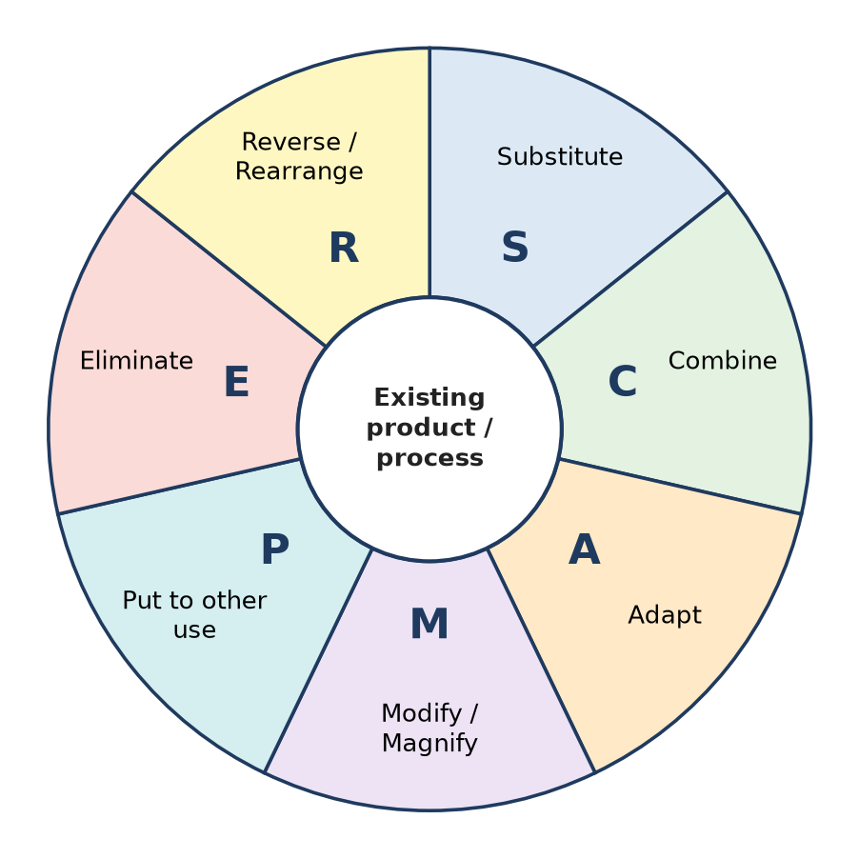
Figure: SCAMPER: seven questions asked about an existing product
SCAMPER | Question | Adidas example
Substitute | What material can be replaced? | Shoes made with Parley Ocean Plastic (recycled marine plastic) instead of new polyester
Combine | What can be joined together? | Boost foam midsole + Primeknit upper; shoes + the adidas Running app for tracking runs
Adapt | What idea can be borrowed? | Futurecraft 4D – 3D-printed midsole made with Carbon's light-based printing
Modify | What can be changed or customised? | miadidas – customers choose colours and add text to their shoes
Put to other use | Other users or uses? | Sports shoes sold as fashion/streetwear (Adidas Originals, Superstar, Stan Smith)
Eliminate | What can be removed? | Futurecraft Loop – one material and no glue, so the shoe is easy to recycle
Reverse | Can the process be reversed? | "Made to be remade": the worn shoe is returned and recycled into a new one

Result: SCAMPER helped Adidas move from "just sports shoes" to sustainable, digital and customised products.
Remember: SCAMPER = Some Cats Always Make Purring Excited Roars – seven questions on an existing product.

Q3. Apply SCAMPER technique and demonstrate the SCAMPER product example – STARBUCKS.
Apply • Moderate • CO3
SCAMPER is applied to an existing product or service to find improvements by asking seven questions (see the SCAMPER wheel in Q2).
SCAMPER | Starbucks example
Substitute | Plant-based milks (oat, almond, soy) offered in place of dairy milk; reusable cups in place of paper cups
Combine | Coffee + the "third place" idea (a space between home and work with seating and Wi-Fi); payment + loyalty in the Starbucks Rewards app
Adapt | Menus adapted to local tastes in each country (for example, local snacks in Indian stores run with Tata)
Modify | Seasonal drinks such as the Pumpkin Spice Latte; premium Reserve Roasteries for a bigger coffee experience
Put to other use | Store used as a workspace and meeting place; used coffee grounds given away for gardens
Eliminate | Mobile Order & Pay removes waiting in the queue; pickup-focused stores remove seating
Reverse | Instead of the customer coming to the counter, coffee goes to the customer: drive-thru and delivery; ready-to-drink bottled Frappuccino sold in shops

IT angle: most Starbucks innovations (app ordering, rewards, personalised offers) are digital – the app turns a coffee shop into a technology platform.
Conclusion: SCAMPER shows how one core product (coffee) can grow into many new offerings without inventing a new product.
Remember: Starbucks SCAMPER in one line: same coffee, new channels (app, drive-thru, bottle).

Q4. Apply SCAMPER Technique to modify the existing business model of McDonald's.
Apply • Moderate • CO3
McDonald's business model = fast, standard, low-cost food through a franchise network. SCAMPER can be applied to each part of this model.
SCAMPER | Change to the business model
Substitute | Plant-based patty (McPlant) for meat-free customers; paper straws and packaging in place of plastic
Combine | McCafé coffee inside restaurants; Happy Meal = meal + toy for families
Adapt | Local menus, e.g. McAloo Tikki burger in India for vegetarian customers
Modify | Self-order kiosks and digital menu boards; all-day breakfast in some markets
Put to other use | Restaurants used as Wi-Fi hangouts; kitchens serve McDelivery orders through apps (Swiggy, Zomato, own app)
Eliminate | The original Speedee Service System (1948) removed waiters, plates and a long menu; today the app and kiosk remove the cashier queue
Reverse | Customer orders and pays in the app before arriving; drive-thru brings food to the car

Effect on the model: new customer segments (vegetarian, health-conscious), new channels (app, delivery, kiosk), new revenue (coffee, delivery fees, loyalty offers) and lower cost per order through self-service.
Conclusion: SCAMPER changes not just the product but how McDonald's reaches customers and earns money.
Remember: McDonald's lesson: Eliminate waiting, Adapt to local taste, Combine with digital.

Q5. Explain the purpose of paper prototyping and use of high-fidelity prototype.
Analyze • Moderate • CO3
A prototype is an early model of a product built to test an idea with users. It can be low or high fidelity.
Paper prototyping (low fidelity) – purpose
1. Test the idea quickly and cheaply – screens are hand-drawn on paper or sticky notes in minutes.
2. Check flow and navigation – a facilitator swaps paper screens as the user "taps".
3. Find usability problems early – before any code is written, so changes cost nothing.
4. Encourage honest feedback – users criticise rough sketches more freely.
High-fidelity prototype – use
1. Looks and behaves almost like the final app (Figma, Adobe XD, coded demo).
2. Tests visual design, colours, micro-interactions, real data and timing.
3. Used for final usability testing, stakeholder/investor demos and developer handoff.
Point | Paper prototype | High-fidelity prototype
Stage | Early (Ideate → first Prototype) | Late (before development)
Cost and time | Very low, minutes | Higher, days
Tests | Concept, flow, layout | Look, feel, detailed usability
Change | Redraw instantly | Needs design rework

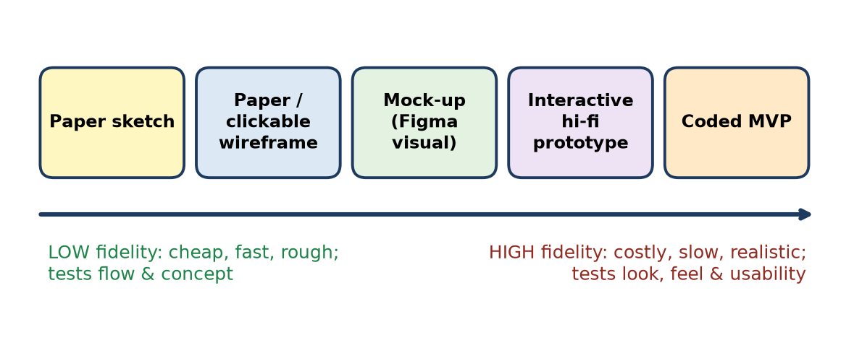
Figure: Fidelity increases from paper sketch to coded MVP
Paper to learn, pixels to confirm.

Q6. Differentiate between divergent and convergent thinking. Give suitable example for it.
Analyze • Moderate • CO3
Divergent thinking opens up many possible ideas; convergent thinking narrows them down to the best one. Design Thinking uses both, one after the other (as in the Double Diamond).
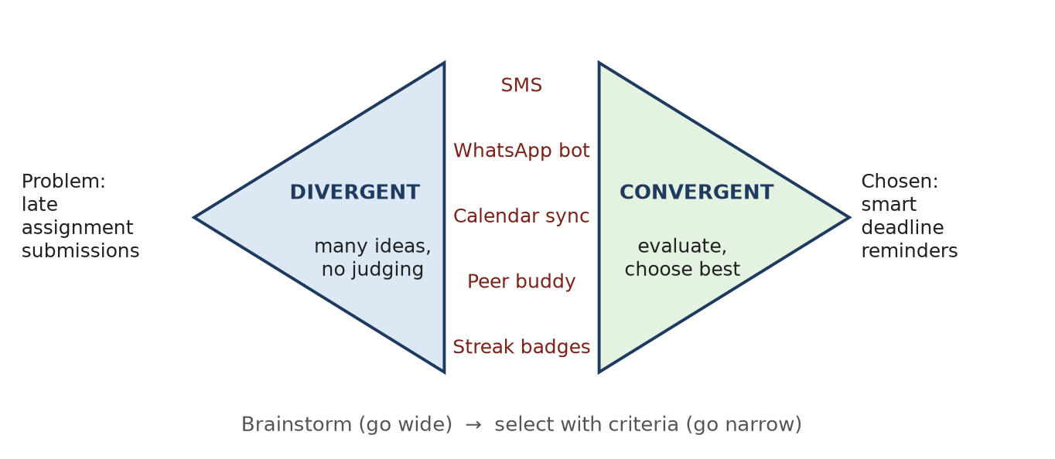
Figure: Divergent then convergent thinking for late assignment submissions
Basis | Divergent thinking | Convergent thinking
Aim | Generate many options | Select the best option
Direction | Goes wide, explores | Goes narrow, focuses
Judgement | Deferred – no criticism | Applied – ideas are evaluated
Tools | Brainstorming, mind map, SCAMPER, lateral thinking | Dot voting, impact–effort matrix, criteria scoring
Stage | Discover, Ideate (Develop) | Define, Deliver / prototype selection
Output | Long list of ideas | One clear decision

Example (late assignment submissions):
- Divergent: team lists SMS alerts, WhatsApp bot, Google Calendar sync, peer buddy, streak badges, auto-extension requests.
- Convergent: ideas are scored on user value, cost and feasibility → smart deadline reminders synced to the student's calendar is selected for prototyping.
Diverge = go wide, Converge = decide. Never do both at the same moment.

Q7. Construct an empathy map for a student who faces difficulties using the college canteen during peak hours.
Apply • Moderate • CO3
An empathy map records what a user Says, Thinks, Does and Feels, so the team understands needs beyond what is spoken. It is built from observation and interviews at the canteen between 1 and 2 pm.
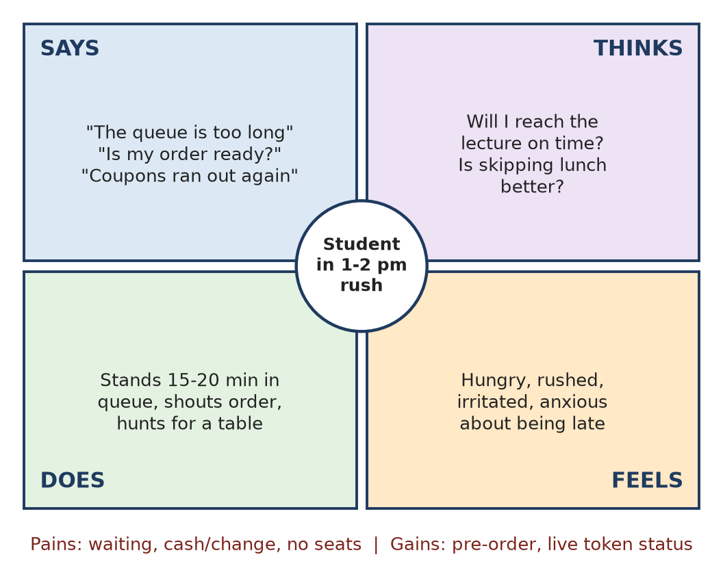
Figure: Empathy map: student at the canteen in peak hours
Pains: long queue (15–20 min), cash and change problems, coupons running out, no free table, risk of missing the next lecture. Gains wanted: order in advance, know exactly when food is ready, quick payment, a place to sit.
User needs derived
1. Students need to order and pay before reaching the canteen.
2. Students need live order status so they do not wait at the counter.
3. Canteen staff need demand estimates to prepare popular items early.
Possible solutions: pre-order app with UPI payment, token number on phone with "ready" notification, time-slot pickup, live seat-availability display.
Remember: Empathy map = S-T-D-F (Says, Thinks, Does, Feels) + Pains and Gains.

Q8. Develop a persona for a two-wheeler rider who experiences road-safety problems during the rainy season.
Understand • Low • CO3
A persona is a fictional but research-based profile of a typical user, used to keep the design focused on real needs.
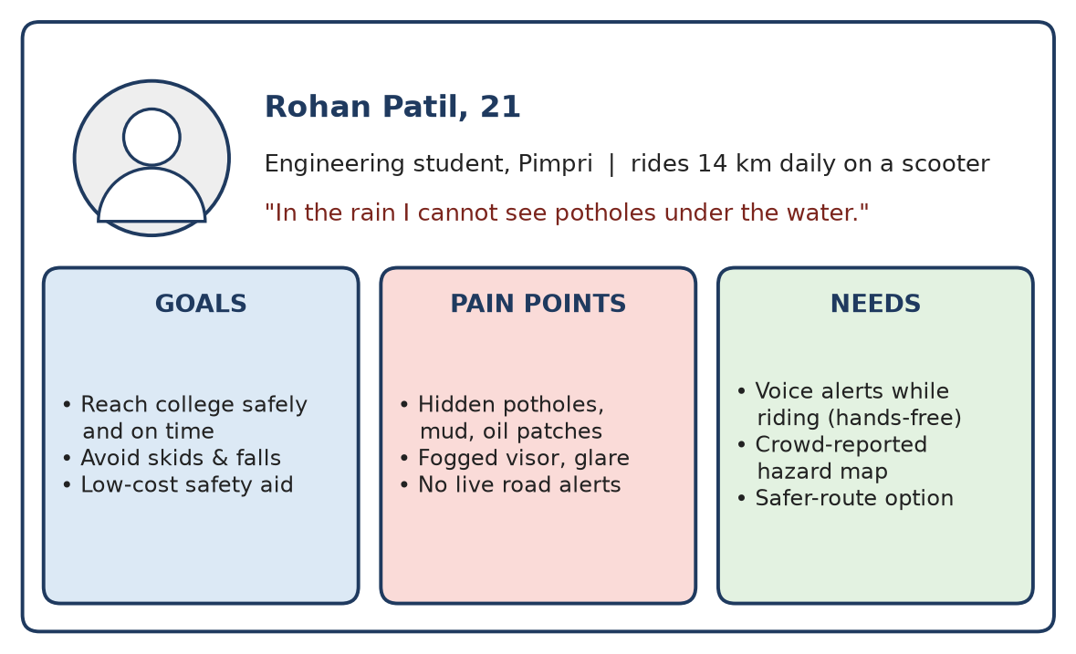
Figure: Persona: two-wheeler rider in the monsoon
- Behaviour: rides 14 km daily, uses Google Maps, often rides at night after practicals.
- Design direction: a hands-free app that gives voice alerts about potholes and water-logging, using a crowd-reported hazard map.
Remember: Persona = Name + Photo + Quote + Goals + Pains + Needs.

Q9. Prepare a customer journey map for a student registering for a technical workshop. Identify pain points and opportunities.
Apply • Low • CO3
A customer journey map shows each step a user goes through, with their emotions, pain points and opportunities.
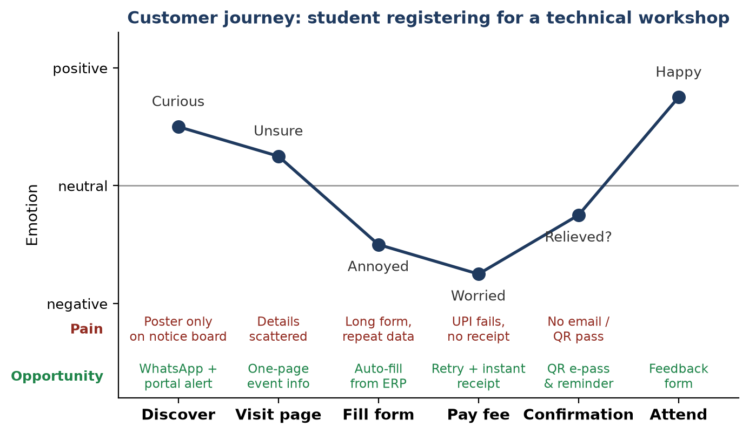
Figure: Customer journey map for workshop registration
Stage | Pain point | Opportunity
Discover | Poster only on notice board | WhatsApp and portal alerts
Fill form | Long form, data typed again | Auto-fill from college ERP
Pay fee | UPI fails, no receipt | Retry option and instant e-receipt
Confirmation | No pass or reminder | QR e-pass and reminder message

The lowest emotion points (form and payment) are where the team should improve first.
Remember: Journey map = Stages → Actions → Emotions → Pains → Opportunities.

Q10. Apply brainstorming techniques to generate solutions for reducing food waste in a college canteen.
Apply • Low • CO3
Brainstorming is a group technique to generate many ideas quickly. Rules (Osborn): defer judgement, go for quantity, build on others' ideas, welcome wild ideas.
Steps: state the question "How might we reduce food waste in our canteen?" → 15-minute idea session → group ideas into themes (mind map) → vote.
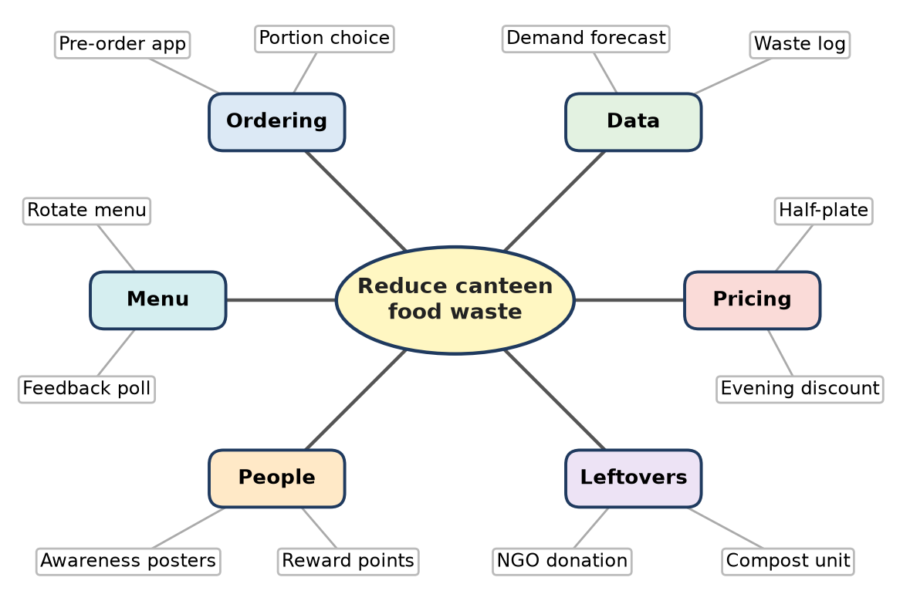
Figure: Mind map of brainstormed ideas for reducing canteen food waste
Top ideas selected: pre-order app so cooks know demand, half-plate option, daily waste log with demand forecasting, and donating safe leftovers to an NGO.
Remember: Brainstorm rules: No criticism, More ideas, Build on others, Wild is welcome.

Q11. Create a storyboard illustrating the steps involved in resolving a student's internet connectivity problem on campus.
Apply • Moderate • CO3
A storyboard is a sequence of simple frames (like a comic strip) that shows how a user meets a problem and how the proposed solution helps. It makes the user's experience visible before anything is built.
Proposed solution: a "Campus Help" app with a one-tap Report Wi-Fi feature.
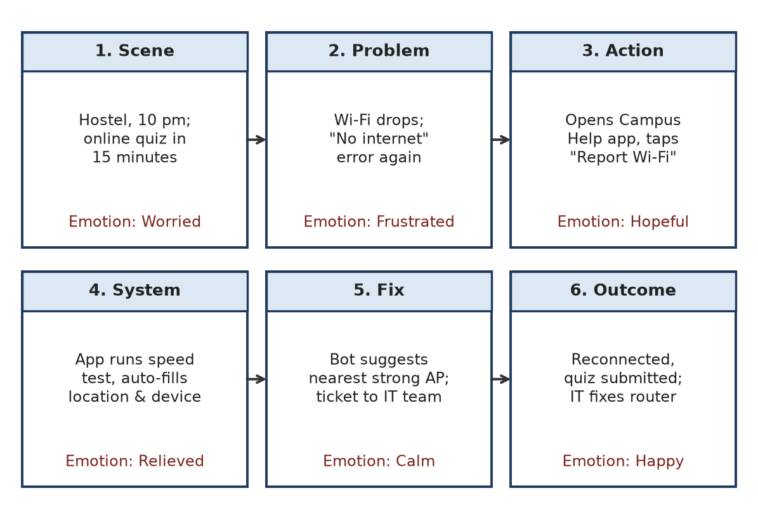
Figure: Storyboard: resolving a campus Wi-Fi problem
Frame-by-frame explanation
1. Scene – Priya is in the hostel at 10 pm with an online quiz in 15 minutes (worried).
2. Problem – Wi-Fi keeps dropping and shows "No internet" (frustrated).
3. User action – She opens the Campus Help app and taps "Report Wi-Fi" (hopeful).
4. System interaction – The app runs a speed test and auto-fills her location, device and time, so she types nothing.
5. Fix – A bot suggests the nearest strong access point and raises a ticket to the IT team.
6. Outcome – She reconnects and submits the quiz; IT staff see a heat-map of complaints and repair the faulty router.
Value: the storyboard shows the emotional journey (worried → happy), the exact moment the system helps, and what the IT team must build (speed test, auto-ticket, complaint heat-map).
Remember: Storyboard = comic strip of the user's problem and your solution.

Q12. Select an appropriate Design Thinking tool to understand the difficulties faced by elderly users of a digital payment application. Justify your selection.
Apply • Moderate • CO3
Selected tool: Empathy Map, filled using observation and contextual interviews (watching seniors make a UPI payment at home or at a shop).
Justification
1. Elderly users often do not say what troubles them (they blame themselves). An empathy map captures Thinks and Feels, not just Says.
2. It records fear (of fraud, of pressing the wrong button) – the main hidden barrier for seniors.
3. It records Does – e.g. asking a grandchild for help, writing the PIN on paper – which reveals real behaviour.
4. It is quick and visual, so the whole team can share the understanding.
Says | Thinks | Does | Feels
"The letters are too small" | "What if money goes to the wrong person?" | Asks family to pay; checks balance many times | Afraid, dependent, embarrassed

Insights → needs: large text and buttons, a confirm screen with the receiver's name and photo, voice guidance in the local language, a simple "Pay / Check balance" home screen.
Support tools: a persona (e.g. "Ramesh, 68, retired clerk") to keep the team focused, and a journey map of one payment to locate the exact failing step.
Remember: For users who hide their struggles, choose the tool that sees feelings – the empathy map.

Q13. A city experiences frequent two-wheeler accidents due to slippery roads, mud accumulation, and potholes during the rainy season. Use Design Thinking tools to investigate the problem and propose an innovative solution.
Apply • Moderate • CO3
Situation: monsoon roads with water-filled potholes and mud cause skids and falls.
Investigation with Design Thinking tools
1. Observation and interviews – ride along with riders, talk to traffic police and ambulance staff.
2. Empathy map – riders feel fear at night, say "I can't see potholes under water", do slow down suddenly.
3. Persona – "Rohan, 21, student rider" (see Q8).
4. Fishbone (cause–effect) diagram – causes grouped as Road (potholes, mud), Rider (speed, worn tyres), Information (no live alerts), Authority (slow repairs).
5. Journey map of a rainy commute – the danger peaks at unlit, water-logged stretches.
Problem statement: How might we warn riders about hidden road hazards early enough, without distracting them while riding?
Ideation (brainstorm + SCAMPER) → Solution: "RainSafe" app
- Crowd-reported hazard map – riders and the public report potholes with photo and GPS.
- Voice alerts through earphones/helmet ("Pothole in 200 m, slow down").
- Safer-route suggestion avoiding water-logged roads.
- Municipal dashboard that ranks hotspots for quick repair.
Prototype and test: paper screens, then a pilot with 50 riders for two weeks; measure alerts received and near-misses reported.
Remember: Tools chain: Observe → Empathy map → Persona → Fishbone → HMW → Prototype.

Q14. Evaluate the effectiveness of empathy mapping and customer journey mapping in identifying hidden user needs. Justify your answer with a real-world example.
Evaluate • High (HOTS) • CO3
Hidden (latent) needs are needs users do not state directly. Two tools help find them.
Empathy mapping – captures what users Say, Think, Do and Feel. Its power lies in the gap between Says and Does: a user may say "the app is fine" but is seen asking friends for help.
Customer journey mapping – lays out every step over time, with emotions. It shows where in the process users drop off or feel frustrated.
Criterion | Empathy map | Journey map
Focus | The person (mind and emotions) | The process (steps over time)
Finds | Fears, motivations, contradictions | Failing touchpoints, drop-off points
Effort | Low; one workshop | Medium; needs data for each step
Limitation | No timeline; can rely on guesswork | Can miss deep emotions
Best used | Empathize / Define stage | Define stage and service redesign

Real-world example – Airbnb (2009): bookings in New York were poor. The founders visited hosts in person and noticed that listing photos were low quality, so guests did not trust the rooms. Nobody had complained about photos – it was a hidden need for trust. They took professional photos, and weekly revenue in that city roughly doubled. Mapping the guest journey (search → view listing → book) would locate this drop at the "view listing" step, while empathy (guests feel unsure) explains why.
Verdict: each tool alone is partial. Empathy maps reveal why users struggle; journey maps reveal where. Used together, built on real observation rather than assumptions, they are highly effective at uncovering hidden needs.
Empathy map = WHY, Journey map = WHERE. Use both.

Q15. Propose a design intervention to improve public transport experiences for senior citizens. Demonstrate how user research, persona development, ideation, and prototyping contribute to your solution.
Analyze • High (HOTS) • CO3
Situation: senior citizens find city buses hard to use – crowded stops, unclear routes, high steps and fast-moving apps.
1. User research – Observe seniors at bus stops, interview 10–15 seniors and conductors, ride along. Findings: cannot read small route boards, unsure when the bus will come, fear of falling while boarding, smartphone apps are confusing.
2. Persona development – "Sudha, 70, retired teacher, Pune; uses a basic smartphone; travels to hospital and temple twice a week."
- Goals: travel independently and safely.
- Pains: long standing wait, small text, no seat assurance.
- Needs: simple information, help while boarding, assurance of the bus timing.
3. Ideation – Brainstorming and SCAMPER produced: large-font live arrival display, IVR call service ("press 1 for next bus"), "senior on board" alert to the driver, priority seat booking, WhatsApp route help. Ideas were prioritised on impact × ease → shortlist: IVR/WhatsApp arrival info + driver alert.
4. Prototyping and testing
- Paper prototype of a 3-button app screen (Next bus / Call help / My trips) and a scripted IVR played to seniors.
- Hi-fi pilot on one route with a "Senior Assist" button that alerts the driver to wait and lower the bus (kneeling bus, where available).
- Feedback led to changes: voice output in Marathi, even larger buttons.
Proposed intervention: "Saathi Ride" – multi-channel arrival information (app, IVR, WhatsApp), driver alert for boarding help, and seat reservation for seniors.
Conclusion: each DT step added value – research found real fears, the persona kept focus, ideation widened options and prototyping refined the solution before full roll-out.
Research finds, Persona focuses, Ideation widens, Prototype proves.

Q16. Develop an innovative solution to improve accessibility of digital learning platforms for students with different learning needs. Explain your choice of Design Thinking tools.
Apply • High (HOTS) • CO3
Situation: students with visual, hearing, learning (dyslexia/ADHD) or motor difficulties, and those on low-end phones, cannot use the learning platform equally.
Choice of Design Thinking tools (and why)
Tool | Why chosen
User interviews and observation with assistive technology (screen reader, captions) | Shows real barriers, not guesses
Multiple personas (blind student, deaf student, dyslexic student, rural student on 2G) | Keeps every group visible in design decisions
Empathy map | Captures feelings such as exclusion and embarrassment
Journey map of "watch lecture → take quiz" | Finds the exact step where each persona fails
SCAMPER / brainstorming | Generates inclusive alternatives
Prototyping + usability testing with real users | Confirms that fixes actually work

Innovative solution: "Learn-For-All" mode
1. Screen-reader friendly pages with alt text and keyboard navigation (following WCAG guidelines).
2. Auto-captions and transcripts for all videos; sign-language summaries for key lectures.
3. Text-to-speech and adjustable reading view – larger fonts, dyslexia-friendly font, high contrast, line focus.
4. Chunked content – 5-minute micro-lessons with progress checkpoints for students with attention difficulties.
5. Low-bandwidth mode – audio-only, downloadable PDFs, offline quiz sync.
6. Flexible assessment – extra time, voice answers, quiz in multiple formats.
7. Personal profile that remembers each student's accessibility settings on every device.
Test: run usability sessions with each persona; measure task success, time and satisfaction; iterate.
Conclusion: inclusive design helps everyone – captions help students in noisy hostels too.
Remember: Accessibility rule: design for the edges, and the middle is covered automatically.

Q17. A student team is unable to generate innovative ideas because of fear of failure, fixed assumptions, and peer pressure. Analyze these mental blocks and propose suitable techniques to overcome them and encourage creative thinking.
Analyze • High (HOTS) • CO3
Mental blocks are internal or social barriers that stop creative thinking. The team shows three of them:
Block | Type | How it shows | Technique to overcome it
Fear of failure | Emotional block | Members stay silent; suggest only "safe" ideas | Defer judgement, "no bad ideas" rule, "worst idea" game (reverse brainstorming), celebrate learning from failed prototypes
Fixed assumptions | Perceptual / intellectual block | "It has always been done this way"; sees the problem from one angle | Challenge assumptions list, lateral thinking (provocation "Po"), SCAMPER, random-word association
Peer pressure | Cultural / social block (groupthink) | Everyone agrees with the topper or senior; dissent is avoided | Brainwriting (silent, anonymous notes), round-robin turns, Six Thinking Hats so everyone thinks in the same mode together

Analysis
- All three blocks reduce quantity and diversity of ideas – the raw material of innovation.
- Fear and peer pressure are social; fixed assumptions are cognitive. So the team needs both a safe environment and thinking tools.
Action plan for the team
1. Start with a 5-minute warm-up (e.g. "30 uses of a paper clip").
2. Brainwrite 6 ideas each in silence (6-3-5 method).
3. Use reverse brainstorming: "How could we make this problem worse?" then flip each answer.
4. Apply SCAMPER to the best ideas.
5. Use dot voting anonymously; build a quick paper prototype.
6. Faculty mentor praises effort and experiments, not only final results.
Conclusion: once fear is removed and assumptions are questioned, the same team can produce bold, useful ideas.
Fear → defer judgement; Fixed → challenge assumptions; Peers → brainwrite.

Q18. Evaluate the effectiveness of lateral thinking, reverse brainstorming, and random-word association in overcoming creative barriers.
Analyze • High (HOTS) • CO3
Creative barriers are habits that keep us thinking in the usual, logical track. Three techniques attack them in different ways.
1. Lateral thinking (Edward de Bono) – solving problems by an indirect, creative approach instead of step-by-step logic. Uses provocation ("Po"), challenging assumptions and finding alternatives.
2. Reverse brainstorming – ask "How could we cause or worsen the problem?", list answers, then reverse each into a solution.
3. Random-word association – pick a random word (e.g. "umbrella"), list its features, and force-connect them to the problem.
Criterion | Lateral thinking | Reverse brainstorming | Random-word association
Barrier it breaks | Fixed assumptions, logical rut | Fear of failure, negativity, blankness | Pattern-locked thinking
Ease for beginners | Medium (needs practice) | High (fun and easy) | High
Originality of ideas | Very high | Medium – often practical fixes | High but many unusable
Time needed | More | Less | Less
Limitation | Can feel abstract | Mostly improves existing system | Needs strong filtering

IT example – students ignore portal notices:
- Lateral: "Po – notices find the student" → push notices into WhatsApp and the timetable app.
- Reverse: "How to make sure nobody reads notices?" → bury them in PDFs, no alerts → flip: short summaries with push alerts.
- Random word "traffic light": colour-coded urgency (red = today, amber = this week).
Evaluation / verdict: reverse brainstorming is the best ice-breaker, random-word is the fastest spark, and lateral thinking gives the most original ideas. Used in that order and followed by convergent selection, they are highly effective at overcoming creative barriers.
Reverse to warm up, Random to spark, Lateral to leap.

Q19. Design an activity using brainstorming, mind mapping, and SCAMPER to help students overcome mental blocks and generate creative solutions to a campus problem.
Analyze • High (HOTS) • CO3
Campus problem chosen: long queues and food waste at the college canteen. Activity name: "Idea Sprint" – 75 minutes, teams of 5, with sticky notes, chart paper and markers.
Time | Step | Tool | Mental block it removes
0–10 min | Warm-up: "20 uses of a plate" | Fun divergent game | Fear of looking silly
10–15 min | Frame the challenge: "How might we serve 500 students in 30 minutes with less waste?" | HMW question | Vague thinking
15–30 min | Brainstorming – silent writing (1 idea per sticky note) then sharing; no criticism | Brainwriting + brainstorming | Peer pressure, judgement
30–45 min | Mind mapping – put the problem in the centre; branches: Ordering, Payment, Menu, Seating, Leftovers; place and extend notes | Mind map | Narrow, one-track thinking
45–60 min | SCAMPER on the top 3 ideas (e.g. Substitute cash with UPI, Combine menu and pre-order app, Eliminate the payment counter, Reverse – food delivered to class pickup points) | SCAMPER | Fixed assumptions
60–70 min | Dot voting on impact and ease; choose one idea | Convergent selection | Endless discussion
70–75 min | Each team pitches in 60 seconds with a paper sketch | Storyboard / sketch | Fear of presenting

Facilitator rules: quantity over quality, build on others ("Yes, and…"), wild ideas welcome, every voice counted (round-robin).
Expected outcome: 60–100 ideas in total, a mind map showing idea clusters, and 2–3 refined concepts such as a pre-order app with time-slot pickup and a half-plate option with waste tracking.
Brainstorm = volume, Mind map = structure, SCAMPER = stretch.

Q20. Illustrate how mind mapping and SCAMPER can help individuals move beyond conventional thinking.
Apply • Moderate • CO3
Conventional thinking stays with the first, obvious answer. Mind mapping and SCAMPER force the mind to explore further.
Mind mapping – a radial diagram with the problem in the centre and branches for sub-topics.
- Shows links between ideas that a list hides.
- Each branch invites new sub-ideas, so thinking spreads in many directions (non-linear).
- Works like the brain's own association, helping recall and creativity.
SCAMPER – seven question prompts applied to an existing product.
- Gives a checklist, so a person is never "stuck".
- Each letter forces a different angle (substitute, combine, reverse …).
Figure: SCAMPER prompts used after a mind map
Example – college library app:
- Mind map branches: Search, Availability, Reminders, Reading spaces, Community.
- SCAMPER on "Reminders": Substitute email with WhatsApp; Combine due date with timetable; Adapt Netflix-style "continue reading"; Modify – auto-renew if no one is waiting; Put to other use – reminders also suggest related books; Eliminate fines with a points system; Reverse – the book "asks" to be returned when someone reserves it.
Result: instead of "send an email reminder" (conventional), the user reaches auto-renewal and gamified returns.
Mind map spreads ideas out; SCAMPER twists each idea.

Q21. A college plans to develop a mobile application for student attendance management. Design a low-fidelity prototype to demonstrate the application's basic features.
Apply • Moderate • CO3
A low-fidelity prototype is a rough, quick, cheap model (paper sketches or simple wireframes) used to test the structure and flow before design and coding.
Step 1 – Information architecture (what screens exist and how they link):
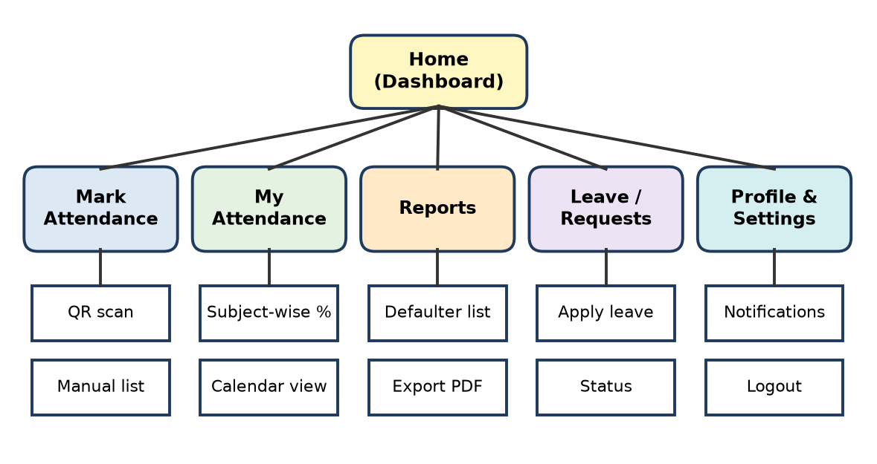
Figure: Information architecture of the attendance app
Step 2 – Paper screens (one card per screen):
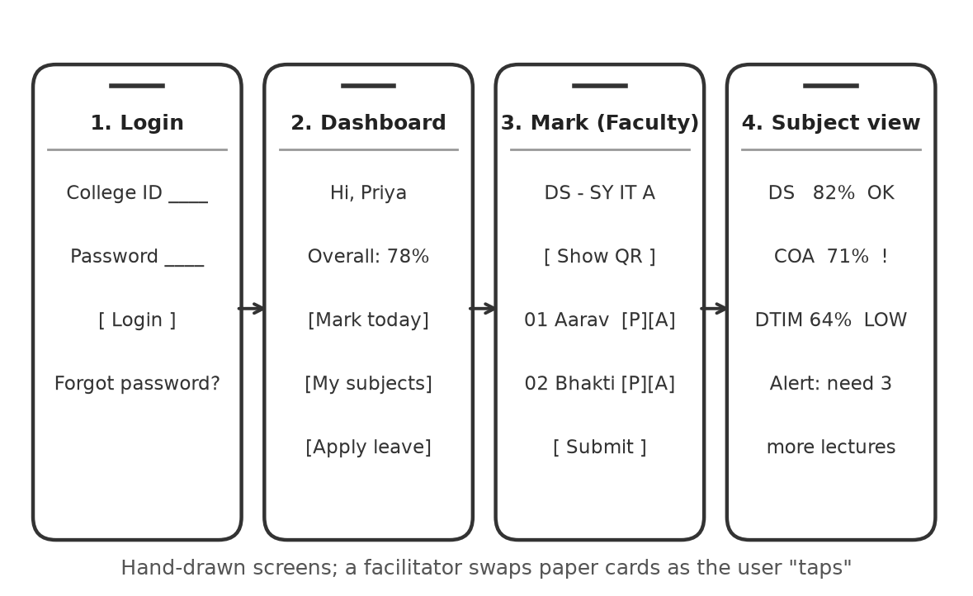
Figure: Paper prototype screens of the attendance app
Basic features shown
1. Login with college ID.
2. Dashboard – overall attendance %, quick buttons.
3. Mark attendance (faculty) – show a QR code for students to scan, or tick P/A on a list.
4. Subject-wise view (student) – % per subject with a low-attendance alert ("need 3 more lectures").
5. Leave request and notifications.
Step 3 – Test: a student and a faculty member are given tasks ("Check your DTIM attendance", "Mark today's lecture"). A facilitator swaps paper cards as they tap. Confusions (e.g. P/A buttons too close) are noted and screens redrawn.
Remember: Lo-fi = IA tree + paper screens + task test in one afternoon.

Q22. Differentiate between low-fidelity and high-fidelity prototyping in terms of cost, time, functionality, and user feedback.
Apply • Moderate • CO3
Fidelity means how closely a prototype looks and works like the final product.
Basis | Low-fidelity prototype | High-fidelity prototype
Cost | Very low – paper, pen, sticky notes or simple wireframe tools | Higher – design tools (Figma, Adobe XD), designer/developer effort
Time | Minutes to a few hours | Days to weeks
Functionality | Little or none; flow is simulated by a person swapping screens | Clickable or partly working; real-looking UI, transitions, sample data
User feedback | On concept, flow, layout, missing features; users give honest criticism | On visual design, details, micro-interactions, real task performance
Look | Rough sketch, black-and-white | Close to final colours, fonts, images
Changes | Very easy, redraw instantly | Harder, need design rework
Stage | Early (Ideate / first Prototype) | Late (before development, stakeholder demo)
Example | Paper screens of a canteen app | Figma clickable prototype of the same app

Figure: Fidelity spectrum from paper sketch to coded MVP
Conclusion: start low-fidelity to test the idea cheaply, then move to high-fidelity to test the details – the two are complementary, not competitors.
Low-fi = cheap, quick, rough, flow. High-fi = costly, slow, real, feel.

Q23. A team develops a prototype of a Water purifier system in rural area and develops an application to monitor its usage. Describe how usability testing can identify design flaws and guide improvements.
Apply • Low • CO3
Usability testing means watching real users try a prototype to complete tasks, and noting where they struggle.
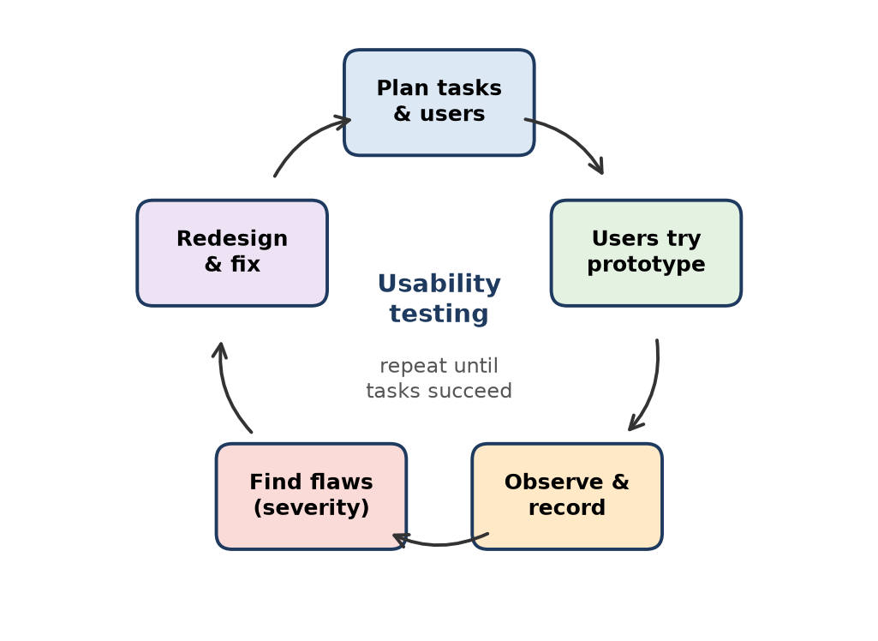
Figure: Usability testing cycle
How it works here
1. Tasks: village operator checks litres purified, sees filter-change alert, reports a fault.
2. Observe: success rate, time taken, errors, comments ("Where is the filter status?").
3. Flaws found: English-only text, small icons, app needs constant internet, alert not noticed.
4. Improvements: Marathi/Hindi voice and icons, offline data with SMS sync, big red/green status light, SMS alerts.
Remember: Usability test = real users + real tasks + watch, don't help.

Q24. Users find a proposed mobile banking application's interface confusing. Evaluate whether low-fidelity or high-fidelity prototyping would be more appropriate at different stages of the design process. Justify your answer.
Apply • Low • CO3
Both are needed, but at different stages:
Stage | Best choice | Justification
Early – find why the interface confuses | Low-fidelity (paper / wireframe) | Cheap and fast to try 3–4 new menu layouts and navigation flows; users comment freely
Middle – flow is agreed | Mid/clickable wireframe | Check task paths such as "Send money" end to end
Late – before coding | High-fidelity (Figma clickable) | Test fonts, colours, icons, security prompts and trust; get stakeholder approval

Verdict: since the problem is confusing structure, start with low-fidelity to fix navigation, then use high-fidelity to polish and confirm.
Fix the flow on paper, fix the feel in pixels.

Q25. Demonstrate paper prototyping with an example and explain its role in the Design Thinking process.
Apply • Low • CO3
Paper prototyping = drawing app screens by hand on paper and letting a user "use" them while a facilitator swaps the sheets.
Example – attendance app: four paper screens (Login → Dashboard → Mark attendance → Subject view) are drawn; a student is asked to "check DTIM attendance" and taps with a finger.
Figure: Paper prototype example
Role in Design Thinking
- Belongs to the Prototype stage and feeds the Test stage.
- Turns ideas into something users can react to, in minutes.
- Finds flow and layout problems before coding, saving cost.
- Supports fast iteration – redraw and retest the same day.
Remember: Paper prototype: draw it, show it, fix it – same day.

Q26. Explain how paper prototyping can help identify usability problems before developing the actual software.
Apply • Moderate • CO3
Paper prototyping lets real users try hand-drawn screens of the planned software. Because it happens before coding, every problem found is cheap to fix.
How it identifies usability problems
1. Navigation problems – users cannot find a feature (e.g. "Where do I renew my book?"), showing that menu labels or structure are wrong.
2. Missing steps or screens – users ask for a "Back" or "Confirm" screen the team forgot.
3. Confusing words and icons – users misread labels such as "Submit" vs "Save".
4. Wrong order of steps – users try to pay before choosing a time slot, showing the flow does not match their mental model.
5. Information overload – too many items on one screen become obvious on paper.
6. Task failure points – the facilitator records where users stop, hesitate or guess.
Process: give tasks → user "taps" on paper → facilitator swaps screens → observer notes problems → screens redrawn → retest.
Why before software: after coding, a fix needs redesign, recoding and retesting; on paper it needs only a pencil.
Example: in a paper test of a canteen pre-order app, 4 of 5 students looked for the cart at the bottom instead of the top – the team moved it before writing code.
Every bug found on paper is a bug never coded.

Q27. Students frequently forget assignment deadlines despite receiving email notifications. Apply lateral thinking to propose alternative ways of reminding students.
Apply • Moderate • CO3
Lateral thinking (Edward de Bono) solves problems by looking at them from unusual angles, rather than improving the obvious solution ("send more emails").
Step 1 – Challenge the assumption: "Reminders must come by email." Students rarely open college email; they live on WhatsApp, Instagram and their phone's lock screen.
Step 2 – Provocation (Po): "Po – the assignment reminds itself" / "Po – students remind each other" / "Po – the deadline is visible without opening anything".
Step 3 – Alternatives generated
1. WhatsApp bot messages with one-tap "submitted" confirmation.
2. Auto-sync to Google Calendar with alerts 3 days, 1 day and 3 hours before.
3. Phone lock-screen / home-screen widget showing the next deadline countdown.
4. Peer buddy system – class representatives or study partners get a group reminder.
5. Gamification – streak points and badges for on-time submission on the LMS.
6. Smart reminders based on behaviour – students who usually submit late get earlier nudges.
7. Classroom display or Wi-Fi login page shows "Due this week" list.
8. Break the task into milestones – reminders for draft, review and final.
Step 4 – Select: calendar sync + WhatsApp bot + LMS widget are quick, cheap and reach students where they already are.
Remember: Lateral thinking: don't shout louder by email – reach them somewhere else.

Q28. A college wants to reduce paper consumption but cannot completely eliminate printed documents. Develop innovative alternatives by applying lateral thinking.
Apply • Low • CO3
Challenge the assumption: "Every document needs its own full printout." Provocation: "Po – paper is printed only when someone truly needs it."
Alternatives
1. Print-on-demand – default is digital; print only on request at a shared kiosk.
2. Double-sided, multi-page-per-sheet default on all printers.
3. QR codes on notices linking to full details – one small poster instead of many pages.
4. E-signature (DigiLocker / online forms) for approvals and leave.
5. Reuse one-side-printed sheets for rough work and paper prototypes.
6. Print quota per department shown on a dashboard.
Remember: Lateral thinking here: print less, not never.

Q29. Select a common problem faced by students and apply the Six Thinking Hats or Random Word Technique to generate at least five alternative solutions. [white hat, red hat, black hat, green hat, blue hat, yellow hat]
Apply • Low • CO3
Problem: students cannot find a quiet place to study on campus during exams. Six Thinking Hats (Edward de Bono) – the group looks at the problem in one mode at a time.
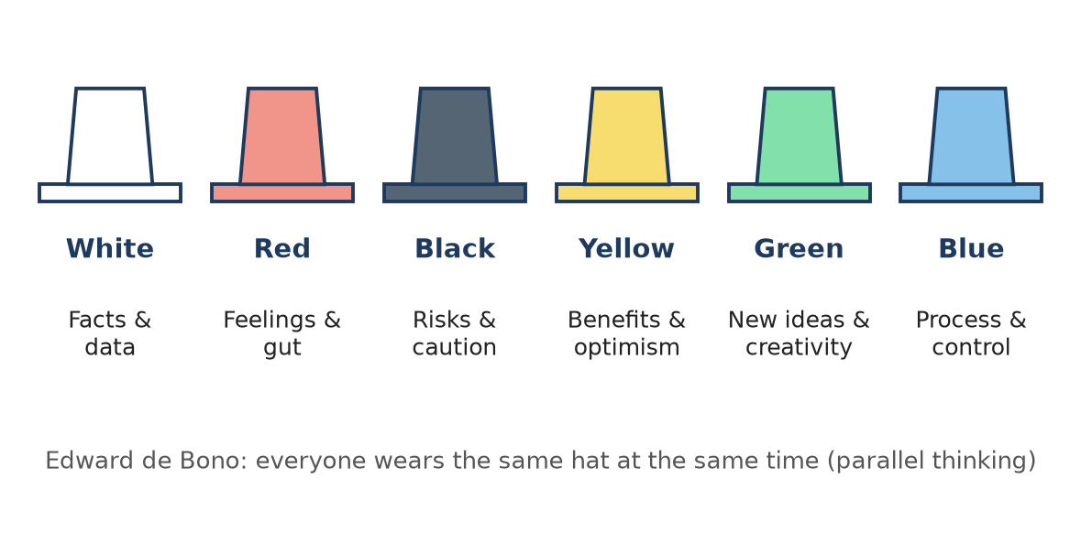
Figure: Six Thinking Hats
Hat | Thinking | Points
White | Facts | Library has 120 seats for 2,000 students; empty classrooms after 4 pm
Red | Feelings | Students feel stressed and annoyed searching for seats
Black | Risks | Security of open rooms, electricity cost, noise
Yellow | Benefits | Better results, less crowding in hostels
Green | New ideas | Solutions below
Blue | Process | Pilot two ideas for one exam season, then review

Solutions (Green hat): (1) seat-booking app for library and empty classrooms, (2) open selected classrooms till 10 pm, (3) live occupancy display using Wi-Fi counts, (4) silent zones in the canteen after 5 pm, (5) outdoor study pods with charging points.
Remember: Hats order trick: White facts, Red feel, Black risk, Yellow gain, Green ideas, Blue control.

Q30. Demonstrate brainstorming and mind mapping can be combined to generate ideas for solving a real-world IT problem.
Evaluate • High (HOTS) • CO3
IT problem: the college result portal crashes when thousands of students log in at the same time on result day.
Step 1 – Brainstorming (divergent). The team (developers, network staff, students) spends 15 minutes listing ideas on sticky notes, following the rules: no criticism, quantity, build on others, wild ideas welcome. Raw ideas: buy a bigger server, cloud auto-scaling, send results by SMS, release results batch-wise, cache the result page, waiting-room queue, email PDF results, load test before the day, status banner, lighter result page …
Step 2 – Mind mapping (organise and extend). The problem goes in the centre; brainstormed notes are placed on branches. Empty or thin branches trigger more ideas.
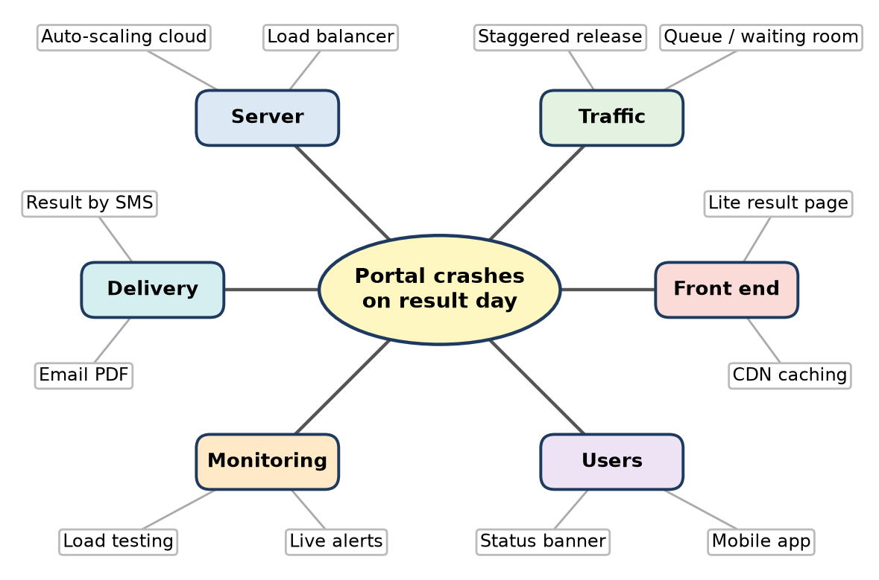
Figure: Mind map built from brainstormed ideas for the portal crash problem
Step 3 – Evaluate and select (convergent).
Idea | User value | Cost | Feasibility | Decision
Cloud auto-scaling + load balancer | High | Medium | High | Select
Results by SMS / email PDF | High | Low | High | Select
Staggered branch-wise release | Medium | Nil | High | Select
Buy bigger physical server | Medium | High | Medium | Reject

Evaluation of the combination
- Brainstorming alone gives a messy list; the mind map groups it, shows links (traffic + server + front end), and exposes gaps (no one thought of monitoring until the branch looked empty).
- Mind mapping alone may be done by one person; brainstorming adds many minds.
- Together they produce both quantity and structure, leading to a balanced solution covering infrastructure, traffic and user communication.
Conclusion: combining the two tools is highly effective for complex IT problems that have several causes.
Brainstorm fills the bucket; the mind map sorts it.

Q31. A team generates 50 ideas for improving a digital library system. Evaluate these ideas on grouping and priority and shortlist for prototyping.
Evaluate • Moderate • CO3
Step 1 – Grouping (affinity mapping). Each idea is written on a sticky note. The team silently moves similar notes together and names each cluster.
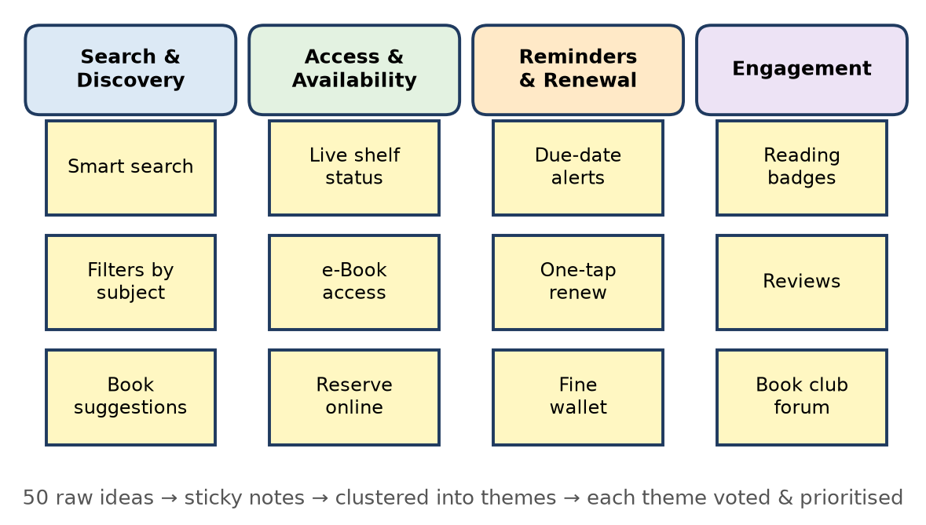
Figure: Affinity map: 50 ideas grouped into themes
Step 2 – Prioritisation. Each member gets 3–5 votes (dot voting). Top-voted ideas are then placed on an impact–effort matrix:
Idea | User impact | Effort | Priority
Live shelf availability | High | Low | Quick win – prototype
Smart search with filters | High | Medium | Prototype
One-tap renew + due-date alerts | High | Low | Quick win – prototype
e-Book access | High | High | Plan for later phase
Reading badges, book club forum | Low | Medium | Park for now

Step 3 – Shortlist for prototyping: (1) smart search with filters, (2) live availability with online reserve, (3) one-tap renewal with alerts. These address the main pains seen in research – finding, checking and renewing books.
Cluster → Vote → Impact–Effort → Prototype the quick wins.

Q32. Explain how emotions, user actions, pain points, and proposed solutions can be represented in a storyboard for an IT-based system.
Apply • Moderate • CO3
A storyboard tells the user's story in a series of frames. Each element is shown in a clear visual way:
1. User actions – drawn as the main picture of each frame (e.g. "student taps Upload"), with a short caption underneath. They show the step-by-step flow.
2. Emotions – shown with facial expressions, emoji or a speech/thought bubble ("Will it upload in time?"). An emotion line across frames shows the high and low moments.
3. Pain points – highlighted with a red mark, warning icon or "!" in the frame where things go wrong (e.g. "Server error 504").
4. Proposed solutions – shown in the following frames as the system helping: a phone screen with the new feature (e.g. "Upload saved offline – will auto-submit"), usually in a different colour.
5. Outcome – the final frame shows the result with a positive emotion.
Example – online project submission system:
Frame | Action | Emotion | Pain / Solution
1 | Opens portal at 11:50 pm | Anxious | –
2 | Uploads 40 MB file | Panic | Pain: size limit error
3 | App compresses file automatically | Relieved | Solution: auto-compress
4 | Gets instant receipt | Happy | Solution: e-receipt

Remember: Storyboard symbols: picture = action, face = emotion, red ! = pain, new screen = solution.

Q33. A design team has developed a technical solution but cannot effectively communicate its benefits to stakeholders. Explain how a storyboard can demonstrate the problem, proposed intervention, and expected impact.
Apply • High (HOTS) • CO3
Situation: the team built a QR-based smart attendance system, but management sees only "a new app" and its cost. A storyboard turns technical features into a human story that stakeholders understand in two minutes.
1. Showing the problem (frames 1–2)
- Frame 1: a faculty member spends 10 minutes of a 60-minute lecture calling 70 names.
- Frame 2: proxy attendance, errors in the register, and a clerk typing data into Excel at month-end; parents receive late defaulter letters.
- Emotions shown: frustration, wasted time. Stakeholders feel the cost of the current way.
2. Showing the proposed intervention (frames 3–4)
- Frame 3: faculty displays a QR code that changes every few seconds; students scan within 30 seconds; geo-fencing blocks proxies.
- Frame 4: attendance flows automatically to the ERP; students and parents see live percentages; low-attendance alerts are sent in week 4, not at the end of the semester.
- Technical parts (dynamic QR, API to ERP) appear only as simple system actions.
3. Showing the expected impact (frames 5–6)
- Frame 5: about 8 minutes of teaching saved per lecture; no manual data entry.
- Frame 6: dashboard for the principal showing defaulter trends; a happy parent getting an early alert.
- Add a small "before vs after" panel: time, errors, cost.
Why it works: no jargon, shows real people and emotions, links each feature to a benefit, and gives everyone one shared story to comment on.
Conclusion: the storyboard sells the change in people's day, not the technology, which is what stakeholders fund.
Remember: Stakeholders buy stories of impact, not lists of features.

Q34. A proposed mobile application receives negative feedback because its workflow does not match user expectations. Evaluate how storyboarding can help identify usability problems before software development.
Evaluate • Moderate • CO3
Situation: a food-ordering app forces users to register and add an address before they can see the menu; users expected to browse first. Storyboarding could have caught this early.
How storyboarding helps
1. Shows the workflow as the user lives it – each frame is one step, so the team sees if the order of steps feels natural.
2. Reveals mismatches with mental models – when users walk through the frames, they say "I would look at the menu first", exposing the wrong sequence.
3. Highlights emotional low points – frames where the user is annoyed (forced sign-up, long forms) are marked as pain points.
4. Finds missing steps – e.g. no "edit order" or "track delivery" frame.
5. Cheap and quick to change – reorder or redraw frames in minutes instead of rewriting code.
6. Common language – designers, developers and clients review the same story.
Evaluation
Strength | Limitation
Very early, cheap, visual | Not interactive; detailed UI problems are missed
Good for flow and context | Depends on realistic user research

Verdict: storyboarding is highly effective for workflow-level usability problems before development, and should be followed by paper or clickable prototypes for screen-level issues.
Storyboard the journey before you code the screens.

Q35. Develop a storyboard for a proposed IT solution using the following elements in each frame: Scene, User Action, User Thought or Emotion, Problem Encountered, System Interaction, and Outcome.
Analyze • High (HOTS) • CO3
Proposed IT solution: "CanteenGo" – a pre-order and pickup app for the college canteen. User: Aditi, SY B.Tech student with a 30-minute lunch break.
Frame | Scene | User action | Thought / emotion | Problem encountered | System interaction | Outcome
1 | Classroom, 12:50 pm, lecture ending | Thinks about lunch | "The queue will be huge" – worried | Only 30 min break; 20 min queue | – (current situation) | Plans to skip lunch
2 | Corridor, walking out | Opens CanteenGo app | "Let me try this" – curious | Unsure how it works | App shows today's menu with prices and wait time | Understands quickly
3 | Corridor | Adds thali and tea to cart | "Is thali still available?" – doubtful | Items sometimes sell out | Live stock count shows "12 left" | Confident in choice
4 | Stairs | Picks 1:05 pm slot and pays by UPI | "Hope payment works" – tense | UPI timeout | App retries and shows instant e-receipt and token no. 47 | Relieved
5 | Canteen counter | Gets "Order ready" notification, collects food | "No queue!" – happy | Crowd near counter | Separate pickup counter, token scanned | Food in 2 minutes
6 | Table, 1:20 pm | Rates the meal | "I'll use this daily" – satisfied | – | App collects rating; canteen sees demand data | Reaches next lecture on time; canteen cuts waste

Analysis: the emotion curve dips at frames 1 and 4, so queue avoidance and reliable payment must be strongest. Each "System interaction" becomes a feature to build, and each "Problem encountered" becomes a usability test case.
Conclusion: a six-element storyboard links every user moment to a system feature before development starts.
Remember: Six elements per frame: Scene, Action, Feeling, Problem, System, Outcome – "SAF-PSO".

Quick Revision – Unit III
Term | Meaning / key fact
Mental block | Fear, habit or assumption that stops creative ideas (emotional, perceptual, cultural)
Brainstorming | Group idea generation: defer judgement, quantity, build on ideas, wild ideas welcome
Brainwriting | Silent written idea generation (e.g. 6-3-5); removes peer pressure
Reverse brainstorming | "How to make the problem worse?" then flip each answer
Mind map | Radial diagram, problem in centre, branches of linked ideas
Affinity map | Grouping many ideas or research notes into named clusters
SCAMPER | Substitute, Combine, Adapt, Modify, Put to other use, Eliminate, Reverse
Lateral thinking | Edward de Bono; indirect thinking using provocation (Po) and challenging assumptions
Six Thinking Hats | White facts, Red feelings, Black risks, Yellow benefits, Green ideas, Blue process
Divergent vs convergent | Go wide (many ideas) vs go narrow (choose best)
Empathy map | Says, Thinks, Does, Feels + Pains and Gains
Customer journey map | Stages, actions, emotions, pain points, opportunities over time
Storyboard | Comic-strip frames of user, problem, solution and outcome
Low-fidelity prototype | Paper or wireframe; cheap, fast, tests flow
High-fidelity prototype | Realistic, clickable; tests look, feel and detailed usability
Usability testing | Real users perform real tasks while the team observes problems

Unit IV: Innovation Management

Q1. Describe the role of technology innovation in improving productivity and competitiveness in IT-based industries.
3 Marks • Understand • Low • CO4
Technology innovation means putting a new or improved technology to commercial use in a product, service or process, so that it creates value.
Role in IT industries:
1. Productivity – automation, cloud and AI tools (CI/CD pipelines, AI code assistants, low-code platforms) let the same team deliver more in less time.
2. Lower cost – cloud pay-per-use replaces costly in-house servers.
3. Competitiveness – new features and faster releases win and keep customers (e.g. Netflix moved from DVD rental to streaming in 2007 and stayed ahead).
4. New markets – SaaS and mobile apps reach users worldwide.
Remember: Innovation = invention + use → "do more, faster, cheaper, better than rivals".

Q2. Differentiate invention and technology innovation with a suitable IT example.
3 Marks • Understand • Low • CO4
Invention is the creation of a new idea, device or method. Innovation is turning that idea into a product or process that users adopt and that creates value.
Point | Invention | Technology innovation
Meaning | New idea or technical creation | Successful use of the idea in the market
Focus | Technical novelty | User value and business value
Done by | Researchers, labs | Firms, product teams
Success measure | Patent, paper, working model | Adoption, revenue, productivity
IT example | The transformer neural-network architecture (research paper, 2017) | ChatGPT and AI coding assistants that millions use daily

Remember: Invention is "first time an idea exists"; innovation is "first time it pays".

Q3. Identify and describe any three major sources of innovation in software organizations, with examples.
4 Marks • Understand • Low • CO4
Sources of innovation are the places from which new ideas for products, features and processes come.
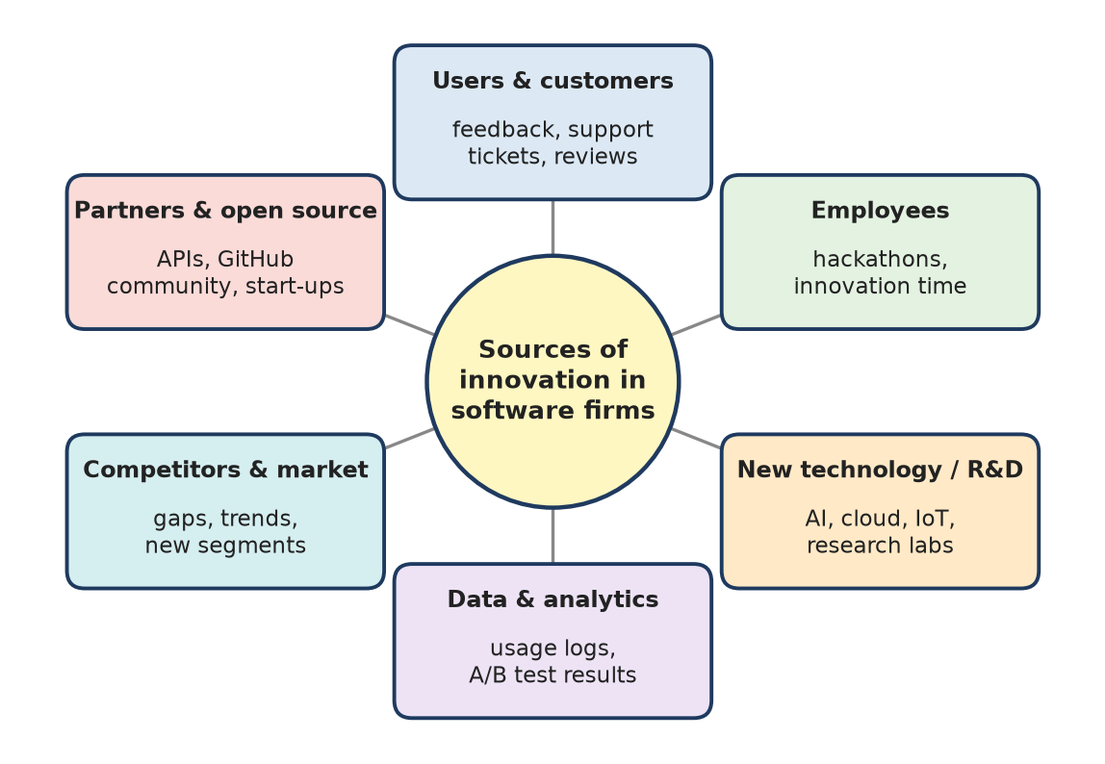
Figure: Sources of innovation in software organizations
1. Users and customers – feedback, app-store reviews, support tickets and usage data reveal unmet needs. Example: user complaints about slow checkout lead to one-tap UPI payment.
2. Employees (internal ideas) – hackathons, innovation days and idea portals. Example: Google's "20% time" is often credited with starting Gmail; many companies run yearly hackathons.
3. New technology / R&D – AI, cloud, IoT and open-source libraries make new features possible. Example: adding AI chat support using a large language model API.
4. Other sources: competitors and market changes, partners and the open-source community, regulation (e.g. data-privacy laws drive new consent features).
Remember: Innovation comes from U-E-T: Users, Employees, Technology.

Q4. Differentiate incremental, radical, disruptive, and architectural innovation with suitable examples.
4 Marks • Understand • Low • CO4
Innovations are classified by how new the technology is and how much the business model or market changes.
Type | Meaning | Risk | IT example
Incremental | Small, continuous improvement to an existing product | Low | New version of an app with faster search, dark mode
Radical | Breakthrough technology that creates new capability | Very high | Generative-AI code completion (GitHub Copilot)
Disruptive | Simpler or cheaper offer that starts with ignored customers and later replaces leaders | Medium–high | Netflix streaming vs Blockbuster DVD stores; WhatsApp vs paid SMS
Architectural | Existing components linked in a new configuration or system design | Medium | Cloud platforms (AWS) that re-package servers, storage and networking as on-demand services

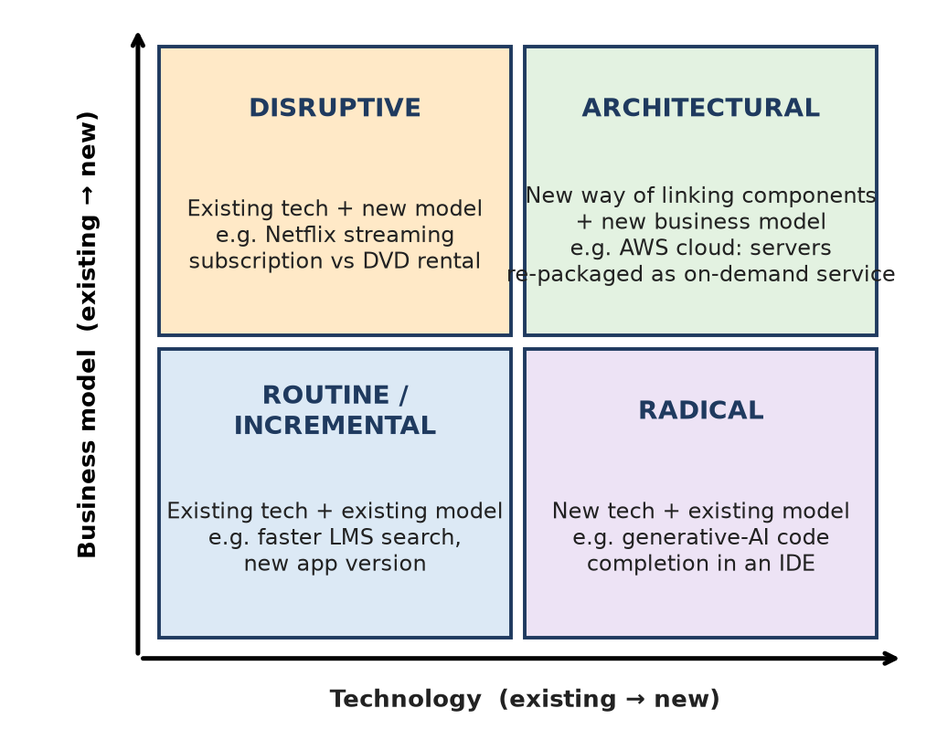
Figure: Innovation types matrix
I-R-D-A: Improve, Revolutionise, Disrupt, re-Arrange.

Q5. Compare Agile innovation with the traditional sequential software-development approach.
3 Marks • Understand • Low • CO4
Agile innovation develops a product in short iterations with constant user feedback, while the traditional (Waterfall) approach completes each phase fully before the next one starts.
Point | Agile innovation | Traditional sequential (Waterfall)
Planning | Adaptive, sprint by sprint | Fixed upfront plan
Delivery | Working increment every 1–4 weeks | One release at the end
Requirement change | Welcomed | Costly, resisted
Customer role | Gives feedback every sprint | Mostly at start and end
Risk | Found early | Found late (at testing)

Remember: Agile = "small slices, frequent tastes"; Waterfall = "one big cake at the end".

Q6. Illustrate the purpose of a Minimum Viable Product (MVP) in validating an IT product idea.
3 Marks • Understand • Low • CO4
A Minimum Viable Product (MVP) is the simplest version of a product with just enough features to be used by early users and to test the most important assumption (Eric Ries, The Lean Startup).
Purpose:
1. Validate demand before spending on full development.
2. Learn fast through the Build–Measure–Learn loop.
3. Save time and money – fail cheaply if the idea is wrong.
4. Attract early users and investors with real data.
Example: Dropbox's MVP was a short demo video; the jump in beta sign-ups proved demand before the full product was built.
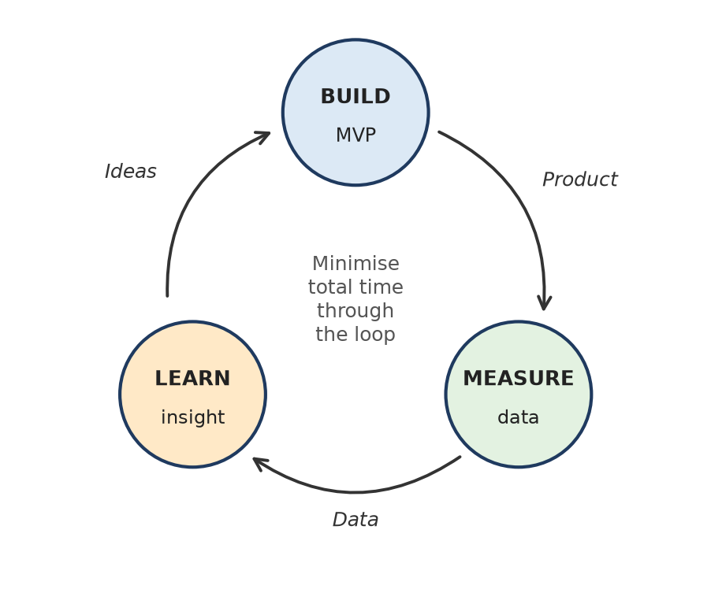
Figure: Build–Measure–Learn loop
Remember: MVP = "smallest thing that teaches the biggest lesson".

Q7. Summarize the importance of risk management and innovation-performance measurement in software organizations.
4 Marks • Understand • Low • CO4
Innovation is uncertain, so software firms must manage risk (what can go wrong) and measure performance (whether innovation is creating value).
Importance of risk management:
1. Identifies threats early – technical, security, financial, market and operational risks.
2. Prioritises them using a probability × impact matrix so limited resources go to the biggest risks.
3. Protects users and data – reduces breaches, downtime and legal penalties.
4. Supports bold ideas safely – small experiments and MVPs limit losses.
Importance of innovation-performance measurement:
1. Shows whether ideas reach users – adoption, retention, revenue from new products.
2. Tracks delivery speed and quality – lead time, deployment frequency, defect rate.
3. Helps decide which projects to scale, change or stop.
4. Builds a learning culture using data, OKRs and retrospectives.
Remember: "Manage what can go wrong, measure what goes right."

Q8. A software company receives complaints about slow application loading and complicated navigation. Identify suitable sources of innovation and propose improvements based on reported user needs.
5 Marks • Apply • Moderate • CO4
Situation: users complain that the app loads slowly and navigation is confusing.
Sources of innovation to use:
1. User feedback – support tickets, app-store reviews, in-app surveys.
2. Usage analytics – page-load times, drop-off screens, heat-maps of clicks.
3. Usability testing – watch 5–8 users perform common tasks.
4. New technology – CDN, caching, lazy loading, performance-monitoring tools.
5. Competitor benchmarking – compare load time and menu design with rivals.
Proposed improvements:
User need | Improvement
Faster loading | Compress images, lazy-load content, CDN, server-side caching, smaller app bundle
Easy navigation | Simplify menu to 4–5 main items, bottom navigation bar, clear labels
Find things quickly | Global search with auto-suggest
Feel in control | Loading skeletons/progress indicators, consistent back button

Validate: release changes to a small group first (A/B test), then measure load time, task success rate and complaint volume.
Conclusion: listening to users plus data turns complaints into incremental innovation.
Remember: Complaints are free innovation ideas – Listen → Measure → Fix → Re-test.

Q9. An IT company wants to automate its customer-support process using AI. Identify innovation opportunities and propose a suitable technology-based solution.
5 Marks • Apply • Moderate • CO4
Situation: support is slow and costly because agents answer many repeated queries by hand.
Innovation opportunities:
1. Repetitive FAQs (password reset, order status) – can be fully automated.
2. 24 × 7 availability – customers in all time zones.
3. Smart ticket routing – send each ticket to the right team automatically.
4. Insights from data – find top complaint themes for product teams.
5. Agent assistance – suggested replies and summaries.
Proposed solution – AI support assistant:
- AI chatbot (large language model + company knowledge base) on website, app and WhatsApp.
- NLP ticket classification for priority and sentiment; angry or complex cases go to a human (human-in-the-loop).
- Agent copilot that drafts replies and summarises long threads.
- Analytics dashboard – resolution time, deflection rate, customer satisfaction (CSAT).
Rollout: start as an MVP on the top 20 FAQs → measure → expand.
Risks and controls: wrong answers (limit bot to verified knowledge base), data privacy (mask personal data), always provide "talk to a human".
Remember: AI handles the routine, humans handle the rare and the emotional.

Q10. An LMS improvement includes accessibility features, better search, and reduced page-loading time. Classify these changes into suitable innovation types and justify your classification.
5 Marks • Apply • Moderate • CO4
Situation: an existing Learning Management System (LMS) adds three improvements.
All three are incremental innovations because they improve an existing product for existing users, use known technology and do not change the business model.
Change | Innovation type | Justification
Accessibility features (screen-reader support, captions, keyboard navigation, high contrast) | Incremental (inclusive/sustaining) | Improves existing LMS; uses known WCAG practices; reaches more students but same market
Better search (filters, auto-suggest) | Incremental (product) | Enhances an existing feature; low risk; quick to release
Reduced page-loading time (caching, CDN, optimised code) | Incremental (process/performance) | Same features, better performance; users notice only that it is faster

When could it become something else? If search were rebuilt with an AI tutor that answers questions from course content, that would move towards radical innovation, because it creates a new capability.
Conclusion: small, low-risk, continuous improvements = incremental innovation; they keep the LMS competitive and raise satisfaction.
Remember: Same product, same users, just better → incremental.

Q11. A start-up develops a software platform using a technology that enables capabilities not previously practical. Distinguish this innovation from incremental innovation and identify the uncertainties involved.
5 Marks • Apply • Moderate • CO4
Situation: the start-up's platform does something that was not practical before (for example, real-time AI video translation). This is a radical innovation.
Point | Radical (this start-up) | Incremental
Technology | New, breakthrough | Existing, known
Change | Creates new capability or market | Improves existing product
Risk | Very high | Low
Time to value | Long, uncertain | Short, predictable
Users | Need to learn new behaviour | Already familiar
Example | First AI coding assistant | Faster search in an LMS

Uncertainties involved:
1. Technical – will the technology work reliably at scale (accuracy, speed, cost)?
2. Market – do users really need it and will they pay?
3. Adoption – users may not trust or understand it.
4. Financial – long development; funds may run out.
5. Regulatory/ethical – data privacy, AI rules.
6. Competitive – big firms may copy fast.
Handling: use rapid experiments and an MVP, pilot with early adopters, and stage funding by milestones.
Remember: Radical = new tech, new capability, new uncertainty.

Q12. An established company faces competition from a low-cost digital service targeting underserved customers. Apply the concept of disruptive innovation to identify how the new service could change the market.
5 Marks • Apply • Moderate • CO4
Disruptive innovation (Clayton Christensen) is a simpler, cheaper or more convenient offer that first serves low-end or non-consumers ignored by leaders, then improves until it attracts mainstream customers.
How the new service could change the market:
1. Foothold – it serves underserved users (small businesses, students, rural users) whom the established company finds unprofitable.
2. "Good enough" at low price – fewer features, but cheap, digital and convenient (mobile-first, pay-per-use).
3. Incumbent ignores it – the leader keeps improving premium features for its best customers.
4. Improves over time – cloud scale and data make the service better each release.
5. Moves up-market – mainstream customers switch; prices and business models in the market reset.
Example: Netflix started by mailing DVDs and then launched streaming (2007); Blockbuster stayed with stores and went bankrupt in 2010.
Response for the established company: create a separate low-cost digital unit, target the same underserved segment, and use its own brand and data before the entrant scales.
Remember: Disruptors start small and cheap, then climb up.

Q13. A company combines cloud computing, AI, analytics, and existing enterprise software components into a unified platform. Classify the innovation and illustrate the role of architectural innovation.
5 Marks • Apply • Moderate • CO4
Classification: this is architectural innovation – the components (cloud, AI, analytics, ERP/CRM modules) already exist, but they are linked in a new way to form a new system (Henderson & Clark).
Role of architectural innovation here:
1. New linkages, known components – data flows from ERP into an analytics lake on the cloud; AI models use it to predict demand.
2. New value – one dashboard, single sign-on, real-time insights instead of separate tools.
3. Integration skills matter – APIs, microservices and a common data model are the key know-how.
4. Competitive edge – rivals who know each component well may still fail at integrating them.
5. Lower cost and faster delivery – reuse of proven parts reduces risk compared with radical innovation.
Henderson–Clark type | Components | Linkages
Incremental | Same | Same
Modular | New | Same
Architectural | Same | New
Radical | New | New

Example: Salesforce combining CRM, cloud hosting, analytics and AI into one platform.
Remember: Architectural = old bricks, new building plan.

Q14. A mobile-banking team receives frequently changing requirements. Apply Agile innovation principles to organize development into short cycles with regular feedback.
5 Marks • Apply • Moderate • CO4
Situation: banking requirements change often (RBI rules, new UPI features, user requests), so a fixed plan fails.
Applying Agile innovation (Scrum):
1. Product backlog – Product Owner lists and prioritises user stories ("As a user I want to block my card instantly").
2. 2-week sprints – team picks top stories in sprint planning.
3. Daily stand-up – 15-minute check on progress and blockers.
4. Build and test in the sprint – automated tests, security checks, CI/CD.
5. Sprint review – demo to customers/business; collect feedback.
6. Retrospective – improve the team's process.
7. Re-prioritise – new or changed requirements enter the backlog, not the running sprint.
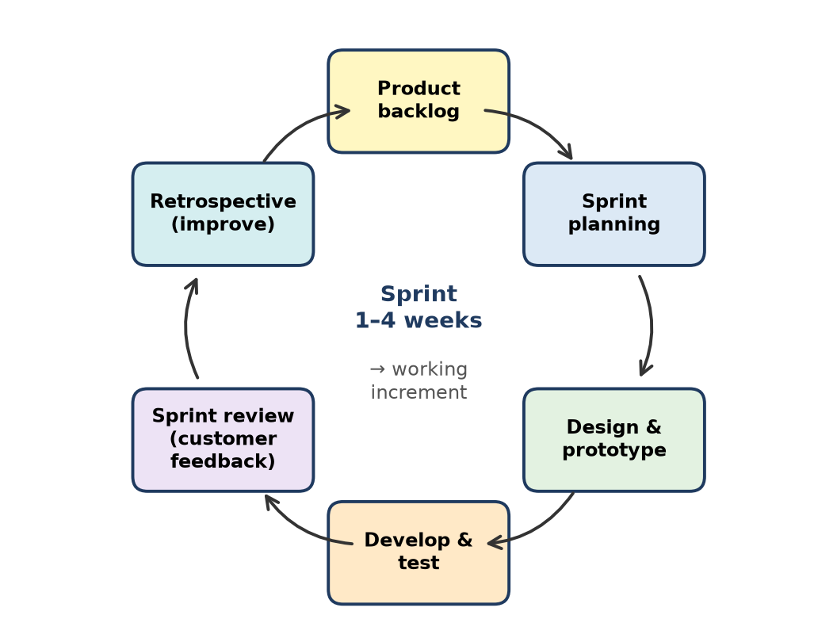
Figure: Agile sprint cycle with feedback
Benefits: change is absorbed every two weeks, users see working features early, compliance and security are checked continuously.
Remember: Change is not a problem in Agile – it joins the backlog.

Q15. An IT product team is uncertain whether users need AI-based code completion. Design a rapid experiment to test this assumption before making a major investment.
5 Marks • Apply • Moderate • CO4
Assumption to test: "Developers will regularly use and pay for AI-based code completion in our IDE."
Rapid experiment design:
1. Hypothesis – at least 40% of invited developers will accept AI suggestions weekly, and 10% will join a paid waitlist.
2. Cheap test options:
- Fake-door test – an "Enable AI completion" button; count clicks and show "coming soon, join waitlist".
- Wizard-of-Oz / concierge – use an existing third-party AI API behind a simple plugin instead of building our own model.
- Landing page + demo video – measure sign-ups (like the Dropbox video MVP).
3. Sample – 100–200 developers from existing users, 2–3 weeks.
4. Metrics – click-through rate, suggestion acceptance rate, weekly active use, retention, willingness to pay, qualitative interview feedback.
5. Decision rule – meet targets → invest; partly met → pivot (e.g. only test generation); not met → stop.
Figure: Build–Measure–Learn
Remember: Test the need with a fake door before building the real house.

Q16. A start-up is developing a campus-management application. Identify the core user problem, select essential features, and propose an MVP scope with justification for the selected features.
6 Marks • Apply • Moderate • CO4
Core user problem: students and faculty waste time on manual attendance and scattered notices; students do not know their attendance status until it is too late.
Users: students (primary), faculty (primary), admin, parents (later).
Feature selection (MoSCoW):
Feature | Priority | Justification
Login with college ID | Must | Needed for every user
Faculty marks attendance (QR / one-tap list) | Must | Solves the main pain – saves lecture time
Student attendance % dashboard with low-attendance alert | Must | Directly addresses students' pain
Notices and timetable | Should | High value, simple to build
Leave application | Could | Useful but not core
Fee payment, exams, parent app, AI analytics | Won't (now) | Costly; validate core first

MVP scope: Android app + web panel for one department, covering login, attendance marking, attendance dashboard and notices.
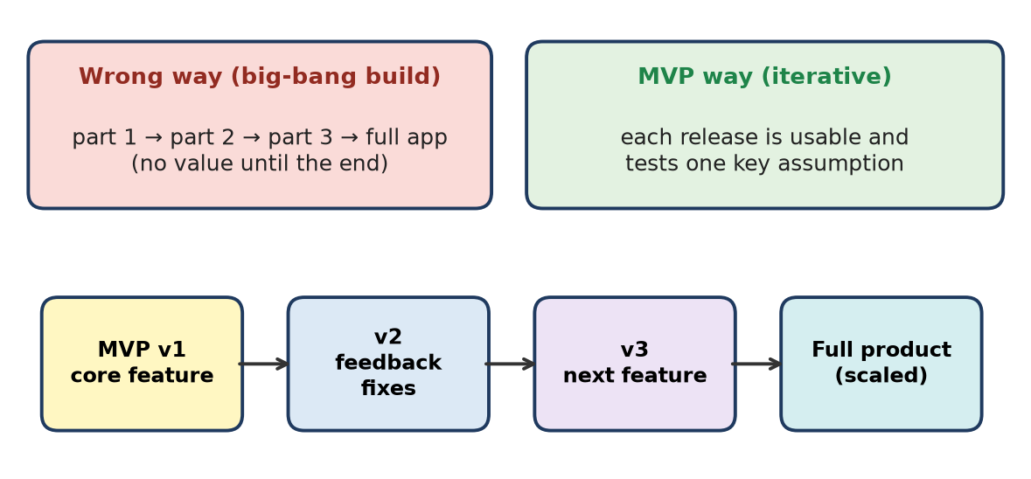
Figure: MVP grows in usable steps
Success criteria: 80% of faculty mark attendance in the app within a month; marking time under 1 minute; weekly student active use above 60%.
Conclusion: the MVP solves one sharp problem well, tests real usage and creates a base to add modules later.
Remember: MVP rule: one pain, few features, measurable result.

Q17. A company launches an MVP but receives low user adoption. Apply feedback collection and validation practices to determine the next development step.
5 Marks • Apply • Moderate • CO4
Situation: the MVP is live but few users sign up or keep using it.
Step 1 – collect feedback:
1. Analytics funnel – visit → sign-up → activation → repeat use; find where users drop.
2. User interviews with both active and dropped users ("What stopped you?").
3. In-app surveys / NPS, app-store reviews, session recordings.
Step 2 – validate assumptions: check which belief failed – problem (users don't feel the pain), solution (feature doesn't solve it), usability (too hard), or channel (wrong users reached).
Step 3 – decide the next step (pivot or persevere):
Finding | Next step
Users like it but onboarding is hard | Persevere – fix UX, simplify sign-up
One feature used heavily, rest ignored | Zoom-in pivot – focus on that feature (Instagram pivoted from Burbn to photos)
Wrong target users | Customer-segment pivot
No real need | Stop or explore a new problem

Step 4: run the next Build–Measure–Learn cycle with clear metrics (activation %, week-1 retention).
Remember: Low adoption is data, not defeat – find the drop, then pivot or persevere.

Q18. Apply the Agile innovation framework--exploration, incubation, acceleration, continuous learning, and scaling--to an AI-based student-assistance application.
6 Marks • Apply • Moderate • CO4
Product: an AI assistant that answers students' academic queries, reminds deadlines and suggests study material.
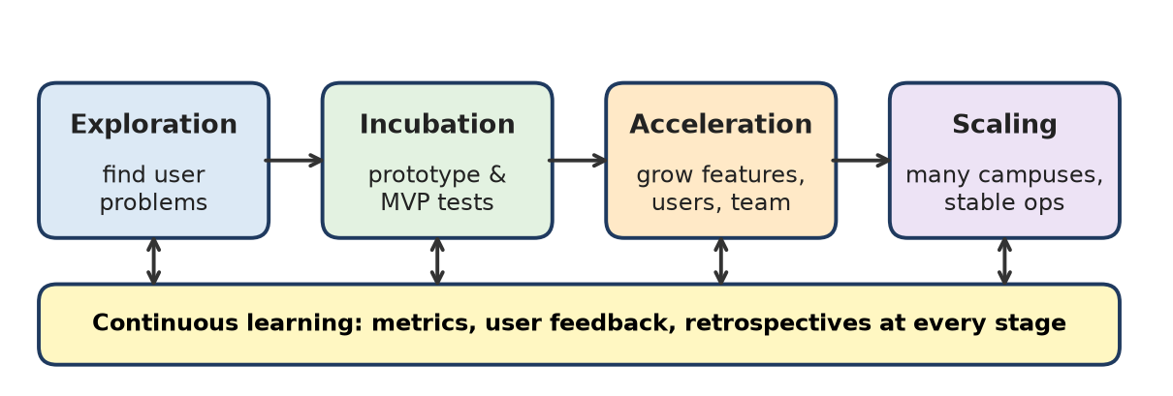
Figure: Agile innovation framework
Stage | What the team does for the AI student assistant | Output
1. Exploration | Interview students, study help-desk queries, list pain points (missed deadlines, can't find notes); brainstorm AI use cases | Validated problem + idea shortlist
2. Incubation | Build a prototype chatbot on top 50 FAQs using an LLM API; test with one class; check accuracy | MVP + early metrics
3. Acceleration | Add LMS integration, deadline reminders, Marathi/Hindi support; 2-week sprints; more users | Growing product and team
4. Continuous learning | Track answer accuracy, usage, satisfaction; collect thumbs-up/down; retrain and improve prompts; sprint retrospectives | Better model and process each cycle
5. Scaling | Roll out to all departments and other campuses; cloud auto-scaling, monitoring, data-privacy controls, support team | Stable, widely used product

Key points:
- Each stage has a gate – move ahead only if metrics are met.
- Continuous learning runs through every stage, not just at the end.
- Risks such as wrong answers and privacy are handled with human review and data masking.
Conclusion: the framework lets the team move from an idea to a campus-wide AI service in safe, measurable steps.
E-I-A-S, with Learning everywhere: Explore, Incubate, Accelerate, Scale.

Q19. An IT organization experiences slow releases because of silos between development, testing, and operations teams. Recommend innovation-management practices to improve collaboration and time to market.
6 Marks • Apply • Moderate • CO4
(This question appears under both "Agile innovation and innovation strategy" and "Evolution of innovation management in IT companies".)
Situation: Dev writes code, "throws it over the wall" to Test, then to Ops; hand-offs, blame and waiting slow releases.
Recommended practices:
1. DevOps culture – one shared goal ("working software in production"), shared ownership and on-call.
2. Cross-functional teams – developers, testers and ops engineers in one squad (like Amazon's small "two-pizza" teams).
3. CI/CD pipeline – every commit is built, tested and deployed automatically.
4. Test automation and shift-left testing – testers write automated tests from day one of the sprint.
5. Infrastructure as Code and containers (Docker, Kubernetes) – same environment from laptop to production.
6. Agile ceremonies – joint sprint planning, reviews and blameless retrospectives.
7. Monitoring and feedback – dashboards and alerts shared by all teams.
8. Measure with DORA metrics – deployment frequency, lead time for changes, change-failure rate, mean time to restore (MTTR).
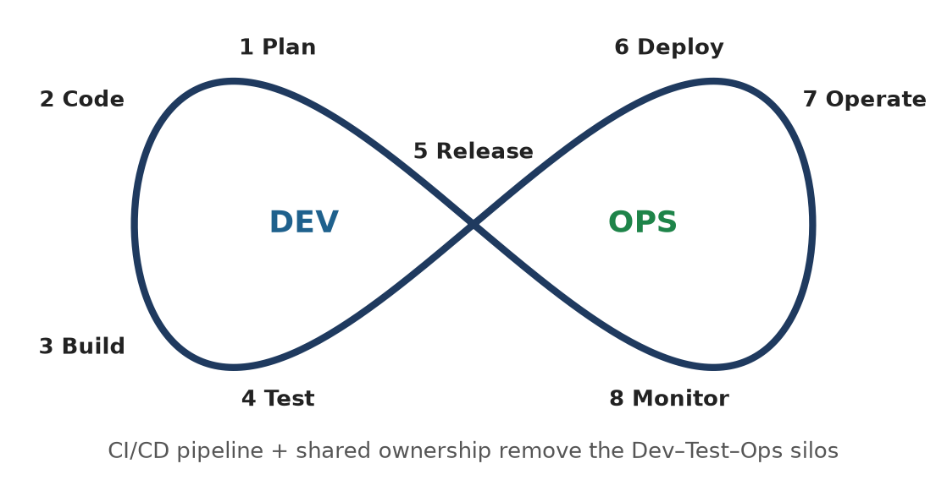
Figure: DevOps loop removes silos
Before (silos) | After (DevOps)
Release every few months | Release weekly or daily
Manual testing and deployment | Automated pipeline
Blame between teams | Shared responsibility

Conclusion: breaking silos with DevOps, automation and shared metrics cuts time to market and improves quality.
C-A-M-S: Culture, Automation, Measurement, Sharing.

Q20. An IT company is moving from traditional R&D-driven innovation to Agile, data-driven, and ecosystem-based innovation. Prepare a phased transition plan.
6 Marks • Apply • Moderate • CO4
(This question appears under both "Agile innovation and innovation strategy" and "Evolution of innovation management in IT companies".)
Evolution of innovation management: closed, lab-based R&D (long cycles, secret projects) → Agile and Lean (short cycles, user feedback) → data-driven (decisions from analytics and experiments) → open/ecosystem innovation (partners, start-ups, APIs, open source).
Phased transition plan:
Phase (time) | Focus | Key actions | Success measure
1. Prepare (0–3 months) | Leadership and mindset | Set innovation vision and OKRs; train staff in Agile and Design Thinking; pick 2 pilot teams | Pilots started
2. Agile pilots (3–9 months) | Short cycles | Scrum/Kanban in pilots, product owners, MVPs, CI/CD | Lead time ↓, user satisfaction ↑
3. Data-driven (6–12 months) | Evidence-based decisions | Product analytics, A/B testing platform, dashboards, experiment culture | Experiments per month, decisions backed by data
4. Ecosystem (12–18 months) | Open innovation | Public APIs, partner programme, hackathons, start-up collaboration, open-source contribution | Partner integrations, external ideas adopted
5. Scale and sustain (18+ months) | Whole organisation | Roll out to all teams, innovation portfolio board, rewards, regular reviews | % revenue from new products

Risk controls: change resistance (communication, champions), skill gaps (training), data privacy (governance).
Conclusion: a phased plan lets the company keep R&D strengths while gaining speed, evidence and partners.
Prepare → Pilot → Prove with data → Partner → Scale.

Q21. For a cloud-based document-management system, identify and categorize the major technical, financial, operational, market, and security risks.
5 Marks • Apply • Moderate • CO4
Situation: a SaaS system where organisations store, share and search documents in the cloud.
Category | Major risks
Technical | Cloud outage, data loss or corruption, poor performance with large files, integration failures with other tools, vendor lock-in
Financial | Cloud storage and bandwidth costs grow faster than revenue, budget overrun, slow customer payments
Operational | Weak backup and restore process, key staff leaving, poor incident response, support overload
Market | Strong competitors (Google Drive, Microsoft OneDrive/SharePoint, Dropbox), low adoption, price pressure, changing customer needs
Security | Unauthorised access, data breach, ransomware, insider misuse, weak encryption, non-compliance with data-protection law (e.g. India's DPDP Act 2023)

Typical mitigations: multi-region backups, encryption at rest and in transit, role-based access and MFA, cost monitoring, clear differentiation (e.g. compliance features for colleges or hospitals), documented runbooks.
T-F-O-M-S: "Tech Fails, Operations Miss, Security Slips".

Q22. A start-up with limited funds is developing an AI healthcare application. Apply a probability–impact matrix to prioritize risks and recommend suitable mitigation measures.
6 Marks • Apply • Moderate • CO4
Method: rate each risk for probability (P) and impact (I) on a 1–5 scale; risk score = P × I. Scores 15–25 = high (act now), 8–14 = medium (plan), below 8 = low (monitor).
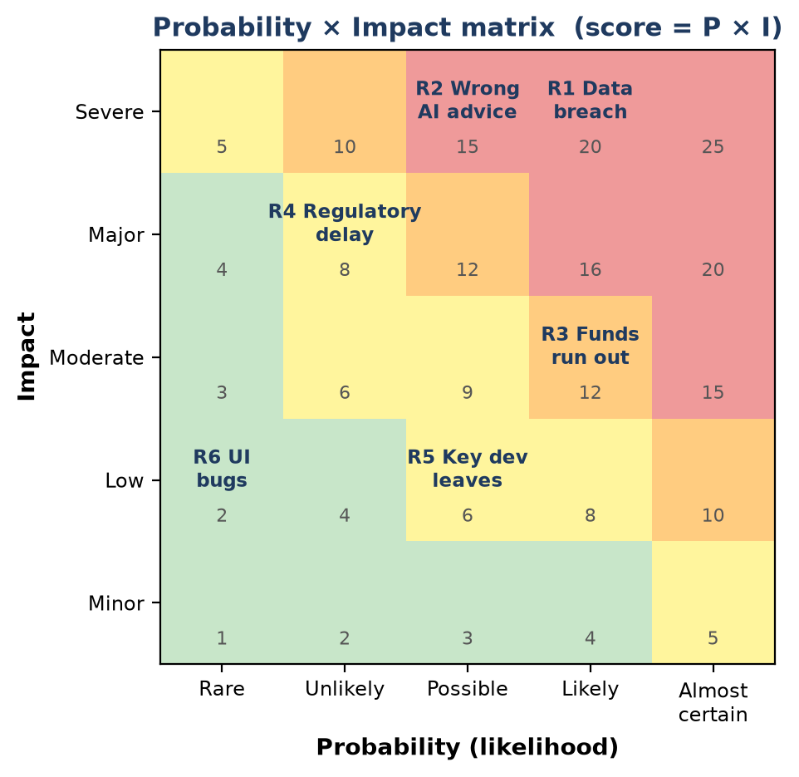
Figure: Probability × impact matrix for the AI healthcare app
Risk | P | I | Score | Priority | Mitigation
R1 Patient data breach | 4 | 5 | 20 | High | Encryption, access control, security audit, DPDP Act compliance
R2 Wrong AI advice | 3 | 5 | 15 | High | Doctor-in-the-loop review, use only validated data, clear disclaimers
R3 Funds run out | 4 | 3 | 12 | Medium | Lean MVP, staged spending, grants/incubators, early paying pilot hospitals
R4 Regulatory approval delay | 2 | 4 | 8 | Medium | Early talks with regulators, documentation from day one
R5 Key developer leaves | 3 | 2 | 6 | Low | Code documentation, pair programming, ESOPs
R6 Minor UI bugs | 2 | 1 | 2 | Low | Automated testing, beta users

Response strategies: avoid (drop risky feature), reduce (controls above), transfer (cyber insurance, certified cloud provider), accept (low risks, monitor).
Conclusion: with limited funds, the start-up should spend first on R1 and R2, because they can harm patients and end the company.
Score = P × I; fix the red corner first.

Q23. A software company plans to integrate a third-party AI API. Identify technology-dependence, privacy, reliability, and cost risks and recommend safeguards.
6 Marks • Apply • Moderate • CO4
Situation: the company will call an external AI service (e.g. an LLM or vision API) from its product instead of building its own model.
Risk type | What can go wrong | Safeguards
Technology dependence (vendor lock-in) | Provider changes the model, deprecates the API or raises prices; product breaks | Abstraction layer/adapter in code; support a second provider or open-source model as fallback; version pinning; contract with notice period
Privacy | User personal data sent outside; data stored or used for training; legal breach | Mask/anonymise personal data before sending; choose providers with no-training and data-residency options; sign data-processing agreement; user consent
Reliability | Outages, slow responses, rate limits, wrong or biased outputs ("hallucinations") | Timeouts, retries, caching, graceful fallback message; monitor latency and errors; human review for critical outputs; test sets to check quality
Cost | Pay-per-token bills grow with usage; unpredictable monthly cost | Usage quotas and alerts, caching repeated answers, smaller/cheaper models for simple tasks, budget dashboards, price user plans accordingly

Additional controls: security review of the API (keys stored in a secrets vault, not in code), SLA review, a proof-of-concept before full integration.
Conclusion: a third-party AI API speeds up innovation, but the company must design for "provider may fail, leak or cost more" from day one.
Lock-in, Leak, Lag, Bill – plan a safeguard for each.

Q24. For a subscription-based productivity application, select suitable performance indicators for adoption, retention, usability, delivery speed, and financial viability.
5 Marks • Apply • Moderate • CO4
Situation: a SaaS to-do/notes app with free and paid monthly plans.
Area | Suitable KPIs | What it tells us
Adoption | New sign-ups, activation rate (% who create first task in 24 h), DAU/MAU | Are people starting to use it?
Retention | Day-7 / Day-30 retention, churn rate (% subscribers cancelling per month), renewal rate | Do they keep using and paying?
Usability | Task success rate, time to complete key task, System Usability Scale (SUS) score, support tickets per 100 users | Is it easy to use?
Delivery speed | Deployment frequency, lead time for changes, sprint velocity, cycle time | How fast do we deliver improvements?
Financial viability | MRR/ARR, ARPU, customer acquisition cost (CAC), customer lifetime value (LTV), LTV:CAC ratio (≥ 3 is healthy), free-to-paid conversion % | Is the business sustainable?

Practice: show these on one dashboard, set targets (e.g. churn < 5% per month), review every sprint.
A-R-U-D-F: "Are Real Users Delighted & Funding us?"

Q25. A company develops an automated testing tool. Prepare a KPI measurement plan to track defect reduction, testing time, and development cost.
5 Marks • Apply • Moderate • CO4
Goal: prove that the automated testing tool improves quality, speed and cost.
Objective | KPI | Formula / measure | Baseline → Target | Source | Frequency
Defect reduction | Defect leakage (bugs found in production) | Prod defects ÷ total defects × 100 | 25% → below 10% | Bug tracker (Jira) | Per release
 | Defect density | Defects per 1,000 lines of code (KLOC) | Reduce by 30% | Code + bug data | Monthly
Testing time | Regression test cycle time | Hours to run full regression suite | 3 days → 4 hours | CI/CD logs | Per build
 | Test automation coverage | Automated tests ÷ total tests × 100 | 30% → 80% | Test management tool | Sprint
Development cost | Cost of rework | Hours spent fixing bugs × hourly rate | Reduce by 25% | Timesheets | Monthly
 | Testing cost per release | Tester effort + tool cost | Track trend | Finance + timesheets | Quarterly

Steps: record the baseline before rollout → automate data collection → monthly review dashboard → act on gaps → report ROI (savings ÷ tool cost).
Remember: Measure before and after – a KPI without a baseline proves nothing.

Q26. A start-up has three product ideas but sufficient funds to pursue only one. Apply innovation-selection criteria involving customer value, technical feasibility, business viability, risk, and strategic fit.
6 Marks • Apply • Moderate • CO4
Method: weighted scoring matrix – the screening gate of the innovation funnel. Score each idea 1–5 on every criterion, multiply by the weight, and add.
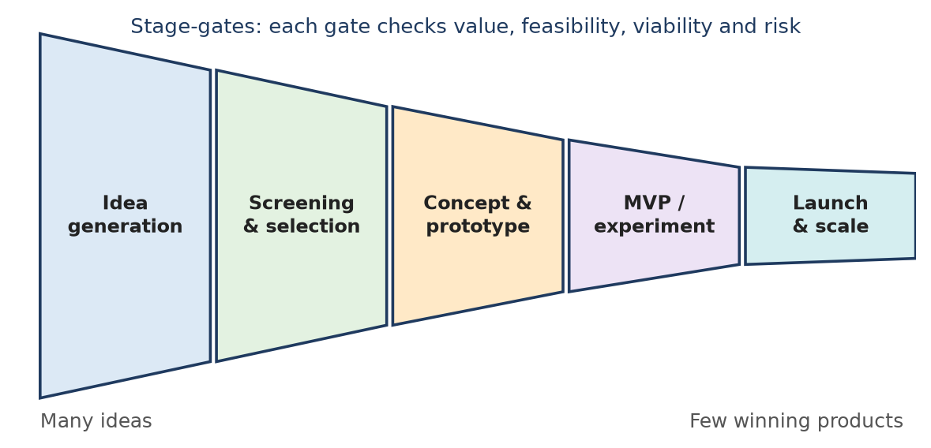
Figure: Innovation funnel with stage-gates
Ideas: A – AI resume-review app for students; B – campus food pre-ordering app; C – AR-based campus navigation app.
Criterion (weight) | A: AI resume review | B: Food pre-order | C: AR navigation
Customer value (30%) | 4 | 5 | 3
Technical feasibility (20%) | 4 | 5 | 2
Business viability (20%) | 3 | 4 | 2
Risk – higher score = lower risk (15%) | 3 | 4 | 2
Strategic fit (15%) | 4 | 4 | 3
Weighted total (out of 5) | 3.65 | 4.50 | 2.45

Working for B: 5×0.30 + 5×0.20 + 4×0.20 + 4×0.15 + 4×0.15 = 1.5 + 1.0 + 0.8 + 0.6 + 0.6 = 4.50. Working for A: 1.2 + 0.8 + 0.6 + 0.45 + 0.6 = 3.65. Working for C: 0.9 + 0.4 + 0.4 + 0.3 + 0.45 = 2.45.
Decision: choose Idea B – clear daily pain (queues), simple proven technology, canteen commission or subscription revenue, low risk, fits the team's campus focus.
Next step: validate B with an MVP in one canteen before full build; keep A as the next idea.
V-F-V-R-S: Value, Feasibility, Viability, Risk, Strategy – weigh, score, pick.

Q27. An Agile software team experiences delayed releases and low customer satisfaction. Apply performance metrics and feedback practices to identify improvement opportunities.
6 Marks • Apply • Moderate • CO4
Situation: sprints overrun, releases slip and customers are unhappy.
Step 1 – measure (metrics):
Area | Metric | What a bad value suggests
Planning | Sprint velocity trend, say/do ratio (committed vs completed points) | Over-commitment, poor estimation
Flow | Cycle time, lead time, work-in-progress (WIP) | Bottlenecks, too much multitasking
Quality | Escaped defects, change-failure rate, reopened tickets | Weak testing, rework
Delivery | Deployment frequency | Big, risky releases
Customer | CSAT, NPS, feature usage, support tickets | Building the wrong things

Step 2 – collect feedback:
1. Sprint reviews with real customers, not only managers.
2. Retrospectives (start/stop/continue) to find process issues.
3. Customer interviews and in-app surveys; analyse complaint themes.
4. Burndown and cumulative-flow charts to see where work waits.
Step 3 – improvement opportunities:
- Smaller user stories and a clear Definition of Done.
- WIP limits and fewer parallel tasks.
- Test automation and CI/CD to cut rework.
- Product Owner prioritises by customer value; validate features with prototypes before building.
- Release smaller increments more often.
Conclusion: combining hard metrics with customer and team feedback shows where delays come from and what customers really want.
Measure the flow, ask the users, fix the bottleneck.

Q28. A successful MVP is ready to be scaled into a full product. Prepare an implementation plan covering innovation management, risk assessment, resource allocation, and deployment.
6 Marks • Apply • Moderate • CO4
Situation: the MVP has proven demand (good retention and paying users); now it must grow safely.
Area | Plan
Innovation management | Product roadmap from MVP learning; prioritise backlog by value; Agile sprints; keep Build–Measure–Learn with A/B tests; stage-gate review each quarter
Risk assessment | Risk register with probability × impact scores; key risks – scalability, security/data privacy, cost overrun, competition, team burnout; owner and mitigation for each
Resource allocation | Hire/assign: backend, mobile, QA, DevOps, UX, customer success; budget split (e.g. development, cloud, marketing, support); use cloud pay-as-you-grow
Deployment | Move to scalable architecture (microservices, auto-scaling, CDN); CI/CD pipeline; staged rollout – beta → 10% → 50% → 100% (canary releases); monitoring, backups, incident runbook
Measurement | KPIs: active users, retention, uptime (e.g. 99.9%), response time, MRR, CSAT

Timeline: Month 1–2 stabilise and re-architect; Month 3–4 add priority features; Month 5–6 phased launch and marketing; then continuous improvement.
Conclusion: scale only what is validated, add resources step by step, and keep measuring so growth does not break the product.
Remember: Scaling = Roadmap + Risk register + Resources + Rollout.

Q29. An IT company observes declining user engagement in its LMS. Apply suitable innovation practices to propose improvements while considering user needs, time, and cost constraints.
8 Marks • Apply • High • CO4
Situation: students log in less, watch fewer videos and drop courses; budget and time are limited.
1. Understand user needs (Design Thinking + data):
- Analytics: where students drop (login, video, quiz).
- Interviews/surveys with students and faculty; empathy map and journey map.
- Typical findings: slow pages on mobile, hard-to-find material, no reminders, boring content, no sense of progress.
2. Generate and select ideas – brainstorm, then prioritise on a value vs effort grid:
Improvement | Innovation type | User value | Cost/time | Priority
Mobile-first, faster pages | Incremental | High | Low | Now
Smart search and course home page | Incremental | High | Low | Now
Deadline reminders (WhatsApp/push) | Incremental | High | Low | Now
Progress bar, badges, streaks (gamification) | Incremental | Medium | Medium | Next
Discussion forum / peer groups | Incremental | Medium | Medium | Next
AI study assistant for doubts | Radical | High | High | Later (pilot)

3. Rapid experimentation: A/B test reminders and gamification with one batch; prototype the AI assistant with a third-party API before investing.
4. Agile delivery under constraints: 2-week sprints; "quick wins" first; reuse open-source plug-ins and existing cloud services; MVP for each new feature.
5. Measure: weekly active learners, course-completion rate, average session time, quiz attempts, NPS.
6. Risk control: limit scope creep (MoSCoW), protect student data, collect faculty buy-in.
Conclusion: start with cheap incremental fixes based on real needs, test bigger ideas as experiments, and scale only what raises engagement.
Diagnose → Quick wins → Experiment → Measure → Scale.

Q30. A resource-constrained start-up must choose between improving its existing application and introducing a new technology-based feature. Apply innovation-selection criteria to prepare an implementation plan within budget and time limits.
8 Marks • Apply • High • CO4
Options: Option 1 – improve the existing app (performance, UX fixes, top-requested features). Option 2 – add a new technology feature (e.g. AI recommendations).
Step 1 – apply selection criteria (score 1–5, weighted):
Criterion (weight) | Option 1: Improve existing | Option 2: New AI feature
Customer value / demand evidence (30%) | 4 (users already ask for fixes) | 4 (attractive but unproven)
Technical feasibility with current team (20%) | 5 | 2
Cost and time within budget (20%) | 5 | 2
Risk (higher = lower risk) (15%) | 5 | 2
Strategic fit / differentiation (15%) | 3 | 5
Weighted score | 4.40 | 3.05

Working: Option 1 = 1.2 + 1.0 + 1.0 + 0.75 + 0.45 = 4.40; Option 2 = 1.2 + 0.4 + 0.4 + 0.3 + 0.75 = 3.05.
Decision: do Option 1 now (retains users, quick revenue) and run a low-cost experiment for Option 2 in parallel.
Step 2 – implementation plan (12 weeks, fixed budget):
Weeks | Work | Budget share
1–2 | Analyse feedback and analytics; finalise backlog (MoSCoW) | 5%
3–8 | Three 2-week sprints on performance and UX improvements; CI/CD and testing | 60%
5–8 (parallel) | Fake-door test / small prototype of AI feature using a third-party API | 15%
9–10 | Release improvements; measure retention and ratings | 10%
11–12 | Review AI experiment data → go / no-go for next quarter | 10%

Controls: fixed sprint scope, weekly budget tracking, risk register, KPIs (churn, app rating, experiment sign-ups).
Conclusion: under tight resources, secure the core first and test the new idea cheaply.
Fix what pays now; test what may pay later.

Q31. A start-up is uncertain about the feasibility and user acceptance of an AI-based recruitment application. Develop an MVP plan covering essential features, testing, user feedback, and measurable success criteria.
8 Marks • Apply • High • CO4
Problem: HR teams spend many hours screening resumes; candidates get no response. Uncertain: can AI screen fairly and accurately (feasibility), and will recruiters trust it (acceptance)?
Key assumptions to test: (1) AI ranking matches recruiter judgement; (2) recruiters save time and will use it weekly; (3) candidates accept AI screening if it is transparent.
Essential MVP features:
Feature | Why essential
Job description input + resume upload (PDF) | Core input
AI skill-matching score with short explanation | Tests feasibility and builds trust
Ranked shortlist dashboard; recruiter can override | Keeps human in control
Simple candidate status email | Tests candidate acceptance
Feedback buttons (agree/disagree with ranking) | Collects learning data

Left out for later: video interviews, chat-bot, ATS integrations, salary analytics.
Testing plan:
1. Technical test – compare AI shortlist with recruiters' shortlist on 500 past resumes.
2. Bias check – compare results across gender and college groups; remove names/photos from scoring.
3. Pilot – 5–10 small companies for 4–6 weeks (concierge support).
User feedback: weekly interviews with recruiters, in-app ratings, candidate survey, usage analytics.
Measurable success criteria:
- AI–recruiter shortlist agreement ≥ 75%.
- Screening time per job reduced by ≥ 50%.
- ≥ 60% of pilot recruiters use it weekly; ≥ 3 agree to pay after the pilot.
- No significant score gap between demographic groups.
- Candidate satisfaction ≥ 4 out of 5.
Decision: criteria met → build full product; partly met → pivot (e.g. assistant-only mode); not met → stop.
Remember: MVP plan = Assumptions → Few features → Test → Feedback → Numbers decide.

Q32. An IT company adopts Agile innovation to reduce release delays. Apply Agile practices to design a workflow incorporating sprint planning, prototyping, customer feedback, and continuous improvement.
8 Marks • Apply • High • CO4
Situation: long release cycles and late surprises; the company wants smaller, faster, user-validated releases.
Figure: Agile innovation workflow
Agile workflow (2-week sprint):
Step | Practice | Output
1. Product backlog | Product Owner collects ideas from users, data and business; writes user stories with acceptance criteria; ranks by value | Prioritised backlog
2. Sprint planning | Team selects top stories it can finish; sets sprint goal; estimates in story points | Sprint backlog
3. Prototyping | UX designer makes quick wireframes/clickable prototypes (Figma) for new features; 3–5 users test them early in the sprint | Validated design
4. Development and testing | Daily stand-up; code + automated tests; CI/CD pipeline builds and deploys to staging; Definition of Done | Working increment
5. Sprint review (customer feedback) | Demo to customers/stakeholders; collect feedback; release behind feature flags | Feedback → new backlog items
6. Retrospective (continuous improvement) | Team discusses what went well, what to change; picks 1–2 improvement actions | Better process next sprint

Supporting practices: Kanban board for visibility, WIP limits, small releases, DevOps monitoring after release.
Metrics to track improvement: lead time, deployment frequency, sprint goal success rate, escaped defects, CSAT/NPS.
Benefits: problems found early through prototypes, customers shape the product every sprint, releases become small and predictable.
Conclusion: sprint planning + prototyping + customer feedback + retrospectives form a closed loop that steadily cuts release delays.
Plan → Prototype → Build → Show → Reflect → Repeat.

Q33. A cloud application stores confidential customer data. Apply a risk-assessment method to identify major risks, estimate their probability and impact, prioritize them, and recommend mitigation measures.
8 Marks • Apply • High • CO4
Method (qualitative risk assessment): (1) identify assets and threats → (2) rate probability (P) and impact (I) on 1–5 → (3) risk score = P × I → (4) prioritise: 15–25 high, 8–14 medium, < 8 low → (5) mitigate and monitor.
Asset: confidential customer data (personal details, payment and business records).
Risk | P | I | Score | Priority | Mitigation
Data breach via stolen credentials | 4 | 5 | 20 | High | MFA, least-privilege access (IAM), password policy, login anomaly alerts
Cloud misconfiguration (public storage bucket) | 3 | 5 | 15 | High | Configuration scanning tools, Infrastructure as Code reviews, private-by-default storage
Ransomware / malware | 3 | 5 | 15 | High | Immutable, off-site backups; patching; endpoint protection; tested restore drills
Insider misuse | 2 | 5 | 10 | Medium | Role-based access, audit logs, background checks, data masking
Regulatory non-compliance (DPDP Act 2023 / GDPR) | 2 | 4 | 8 | Medium | Data-protection officer, consent records, privacy impact assessment, regular audits
Service outage / region failure | 2 | 4 | 8 | Medium | Multi-zone deployment, auto-failover, SLA with provider
Insecure APIs | 3 | 4 | 12 | Medium | API gateway, authentication tokens, input validation, penetration testing

Priority order: credential breach → misconfiguration and ransomware → insecure APIs → insider misuse → compliance and outage.
General controls: encryption at rest and in transit, key management service, security monitoring (SIEM), incident-response plan, staff security training.
Risk responses: reduce (controls above), transfer (cyber insurance), avoid (do not store data not needed – data minimisation), accept (only low residual risks).
Conclusion: scoring P × I focuses limited effort on the risks that can expose customer data; review the register every quarter.
Identify → Rate → Rank → Reduce → Review.

Q34. A software organization wants to measure innovation performance. Apply suitable KPIs to prepare a measurement plan covering delivery, adoption, quality, learning, and business outcomes.
8 Marks • Apply • High • CO4
Purpose: know whether innovation effort turns into value, and where to improve.
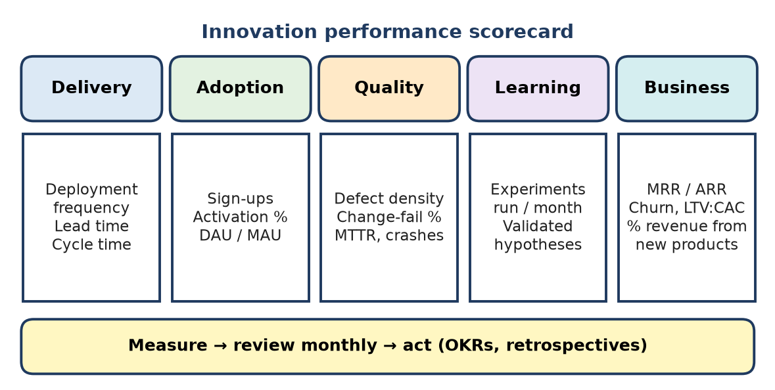
Figure: Innovation performance scorecard
Area | KPI | Target (example) | Data source | Review
Delivery | Deployment frequency; lead time for changes; idea-to-launch time | Weekly releases; lead time < 2 days | CI/CD tools, Jira | Sprint
Adoption | Sign-ups, activation %, DAU/MAU, feature adoption % | New feature used by 30% of users in 30 days | Product analytics | Monthly
Quality | Escaped defects, change-failure rate, MTTR, crash-free sessions, SUS score | Change-fail < 15%; crash-free > 99% | Bug tracker, monitoring | Sprint
Learning | Experiments run per month, % hypotheses validated, ideas submitted/implemented, training hours | ≥ 4 experiments per team per month | Experiment log, idea portal | Monthly
Business outcomes | Revenue from products launched in last 3 years (%), MRR growth, churn, LTV:CAC, innovation ROI | 25% revenue from new products | Finance, billing | Quarterly

Measurement plan steps:
1. Link KPIs to company OKRs (objectives and key results).
2. Record a baseline for each KPI.
3. Automate collection into one dashboard.
4. Review in sprint reviews (team), monthly (product) and quarterly (leadership).
5. Act – scale ideas that meet targets, pivot or stop the rest.
6. Balance leading indicators (experiments, activation) with lagging ones (revenue).
Caution: avoid vanity metrics (total downloads alone); measure outcomes, not just activity.
Conclusion: a balanced scorecard across delivery, adoption, quality, learning and business shows the full picture of innovation health.
D-A-Q-L-B: "Deliver, Adopt, Quality, Learn, Bank."

Q35. An AI-based campus-management MVP has been released. Apply innovation-management practices to prepare the next-stage implementation plan covering user feedback, improvements, risk controls, and scaling criteria.
8 Marks • Apply • High • CO4
Situation: the MVP (attendance, notices and an AI query assistant) is live in one department. Next: improve it and decide when to scale.
1. User feedback collection
- In-app ratings and thumbs-up/down on AI answers; short surveys (NPS).
- Interviews with students, faculty and admin; usage analytics (feature use, drop-offs).
- Support tickets grouped by theme (affinity mapping).
2. Improvements (prioritised backlog)
Feedback | Improvement | Priority
AI gives wrong or vague answers | Better knowledge base, retrieval from official documents, show sources | High
Faculty want faster marking | QR + bulk marking | High
Students miss notices | Push and WhatsApp alerts | Medium
Parents want updates | Parent view (read-only) | Low

Delivered in 2-week sprints, with A/B tests for major changes.
3. Risk controls
Risk | Control
Student data privacy | Role-based access, encryption, consent, DPDP Act compliance
AI errors / bias | Human escalation, answer logging, regular accuracy tests
Scalability | Cloud auto-scaling, load testing before rollout
Low adoption | Training, champions in each department
Cost overrun | Monthly cloud and API cost monitoring

4. Scaling criteria (go / no-go gates)
- ≥ 70% weekly active students; ≥ 80% faculty use for attendance.
- AI answer accuracy ≥ 90% on test set; satisfaction ≥ 4/5.
- Uptime ≥ 99.5%; no critical security issues.
- Cost per user within budget.
5. Scaling plan: Phase 1 – all departments of the college; Phase 2 – 2–3 partner colleges; Phase 3 – subscription model for institutions.
Conclusion: feedback-driven improvement, clear risk controls and measurable gates let the MVP grow safely into a full product.
Feedback → Fix → Fortify → Scale (only through the gates).

Quick Revision – Unit IV
Term | Meaning / key fact
Invention vs innovation | Invention = new idea; innovation = idea used successfully in the market
Incremental innovation | Small improvement to existing product (faster LMS search)
Radical innovation | Breakthrough technology, new capability, highest uncertainty
Disruptive innovation | Cheap/simple offer starts with ignored users, later replaces leaders (Netflix vs Blockbuster)
Architectural innovation | Same components, new linkages (Henderson–Clark)
Sources of innovation | Users, employees, new technology/R&D, data, competitors, partners/open source
Agile innovation | Short sprints, working increments, customer feedback, retrospectives
Agile innovation framework | Exploration → Incubation → Acceleration → Scaling, with continuous learning
MVP | Smallest product that tests the key assumption (Dropbox demo video)
Build–Measure–Learn | Lean Startup feedback loop; pivot or persevere
Rapid experiment | Fake-door, landing page, Wizard-of-Oz, A/B test before big investment
DevOps | Breaks Dev–Test–Ops silos with CI/CD, automation, shared metrics
Risk score | Probability × Impact; mitigate high scores first
Risk responses | Avoid, Reduce, Transfer, Accept
Innovation KPIs | Delivery (DORA), adoption (DAU/MAU), quality, learning (experiments), business (% revenue from new products, LTV:CAC)

